Advertising Competitive Insights 2022

Weekly Updates

DL: [DL-eBay-Competitive-Insights-Ads@ebay.com](mailto:DL-eBay-Competitive-Insights-Ads@ebay.com)

# Calendar Week 33 (Aug 19)

## **Your iPhone may soon have more ads**

Apple could eventually bring ads to more of the apps that come pre-installed on your iPhone and other Apple devices, including Maps, Books, and Podcasts. According to [a report from *Bloomberg*’s Mark Gurman](https://www.bloomberg.com/news/newsletters/2022-08-14/apple-aapl-set-to-expand-advertising-bringing-ads-to-maps-tv-and-books-apps-l6tdqqmg), Apple has internally tested search ads in Maps, which could display recommendations when you search for restaurants, stores, or other nearby businesses.

* Apple already implements a similar advertising model on the App Store, as developers can pay to have their app promoted on a search page for a particular query, like “puzzle games” or “photo editor.” As noted by Gurman, ads on Maps could work in the same way, with businesses paying to appear at the top of search results when users enter certain search terms.
* Gurman believes that Apple could introduce ads to its native Podcasts and Books apps as well. This could potentially allow publishers to place ads in areas within each app, or pay to get their content placed higher in search results. Just like Maps, Podcasts and Books are currently ad-free.
* And while the App Store already has ads on the Search tab, Gurman expects Apple to expand ads to the Today tab and app download pages. According to *9to5Google*, ads on the Today tab will show up as larger cards with the word “Ad” placed beneath the app’s name, while ads on individual app pages will appear highlighted in blue in the “You Might Also Like” section.

<https://www.theverge.com/2022/8/14/23305200/iphone-more-ads-advertising-apple-maps-podcasts-books-mark-gurman-rumors>

## **Amazon Is Very Keen On Adopting A TikTok Themed Feed With Internal Tests In Full Swing**

There are plenty of apps that can’t get over TikTok’s successful layout for its social feed. And that’s why they’re doing everything in their power to take inspiration and generate an algorithm that’s awfully similar. After Facebook, Instagram, Twitter, Snapchat, Pinterest, and more, it now seems Amazon has joined the bandwagon.

* The news report comes to us thanks to Watchful who recently outlined in detail how Amazon has already begun internal testing the idea. And yes, that just goes to show how motivated they are on taking the initiative on board.
* Amazon is experimenting to see whether or not vertical photographs and video content across the app can be a success. The test is solely restricted to just Amazon staff members but if it does turn out well, we can see it being released for the rest of us soon.
* Images were provided by Watchful to the [WSJ](https://www.wsj.com/articles/amazon-tests-tiktok-like-feed-in-app-11660754386?mod=Searchresults_pos1&page=1) in this regard. And by the looks of it, the new feed that has been dubbed ‘Inspire’ is going to be seen across the app’s navigation bar towards the bottom end of the page.

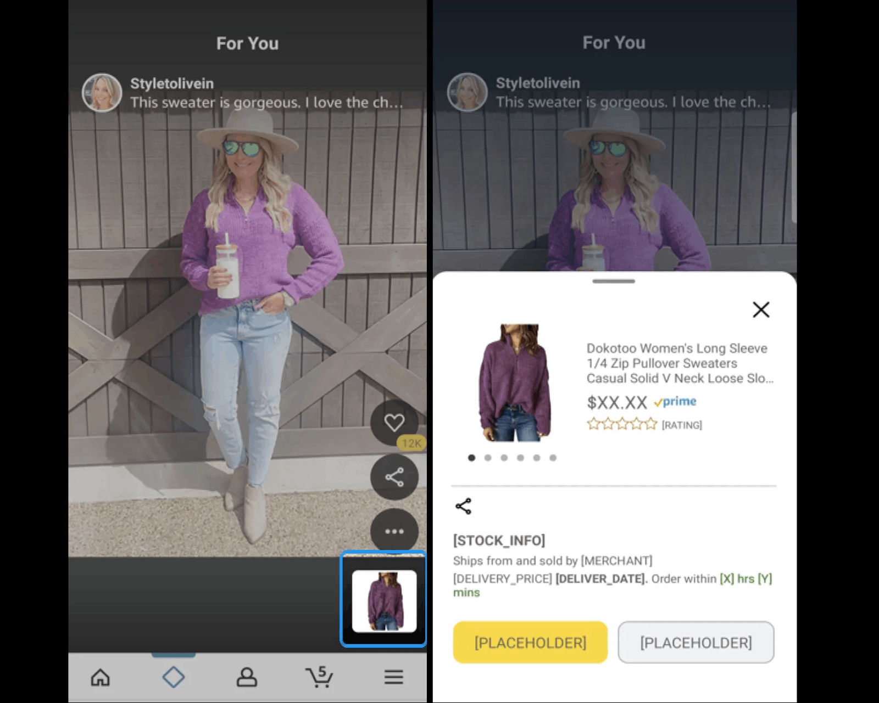

* After clicking on the diamond-shaped image, users will get a glimpse of posts across their feed. This will entail a few links to those goods and services seen across the post.
* For now, we’re not too sure if the feature will actually get launched on Amazon or not. Also, users might not find the native offering of Amazon too appealing as that seen across different platforms.

<https://www.digitalinformationworld.com/2022/08/amazon-is-very-keen-on-adopting-tiktok.html>

## **Meta Launches New B2B Advertising Audiences to Help Marketers Reach Key Decision Makers**

As it works to mitigate the impacts of Apple’s ATT update, which has reduced its data tracking capacity, leading to a significant loss in ad effectiveness and interest, Meta has today announced a new set of B2B targeting audience segments, which will provide another way for B2B marketers to reach key decision-makers across its apps.

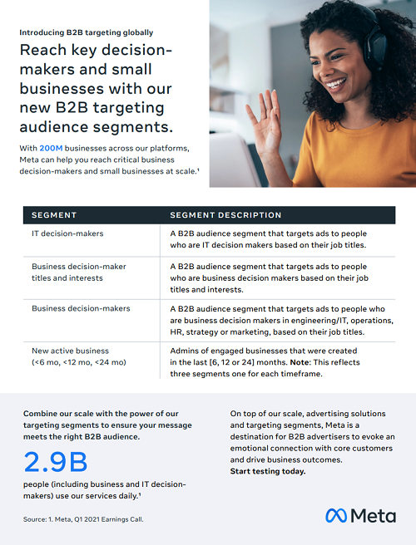

* Meta’s new B2B audience segments will enable advertisers to hone in on specific groups, based on their listed job titles and/or activity in its apps.
* These broader audience groups, as opposed to Meta’s regular personalized targeting, will enable Meta to utilize the data insights that it can reliably maintain, despite Apple’s update, to help marketers reach the right people, and get their ads in front of key decision-makers in its apps.
* LinkedIn is generally considered the king of B2B marketing, and would be the key focus for more B2B brands. But the comparative reach of Facebook will still prove to be a strong lure for many, with these new segments helping to refine your focus, without you having to manually enter equivalent details.

<https://www.socialmediatoday.com/news/meta-launches-new-b2b-advertising-audiences-to-help-marketers-reach-key-dec/629290/>

## **Walmart’s Advertising Revenue Is Small But Soaring**

Walmart, which reported its quarterly on Tuesday, generated total revenue of $153 billion in Q2 alone, the vast majority of which came from store sales.

* But although Walmart didn’t disclose its advertising revenue for the second quarter, it did say that its ads business grew 30% year-over-year. For reference, Walmart’s advertising business, which is primarily the Walmart Connect ad platform, [made $2.1 billion in 2021](https://www.adexchanger.com/ecommerce-2/walmart-breaks-out-ad-business-revenue-at-2-1-billion-and-details-how-ads-power-its-retail-evolution/).
* A 30% YoY bump in Q2 means that Walmart’s ad revenue last quarter was likely in the mid-to-high hundred-million-dollar range.
* One might then wonder why advertising and other businesses that appear marginal to Walmart’s current revenue makeup, such as third-party online marketplace sellers and subscription memberships, are front and center for the company right now?
  + “We continue to advance our flywheel strategy and diversify our income streams,” said John Rainey, Walmart’s CFO, pointing to the company’s ads business, the 240 million SKUs that are now available on Walmart.com and Walmart+, which doesn’t disclose its subscriber count.
* “Even more encouraging than the numbers,” McMillon said, in reference to Walmart’s ad revenue growth and shopper data graph, is that the ad business helped improve customer experience on the site by surfacing better deals and the right products.

<https://www.adexchanger.com/commerce/walmarts-advertising-revenue-is-small-but-soaring/>

## **TikTok Introduces 3 Types Of Shopping Ads**

Advertisers can now run shopping ads on TikTok with three different formats to choose from: TikTok continues its e-commerce push with the introduction of three types of shopping ads with expanded placement options that go beyond the For You page.

* The new advertising formats are accessible in TikTok Ads manager through buying objective ‘Product Sales.’
* Advertisers are **not required** to utilize TikTok Shop, an in-app ecommerce solution, to run shopping ads.
* **Video Shopping Ads:**
  + Video shopping ads allow advertisers to create shoppable videos for display on the For You page.
  + This ad type combines features from existing TikTok ads — collection ads and dynamic showcase ads.
  + Video shopping ads will dynamically combine video creative and product cards into different variations. The format can be either product-specific to drive sales or a broader brand message to drive consideration.
  + As TikTok gathers data, it will optimize a campaign’s performance by dynamically choosing the top converting combinations.
  + When a user taps on the ad, TikTok will create an in-app landing page to better determine a user’s intent to buy. These pages let shoppers learn more about products and redirect users to a retailer’s site when they’re ready to purchase.
* **Catalog listing ads:**
  + Catalog listing ads allow advertisers to promote product catalogs at scale with new placements across TikTok.
  + Something advertisers may appreciate about catalog listing ads is that they’re not required to create video content.
  + The ads allow brands to get in front of the TikTok audience without making videos, which is a first.
  + Instead of video, catalog listing ads pull product images from a retailer’s catalog and promotes them in shoppable placements. Users discover the ads through branded content on the For You page.
* **Live shopping ads:**
  + Live shopping ads are specifically designed to promote live shopping streams.
  + The ads help direct people from the For You page to a live shopping event.

<https://www.searchenginejournal.com/tiktok-introduces-3-types-of-shopping-ads/461788/#close>

# Calendar Week 32 (Aug 12)

## **Sponsored Display launches view metrics for video creative**

Amazon launched **view metrics for reach optimized Sponsored Display video ad groups**, which provides advertisers with a new set of key metrics for measuring and optimizing video campaign performance.

* Video is an important format that advertisers use to tell their brand and product story. When advertisers deliver video creatives, they want to understand how many customers viewed their ad and how they engaged with the video.
* With this launch, advertisers can now measure **the performance of their campaigns across video viewing engagement,** providing transparency into the additional value delivered by Sponsored Display video creative.
* **The new metrics are**: view-through rate (VTR), video first quartile, video midpoint, video third quartile, video complete, video unmute, and click-through rate for views (vCTR).
* For example, advertisers can use video completion metrics to measure how many customers completed their video ads and better understand what type of content resonates best with customers.
* Over time, these insights can help advertisers iterate on video quality and optimize for video viewing to help increase customer engagement and outcome of Sponsored Display video creative ad groups.
* View metrics are available in the advertising console, report center, or through the Amazon Ads API.

<https://advertising.amazon.com/en-us/resources/whats-new/sponsored-display-view-metrics-video-creative/?ref_=a20m_us_wn_gw>

## **86% Of B2B Brands Find Success With Influencer Marketing**

A research report on the state of B2B influencer marketing shares insight into business opportunities in 2022 and beyond.

* Influencer marketing is working for the vast majority of marketers, according to the report.
* The study from Lee Odden’s TopRank Marketing blog finds that **86% of B2B brands are successful with influencer marketing.**
  + Through influencer marketing, B2B brands achieve results from boosting brand awareness and reputation to directly increasing sales.
  + The study surveys B2B marketing and communications professionals about their results with influencer marketing:
    - 86% say it’s either moderately or very successful
    - 72% say it helped improve brand reputation
    - 70% say it improved brand awareness
    - 56% say it helped generate new leads
    - 33% say it was a direct revenue generator
  + When asked about the influencers they partner with, B2B marketers and communications professionals say:
    - Industry experts and analysts (77%)
    - Internal executives (56%)
    - Niche experts (48%)
    - Customers (46%)
    - Professional influencers (45%)
    - Employees (42%)
    - Prospects (12%)
  + TopRank Marketing asked survey respondents to rank a list of qualities of a B2B influencer. The results are:
    - Relevance of audience (98%)
    - Audience sees them as trustworthy (87%)
    - Subject matter expertise (78%)
    - Values align with the brand (69%)
    - Influencer publishes on at least one platform (65%)
    - Ability to create content (54%)
    - Size of audience (49%)
    - Professional credentials (42%)
    - Advocate for our brand (33%)

<https://www.searchenginejournal.com/86-of-b2b-brands-find-success-with-influencer-marketing/460207/#close>

## **Microsoft Bing Adds Coupon Codes To Shopping Searches**

Microsoft Bing is updating shopping search results with annotations that will help shoppers stay informed and save money.

* Microsoft Bing is adding new annotations to shopping search results, including active coupon codes for retailers’ websites.
* Here’s an example of what the new coupon annotation looks like in Bing:

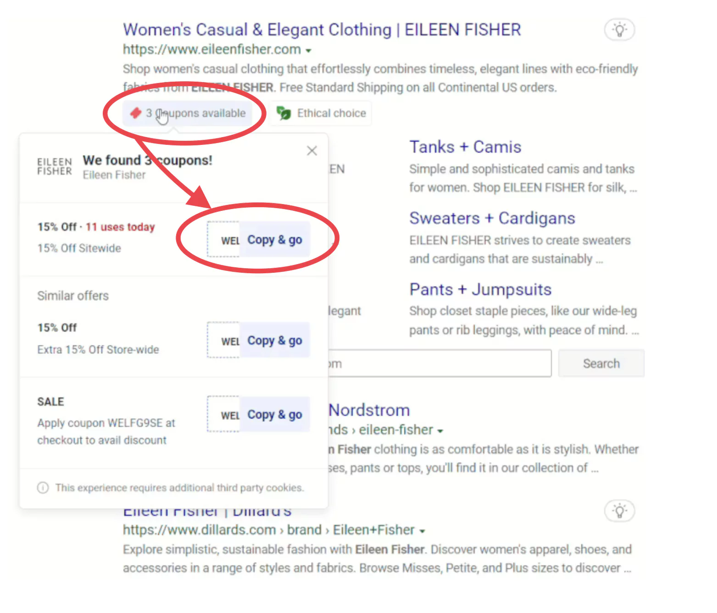

* Microsoft also reminds searchers that it recently made the price history annotation available on Bing.
  + The price history annotation, as shown in the example below, allows you to determine if it’s a good time to buy a particular product.

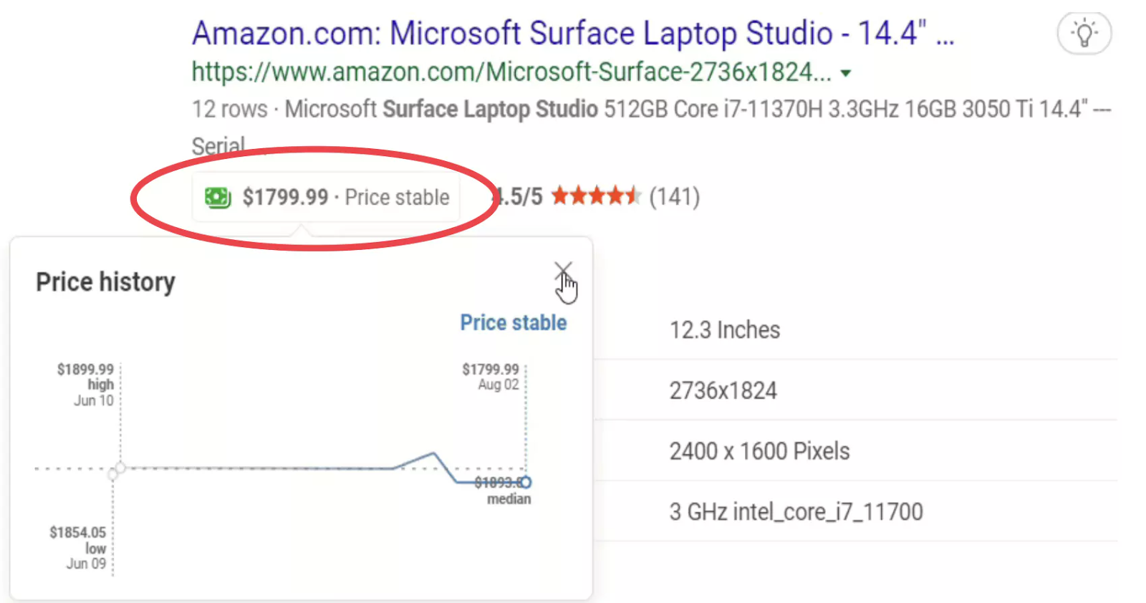

* + In this example, the price is stable and slightly reduced from its highest price. That information lets you know you’re not paying more than you should for the product.

<https://www.searchenginejournal.com/microsoft-bing-adds-coupon-codes-to-shopping-searches/460959/#close>

## **Meta Brings Automation To Small Business Advertising**

Meta is introducing new AI and automation tools to help advertisers get more out of their ad spend.

* When creating an ad through a Facebook page, small businesses can now utilize Meta’s Advantage+ advertising technologies. Advantage+, Meta’s most advanced AI and automation offering for advertisers, was exclusive to full-fledged campaigns. Now, it will be used when running single ads.
* In addition, Meta is upgrading Advantage+ with new capabilities for shopping campaigns, app campaigns, and more.
* When using Advantage+ creative, ads will automatically adjust for each person who views them. Meta will show individual users the version of the ad they’re most likely to respond to.
* Advantage audience allows businesses to target ads to relevant people more effectively. Meta will create personalized audiences for serving ads using details on the business’s Facebook page.
* Meta Advantage+ can now help advertisers running shopping campaigns learn what’s working faster: Using AI and automation technologies, Meta Advantage+ can generate up to 150 creative combinations at once.
* Running multiple versions of ads at once is intended to help advertisers quickly identify what’s converting. With this data, advertisers can make more efficient use of their budgets.
* Later this year, U.S. businesses with a checkout-enabled Shop will have the option to add their Shop as a destination for Advantage+ shopping campaigns.

<https://www.searchenginejournal.com/meta-brings-automation-to-small-business-advertising/460994/#close>

## **ChannelAdvisor integrates with Shopee**

Provider of cloud-based ecommerce solutions ChannelAdvisor has announced its integration with Shopee, one of the most popular ecommerce platforms in Southeast Asia and Taiwan.

* Shopee provides easy, secure, and engaging experiences for millions of customers daily and enables businesses to digitalise and grow their online presence. The company aims to help more people access and benefit from quality digital services, driving digitalisation and financial inclusion.
* By integrating ChannelAdvisor with Shopee, the first will allow its customers to reach new consumers by expanding their multinational commerce strategies and reach new markets across the Asia Pacific region, while leveraging the benefits of a centralised platform.
* The company’s solution will provide brands and retailers various abilities, including to transform product data to meet the unique requirements of each channel, consolidate orders in a unified way, and optimise and manage product content from a centralised location.
* In addition, the integration will boost reach without overselling by synchronising inventory quantity across various channels, as well as identify additional growth opportunities through high-quality reporting and dashboard analytics.

<https://thepaypers.com/ecommerce/channeladvisor-integrates-with-shopee--1257982>

# Calendar Week 31 (Aug 05)

## **Facebook To End Live Shopping on October 1**

Facebook announced it will no longer allow users to host live shopping events beginning October 1, 2022.

* Facebook launched live shopping in August 2020 with the goal of making online shopping easier and empowering retailers of all types to grow their businesses.
* The Facebook Live feature will still be available, but ecommerce merchants will not be able to create product playlists or tag products.
* In a move to compete with TikTok, Meta has increasingly invested in its Reels product, which allows seamless video sharing across both of the company’s major platforms.
* “If you want to reach and engage people through video, try experimenting with Reels and Reels ads on Facebook and Instagram,” Meta suggested in the blog post.
* Meta has also increased the potential for Reels to generate revenue for the company by **allowing merchants and creators to boost their content via paid advertisements.**

<https://www.searchenginejournal.com/facebook-ending-live-shopping/460112/#close>

## **Microsoft announces Automotive Ads, Audience Network expansion, and 7 other updates**

Microsoft has just announced nine (9!) new updates on their blog. The updates include new Automotive Ads, vertical-based ads, and more.

* **Automotive Ads** The new Automotive Ads are specific ad formats that are unique to the auto industry. The new ad format will display a photo of the vehicle for sale, the year, make, and model, condition, dealer website, price, and a short description.

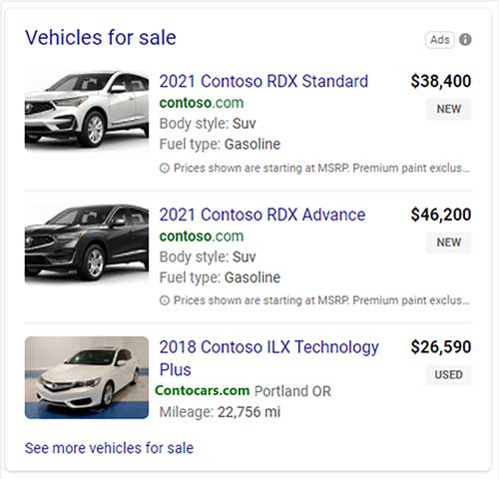

* Vertical-based ads Vertical ads are created from dynamic feeds and appear in different formats depending on what the user is searching for. The ads use intent data and the user needs to create the ad.

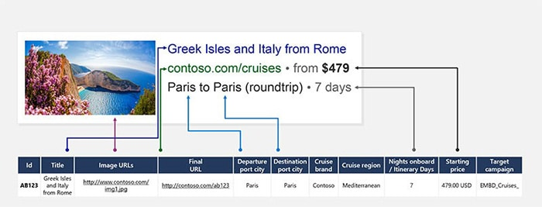

* **Audience network updates**
  + Dynamic Remarketing will be expanded to verticals outside of just retail. Advertisers can now use Dynamic remarketing for travel, auto, and event ads.
  + Automated bidding for video ads has just been launched.
* Advertisers who use a Customer Data Platform can connect it to Microsoft Advertising to import your customer lists.
* There is a new drop-down menu that will help advertisers access all reports. Those reports can be found on the updated landing page grid. Advertisers can also filter the grid to quickly access the reports they need.

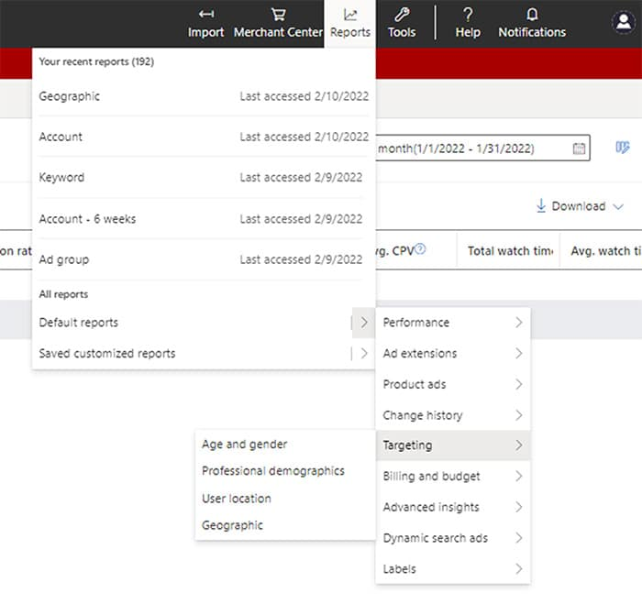

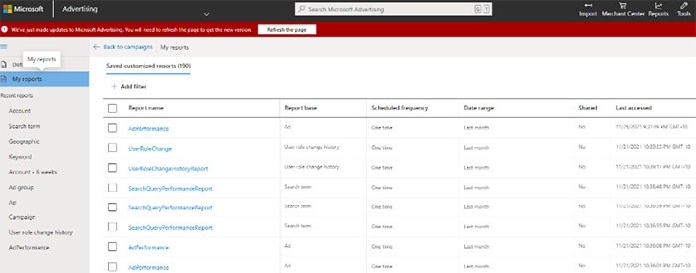

<https://searchengineland.com/microsoft-announces-automotive-ads-audience-network-expansion-and-7-other-updates-386892>

## **Apple is planning to put ads right in the App Store’s Today tab**

Apple is planning to show ads in the **App Store’s Today tab and on individual app pages**.

* The two new ad placements will expand upon the ads you can already see in the App Store’s search tab and in search results.
* **Ads in the Today tab** will appear in the larger card format used by other content in that tab, but you’ll see a small blue box with the word “Ad” inside it under the app’s name.
* **Ads in individual app pages** will appear under the “You Might Also Like” header that suggests apps related to the one you’re looking at.
  + Like in App Store search, ads on app pages will be highlighted in blue to distinguish them from other recommendations.
* Ad buyers won’t be able to target specific applications for these ads, but the ads will be relevant to the app they’re shown under.
* The new ad spots indicate that Apple is exploring new ways to make money from the App Store and that ads could become a more important pillar for the company as it continues to grow its services business.

<https://www.theverge.com/2022/7/29/23284272/apple-app-store-ads-today-tab-page-search>

## **Google announces 4 new features for Discovery ad users**

New Discovery ad features should help advertisers get ahead of the holiday season with new assets, reporting, and targeting.

* Better ad experiences: Google says that they’re working on making ad experiences more browseable in the Gmail Social and Promotions tabs by including richer details, like product images and prices. They’ll also use machine learning to match the asset to the right audience at the right time.
* Improved creative support: The onboarding flow for creating Discovery ads has been rebuilt. During the ad creation, advertisers will see prompts to add additional aspect ratios, unique headlines, and adding text overlays across images. Users will also receive live feedback on ad strength with ratings from “Poor” to “Excellent,” as well as an optimization score with actionable guidance.
* New audience insights: Discovery advertisers can now use the [insights page](https://support.google.com/google-ads/answer/10256472) to see which audience segments may deliver the biggest impact. Advertisers can also use [asset reporting](https://support.google.com/google-ads/answer/9458714) to view performance across the Discovery ads. Users can compare the performance between assets and decide which ones to turn off, switch, or edit. Advertisers can also use [optimized targeting](https://support.google.com/google-ads/answer/10537509) to assess information about keywords and landing pages to find audiences that can meet your campaign goals.
* Enhanced campaign management: There is a new [audience builder](https://support.google.com/google-ads/answer/10537509) advertisers can use to create and reuse audiences across campaigns. Users can also use the Google Ads Editor as well as API to manage campaigns at scale.

<https://searchengineland.com/google-announces-4-new-features-for-discovery-ad-users-386950>

## **Walmart boosts ad network with new partnerships**

Walmart has [added several API partners](http://walmartconnect.com/evolving-our-partner-program-for-brands-of-all-sizes) to its Walmart Connect retail media network, according to a company blog post. The new partners are in addition to a previously announced integration with e-commerce platform CommerceIQ.

* Partnerships are already yielding value for advertisers on Walmart Connect: The retailer noted how BirdRock Brands utilized Pacvue to scale its manual Sponsored Products campaigns and saw a return on ad spend 11% higher than its target and an 83% increase in sales quarter over quarter.
* Key to the latest evolution is the addition of several API partners, which now number 14 in total, that specialize in a combination of e-commerce ads, ad optimization and cross-channel advertising. Intentwise, Perpetua, Quartile and Sellozo join CommerceIQ, a provider of e-commerce management solutions, that [Walmart partnered with last month](https://www.marketingdive.com/news/walmart-connect-ecommerce-CommerceIQ-retail-media/627815/).
* In addition to its owned, onsite channels, Walmart Connect allows advertisers to reach other channels through the Walmart DSP, which the retailer launched in partnership with The Trade Desk in 2021. Colgate-Palmolive recently utilized Walmart Onsite and Offsite Display through Walmart DSP and Walmart Connect's campaign recommendations to drive 30% in new buyers for its dorm essentials range, with an 8% sales lift and $11.16 return on ad spend, per the blog post.
* Walmart in May announced that its [global advertising business grew 30%](https://www.marketingdive.com/news/walmart-q1-earnings-advertising-retail-media/623974/) year-on-year in its Q1 2023 earnings period while its core business and e-commerce sales were affected by inflationary and other pressures.

<https://www.retaildive.com/news/walmart-connect-ad-network-partnerships/628690/>

## **TikTok to overtake Facebook in influencer marketing spend this year, YouTube by 2024**

Instagram may be worried about TikTok’s threat to its business, but in the near-term, it’s still far ahead when it comes to the influencer marketing dollars spent on its platform in the U.S. According to a new analyst report, Instagram is on track to capture nearly 3x the amount of influencer marketing spend compared to TikTok in 2022 — or $2.23 billion spent on Instagram compared with the $774.8 million spent on TikTok.

* However, while Instagram is faring well against TikTok on this front, Meta’s other app, Facebook, is not as lucky.
* The new data, which hails from analysts at Insider Intelligence (previously eMarketer), indicates that TikTok is now on track to overtake Facebook in terms of influencer marketing spend this year and will overtake the No. 2 platform, YouTube, by 2024.
* Currently, YouTube is seeing $948.0 million in influencer marketing dollars spent on its platform in the U.S., ahead of Facebook’s $739.0 million. In addition, TikTok has already overtaken YouTube based on marketer usage for influencer-based marketing, the report notes.

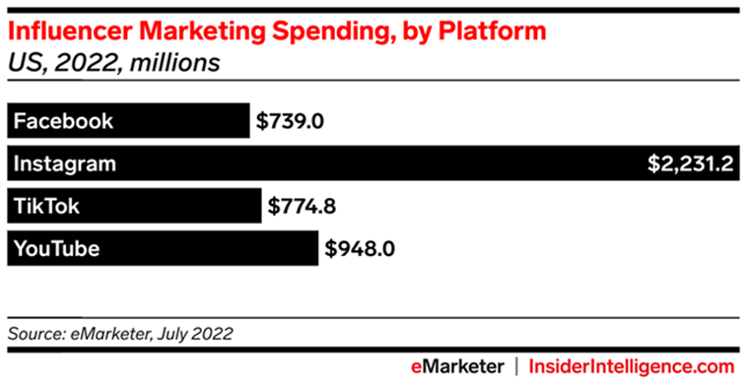

* Instagram has been steadily adjusting its algorithm and feed to highlight creator content, recommended posts and advertising, despite complaints from users who want to see more of their friends’ photos and videos. But as Instagram tweaks how content is ranked in its main feed, some creators have worried their reach could be negatively impacted by the constant changes.
* The report also points out that could be the eventual plan for Instagram, adding that the mix of influencers benefiting from this form of monetization has been shifting over time.
* The report notes, too, that marketing spend on smaller influencer partnerships has been growing quickly. This year, “nano” influencer spending will rise 220.5%, the analysts predict, while spending on “mega” influencers will grow only 8.0%. (Mega influencers have at least 1 million followers, as the firm defines it.)

<https://techcrunch.com/2022/08/02/tiktok-to-overtake-facebook-in-influencer-marketing-spend-this-year-youtube-by-2024-forecast-claims/>

# Calendar Week 30 (Jul 29)

## **Amazon DSP is launching the industry standard report**

Amazon Ads collaborated with the Media Rating Council (MRC) and was awarded accreditation for Amazon DSP owned and operated retail properties for measurement of display begin to render (BTR) impressions and clicks (reported Gross and Net of General Invalid Traffic) within desktop, mobile web and mobile in-app environments, as reported within the Industry Standard custom report template (CRT).

* The Industry Standard CRT is an offline report that offers advertisers the option of using breakdowns such as device type, environment type, impression counting methodology and the measurement source.
* After downloading the report, advertisers have an option to filter for impressions that adhere to MRC's begin to render definition.
* All other reporting outside the Industry Standard CRT and its filters should be considered unaccredited for MRC accreditation purposes.
* Who can use it? Managed service and self-service users.
* Where do I access it? Amazon DSP

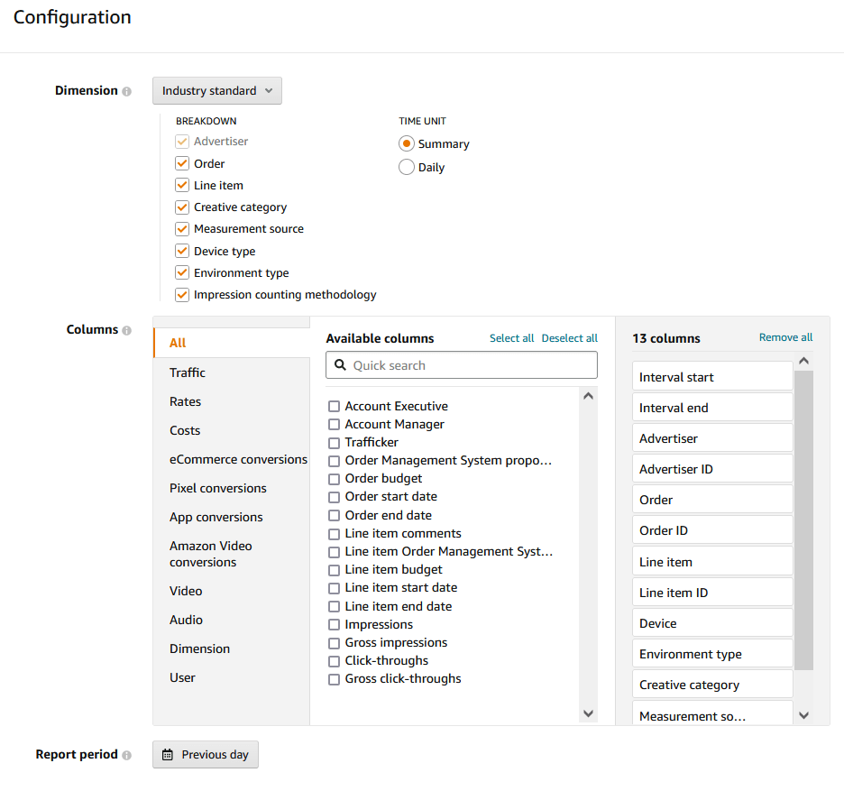

<https://advertising.amazon.com/en-us/resources/whats-new/industry-standard-report/?ref_=a20m_us_wn_gw>

## **Meta Reports First Ever Decline In Ad Revenue**

Meta’s latest earnings report reveals the company’s first-ever year-over-year decline in advertising revenue, signaling a downward trend that it expects to continue.

* Meta’s ad revenue dropped one percent in Q2 2022 compared to last year’s period.
* Meta brought in $28.82 billion from ads, though it expected to earn $28.94 billion.
* The economy is only accelerating a drop in revenue growth that started when Apple made it possible for users to ask apps not to track their data.
  + As a result, people see less relevant ads in their feeds because Meta doesn’t have access to as much data about them.
* In response to the Q2 earnings report, Zuckerberg stresses his commitment to building Facebook and Instagram around Reels.
* The Reels viewer is one of the only sections of Facebook and Instagram that isn’t fully monetized. So it’s not a revenue driver right now, but it can potentially become one in the future.
* Meta’s goal is to be more like TikTok. As Meta increases its focus on Reels, that will inevitably lead to other types of content getting shown less.

<https://www.searchenginejournal.com/meta-reports-first-ever-decline-in-ad-revenue/459341/>

## **Google will automatically switch some advertisers’ attribution models**

Google sent an email letting advertisers know that their ad accounts would be switched to **data-driven attribution**.

* The email tells the advertiser which account(s) qualify for the switch and gives them until August 24 to cancel the auto-switch.
* Google [announced](https://blog.google/products/ads-commerce/data-driven-attribution-new-default/) in September that data-driven attribution would become the default model, but advertisers would still have access to the five other rule-based models.
* **Data-driven attribution** uses advanced machine learning techniques to more accurately understand how each marketing touchpoint contributed to a conversion.
* According to Google, data-driven attribution takes multiple signals into account including ad format and time between the ad and interaction and conversion.
* If you don’t want Google making the switch you can turn it off.

<https://searchengineland.com/google-will-automatically-switch-some-advertisers-attribution-models-386732>

## **AMAZON HIGHLIGHTS ITS 'MARKETING STREAM' AFTER AD REVENUE CLIMBS**

Amazon highlighted updates to its ads platform from the second quarter, including the launch of Amazon Marketing Stream in June.

* Amazon is developing data and marketing services, competing with internet ad giants like Google. The “marketing stream” sends real-time analytics to advertisers about how “sponsored products” ads are performing.
* Amazon’s advertising services led to $8.76 billion in revenue in the second quarter, an increase of 18% year over year.
* Sales increased 7.2% to $121.2 billion in the period ended June 30, the company said Thursday in a statement. Analysts, on average, estimated $119.5 billion.

<https://adage.com/article/marketing-news-strategy/amazon-ad-revenue-climbs-second-quarter/2424906>

## **Instagram Adds In-Chat Payment Feature**

Instagram announced a new **“Payments in Chat” feature** via Meta’s Newsroom. This will allow consumers to purchase directly from qualified small businesses’ direct messages on social media.

* This addition allows buyers and sellers to communicate in real-time, request or collect payments, and track orders directly from an Instagram chat.
* According to Meta, one billion users message businesses weekly across the social media company’s platforms. This includes chatting with brands, browsing products, asking for support, and interacting with stories.
* **Payments in chat** use Meta Pay to simplify purchases within the social media app. Rather than the traditional payment process of clicking between pages and websites.
  + Users can initiate a conversation with merchants via direct message, ask questions about products and then complete purchases within the same thread.
* By simplifying the transaction process, companies using Instagram as a sales platform could witness a boost in sales volume.
* Businesses can utilize this new functionality with Meta Shops, which facilitates the creation of a seamless online store for Facebook and Instagram.

<https://www.searchenginejournal.com/instagram-adds-in-chat-payment-feature/457976/>

## 

# Calendar Week 29 (Jul 22)

## **Google Makes It Easy To Create Video Ads**

Google Ads is launching a handful of new features, including an easy way for businesses to create video ads.

* **Google Ads Video Creation Tool** Businesses can create video ads in minutes using one of Google’s new templates.
  + There are templates for highlighting products, promoting sales events, triggering app downloads, and more.
* **Add a Voice-Over To YouTube Video Ads** Using Google’s AI technologies, a new feature for advertisers converts text input into natural-sounding speech to overlay on YouTube video ads.
  + You can access this feature in the Google Ads asset library. As shown below, you must enter a script and select from one of seven voices.

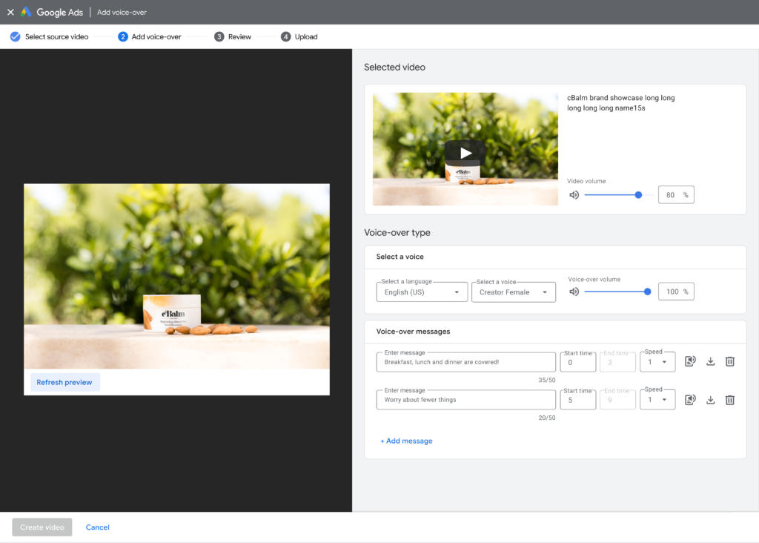

* **Google Ads Asset Storage** Google is introducing a centrally located asset library to improve how images and videos are organized, accessed, and created.
  + This feature is most useful for marketing teams where multiple members are collaborating on the same campaigns.

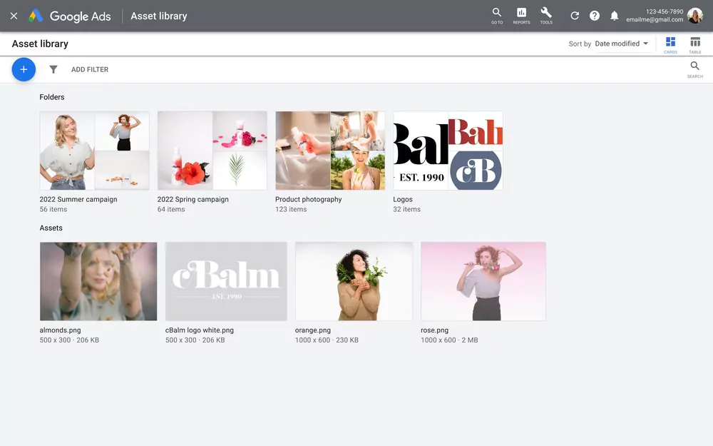

<https://www.searchenginejournal.com/google-makes-it-easy-to-create-video-ads/458409/#close>

## **YouTube partners with Shopify to deliver shopping tools for creators, brands**

Starting next week YouTube viewers will see a new shopping destination in the explore tab. The tab will feature shoppable relevant content from the creators in the US, Brazil, and India.

* **YouTube Studio’s Shopping**. YouTube has also introduced new tools within YouTube Studio’s Shopping tab so creators can manage how their products are tagged and appear across their channels.
* **Shopify partnership.** YouTube also announced a partnership with e-commerce platform giant Shopify. The partnership would allow creators and merchants to feature products across their YouTube channels and content.
  + Creators who link their stores will be able to display their products across their channels.
  + Shopify will perform real-time inventory syncing to ensure product inventory is always up to date. US creators can even enable onsite checkout so viewers can purchase without having to leave the channel.
* To be eligible for YouTube’s shopping features, user must meet certain minimum requirements. These include: the channel must be approved for monetization; if the channel is a music channel, it has to be an officially certified artist channel, etc.

<https://searchengineland.com/youtube-partners-with-shopify-to-deliver-shopping-tools-for-creators-brands-386590>

## **Video builder now available for Amazon Sponsored Brands video placements**

Amazon advertisers can now easily build videos for Sponsored Brands video placements through a selection of ready-to-use customizable templates using video builder.

* Sellers can build videos by pulling product images and copy from your detail pages or by uploading lifestyle and other images from creative assets or your desktop.
* Video builder provides a range of themes to customize the look and feel of your video, and edit the color, font and music options.

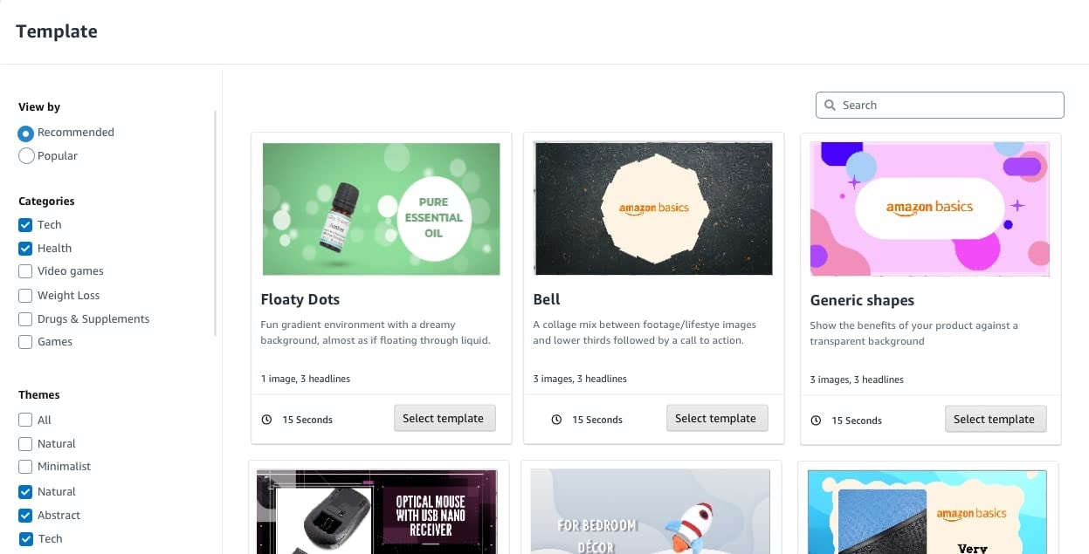

* Getting video assets is a difficult part of launching a video campaign. With video builder, you can now quickly create videos for all of your products, and test multiple versions of videos, experimenting with different messaging.
* Eligibility: sellers and vendors

<https://advertising.amazon.com/en-us/resources/whats-new/video-builder-sponsored-brands-video/?ref_=a20m_us_wn_gw>

## **Instagram Adds New 'Boost' Promotion Option for Reels Clips**

As it continues to double-, and triple-down on short-form video, Instagram will now enable brands to amplify their Reels clips, via a new ‘Boost’ promotion option built into the format.

* *“Reels is our fastest-growing format and an important part of Instagram, as more people watch Reels to be entertained, go deeper with their interests or discover new businesses. Today, we’re announcing that businesses can now boost their reels to turn them into ads for the opportunity to reach new audiences and drive more engagement.”*
* First off, Instagram says that Boosted Reels will be eligible to appear in feed, Stories, the Reels tab and the Explore page to help new customers find your brand.
* To be eligible for boosting, your Reels clips must be less than 60 seconds and have a 9:16 aspect ratio, “which means they’re filmed vertically and have a full-screen format”. Reels that use third-party IP - such as copyrighted music, GIFs, interactive stickers or camera filters - are not eligible for boosting.

<https://www.socialmediatoday.com/news/instagram-adds-new-boost-promotion-option-for-reels-clips/627650/>

## **Walmart integrates CommerceIQ to fortify its retail media advertising platform**

**Walmart Connect’s integration of CommerceIQ gives customers more tools for managing their retail media campaigns and gleaning insights into results beyond return on advertising spend.** The new offerings align with how other digital ad networks have scaled, with a focus on automation and self-service capabilities that tend to be cheaper and easier to modulate than managed campaign services. **The CommerceIQ partnership also allows for flexibility: brands can bring their own agencies, managed services and self-service software to the table.**

* Automation has played a more substantial role for Connect as Walmart plans to grow the U.S. business into a top-10 advertising network. The big-box store has other partnerships aligned around similar goals, including a demand-side platform (DSP) developed with The Trade Desk that helps automate media buying.
* Walmart recently added a customer data-sharing operation with Dunnhumby called Walmart Luminate that supports the DSP.
* Roughly half of Walmart’s ad sales in the fourth quarter came from automated channels. Walmart’s global advertising operations generated $2.1 billion in 2021 and grew 30% year-on-year in the most recent quarter. Luminate saw 75% growth over the prior period in Q2 2022.

<https://searchengineland.com/youtube-partners-with-shopify-to-deliver-shopping-tools-for-creators-brands-386590>

# Calendar Week 28 (Jul 15)

## **Google Ads Rolls Out Diagnostic Insights**

Google is now informing advertisers about diagnostic issues that may be adversely affecting campaign performance.

* Google Ads is rolling out a new data set to the Insights page highlighting any issues found during diagnostic checks.
* Google Ads will provide a detailed breakdown of the following insights:
  + Account status
  + Billing status
  + Policy review
  + Conversion tracking
  + Campaign budget
  + Bid strategy target
  + Campaign status
  + Ad strength
* Diagnostic insights only show when a campaign has not received traffic or conversions.
* If your campaign is running and people are seeing the ads and clicking on them, then there will be no diagnostic issues to report.
* Currently, diagnostic insights are available for Performance Max campaigns. The new dataset will expand to other campaign types over the next few months.

<https://www.searchenginejournal.com/google-ads-rolls-out-diagnostic-insights/456864/#close>

## **TikTok launches Inventory Filters for safe ad placements**

**The Inventory Filter** provides brands with options to show or not show their content near brands or videos that aren’t similar in nature.

* The solution is embedded in the TikTok Ads Manager and empowers advertisers with the options to choose where their content is displayed.
* The TikTok Inventory Filters give advertisers **three layers and tiers of video inventory.** These tiers are created by TikTok’s own policies as well as industry-standard [GARM Brand Safety Floor and Brand Suitability Frameworks](https://wfanet.org/leadership/garm/garm-resource-directory-%28weblog-detail-page%29/2022/06/17/GARM-Brand-Safety-Floor--Suitability-Framework). Advertisers can choose their desired tier within the Ads Manager.
* With the Inventory Filter, the tiers contain videos that have been evaluated based on risk levels based on industry standards.
* Considering these levels of content categorization, the TikTok Inventory Filter will then assess which videos to exclude from a given tier.
* TikTok reported that hundreds of brands tested the Inventory Filter and every campaign saw “exceptional results.”

<https://searchengineland.com/tiktok-launches-inventory-filters-for-safe-ad-placements-386396>

## **Pinterest is doubling down on Shopping by adding 4 new features**

This week Pinterest introduced four new merchant features to help retailers promote their stores.

* Product Tagging on Pins
  + Product Tagging allows merchants to make their pins shoppable, so shoppers can click and purchase seamlessly within the app.

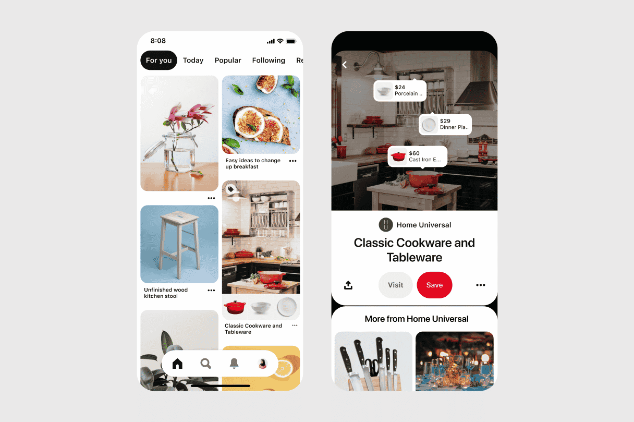

* Video in Catalog
  + Video ad formats increased click-through-rate by 158%, lowered cost-per-click by 42%, and lowered cost-per-acquisition by 58% in early tests versus static images.
* Shop Tab on Business Profiles
  + Merchants will be able to display a prominent Shop button on their business profiles, giving shoppers an easy way to find and view shoppable products.
  + In early tests merchants reported about 30% of their first attributed sales from the Shop tab.

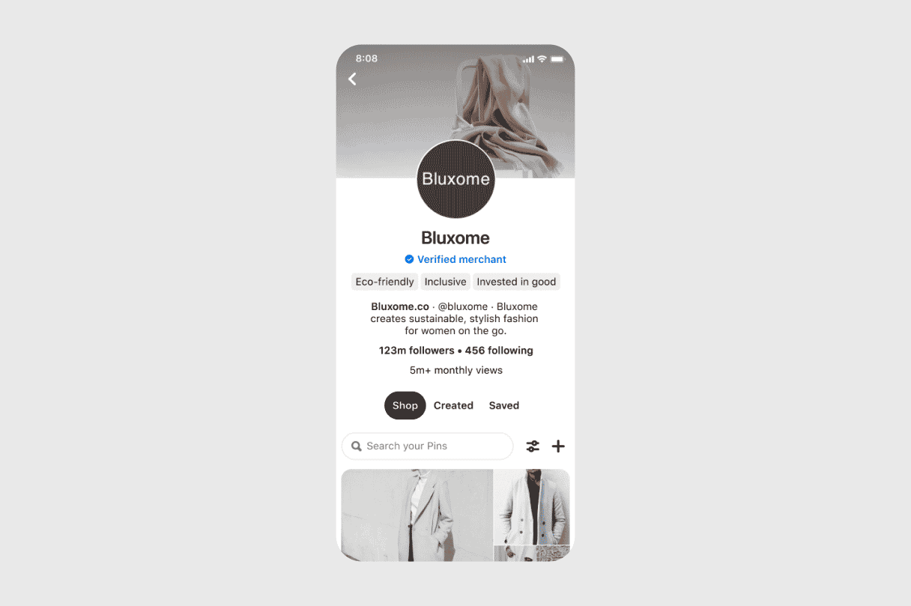

* The API for Shopping
  + The API allows for better and more accurate metadata management and improved quality for products. Accuracy in early tests came in at about 97%.

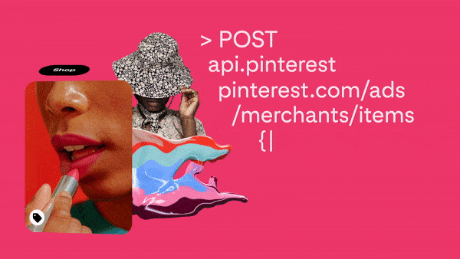

<https://searchengineland.com/pinterest-is-doubling-down-on-shopping-by-adding-4-new-features-386341>

## **Microsoft launches Merchant Promotions Coupons**

**Microsoft will launch Merchant Promotions on July 10.** The new feature will allow advertisers to **promote products directly from the Microsoft Shopping Campaigns inventory with special offer tags**.

* The tags will appear at the bottom of the product listing and will display a “special offer” link.

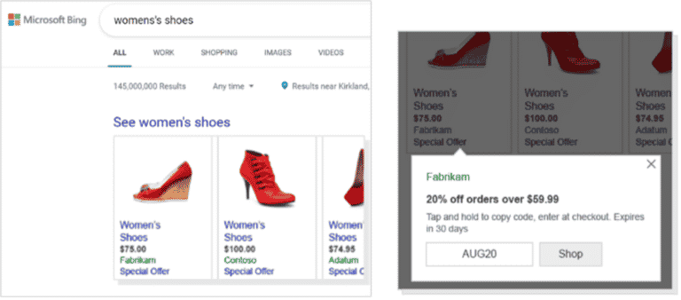

* Microsoft will use crawled data gathered directly from the advertisers’ website to automatically create the Merchant Promotions.
* **Performance transparency.** To see how your automatic and manual Merchant Promotions perform, you can view them in the UI dashboard.
* **Opting out.** If you prefer to opt-out, you can do so by navigating to the Automatic updates tab under Settings, Then selecting Block crawled data.

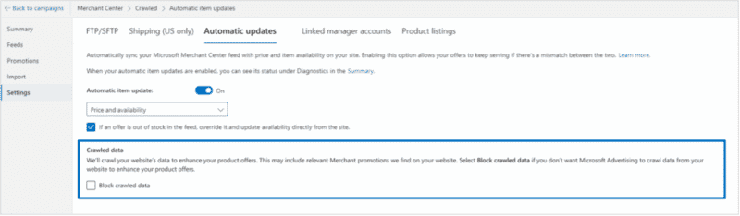

<https://searchengineland.com/microsoft-launches-merchant-promotions-coupons-386251>

## **Microsoft launches auto-updates for shopping campaigns**

Microsoft will enable **automatic updates for shopping campaigns** beginning July 10.

* Microsoft Merchant Center will crawl advertisers’ websites, gathering price and availability data for the products offered. If a price change or availability issue is detected (e.g., if an item is out of stock), the product information will be updated in your ads.
* You can opt-out of auto-updates by navigating to the Automatic Updates tab under Settings in your Merchant Center account.

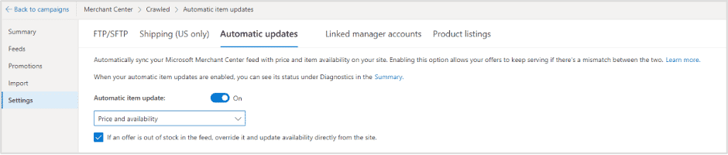

<https://searchengineland.com/microsoft-launches-auto-updates-for-shopping-campaigns-386247>

## **Amazon advertisers can now combine a lifestyle image, headline, and logo when customizing their Sponsored Display creatives**

With this launch, Amazon advertisers using **Sponsored Display** can now **customize their creatives by adding a headline, logo, and lifestyle image together**, **or individually**.

* Advertisers can choose to add any combination of assets while creating or editing their creatives. Ads will now display **a headline, logo, and lifestyle image** to help shoppers discover your brand and product.
* Every creative choice is optional, and they can choose any combination, allowing advertisers to match their style across creatives or repurpose existing assets.
* **Ads will display alongside a product image**, creating consistent branded creatives across ad placements.
* Ads with lifestyle images will support **promotional deals and savings badges** to help improve ad performance.
* When customizing your creative, you will now see a menu of customizable assets that provides real-time feedback and moderation status to quickly provide a holistic status of your creative.
* Sellers and Vendors can customize creative while building a campaign or from the “creative” tab while managing a campaign. This feature applies to new and existing creatives.

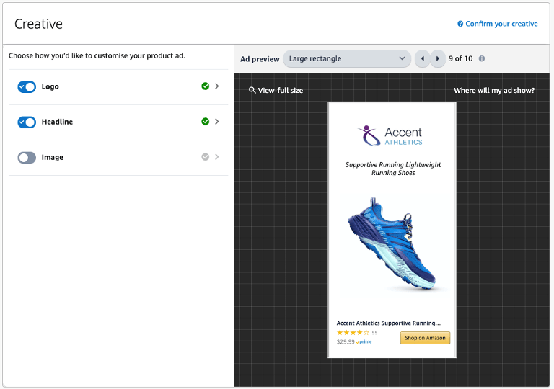

<https://advertising.amazon.com/en-us/resources/whats-new/sponsored-display-multi-asset-ad-creatives/?ref_=a20m_us_wn_gw>

# Calendar Week 26 (Jul 01)

## **TikTok Advertisers Can Now Set Custom Attribution Windows**

An update to TikTok advertising campaigns will allow marketers to set their own attribution windows.

* **Marketers running ads on TikTok can now optimize their campaigns with flexible attribution windows ranging from one day to 28 days.**
* A customizable attribution window allows marketers to optimize campaigns for their individual goals.
* **TikTok Attribution Manager** is a new tool that lives inside TikTok Ads Manager under the Assets menu.
* With **TikTok Attribution Manager,** you can select a specific time period to measure success for both click-through attribution (CTA) and view-through attribution (VTA).
* For web and app campaigns, the CTA window can range from one day to 28 days, while VTA can be up to seven days.
* Advertisers can select from the following options:
  + CTA: 1, 7, 14, 28 day
  + VTA: off, 1 and 7 day

<https://www.searchenginejournal.com/tiktok-attribution-manager/455961/#close>

## **Facebook testing new sidebar, channels for groups**

Facebook is testing a new sidebar that helps users find groups quicker and easier.

* The sidebar lists your groups and their latest activity like posts or chats. You can also pin your favorite groups so you can access them quicker, and even create your own.
* In the new sidebar, you’ll be able to easily see a menu that takes you to links for events, shops, chats or other channels within the group.

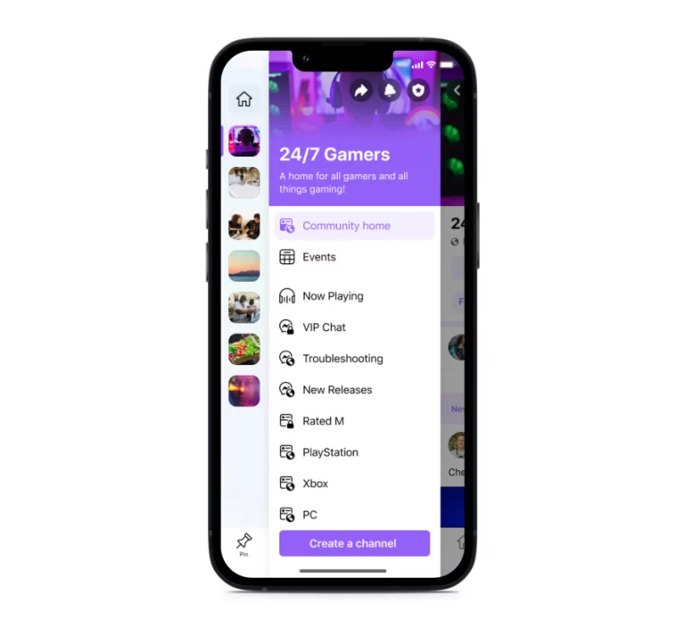

* Within their groups, admins can create individual channels to allow smaller, more casual interactions. This is meant to drive deeper discussions and organize the group around sub-topics of interests and demographics.

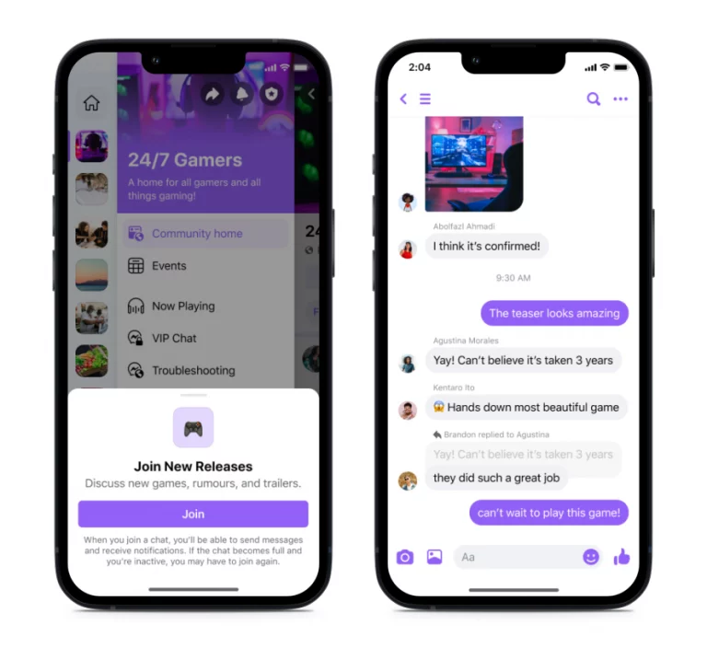

* **Community chat.** Message and collaborate with other group members in private, smaller channels based on a sub-topic or interest.
* **Community audio**. This allows admins and members to hold audio conversations in real-time.
* **Community feed.** Just like with a normal Facebook feed, the community feeds allow you to browse activity within your selected channel.

<https://searchengineland.com/facebook-testing-new-sidebar-ad-channels-for-groups-386096>

## **Amazon Sponsored Display product targeting has evolved to contextual targeting**

Amazon is evolving **Sponsored Display’s product targeting into contextual targeting**, allowing advertisers to reach more of their audiences at more points in their shopping and entertainment journey.

* **The contextual targeting strategy** will now allow advertisers to reach audiences both in the **Amazon store and outside the Amazon store** when customers view **content related to targeting strategies.**
* Advertisers do not need to change their targeted products or categories to enable the new feature: **Sponsored Display will find the right opportunities to expand advertiser reach beyond the store, to web pages and mobile apps.**
* Amazon’s machine learning models will now automatically find more opportunities to deliver campaigns, while still adhering to advertiser bidding strategies and objectives: for instance, when optimizing for page views, we will help find additional opportunities beyond Amazon to serve ads at the same or improved cost per click.
* Advertisers can pair contextual targeting with page view optimization strategies, alongside a remarketing strategy that can help drive additional reach and conversions from the increased visitors to their detail pages.
* **Who can use it?** Sellers and vendors.
* Where do I access it? Advertising console.

<https://advertising.amazon.com/en-us/resources/whats-new/sponsored-display-contextual-targeting/?ref_=a20m_us_wn_gw>

## **Introduction of Amazon Marketing Stream (Beta)**

We are pleased to launch Amazon Marketing Stream (Beta), a product that delivers Amazon Ads campaign metrics and information to the AWS accounts of advertisers or integrators almost real time via a push-based model. You can subscribe to campaign records available on Amazon Marketing Stream by using your existing Amazon Ads API token and providing your AWS account details.

* After the subscription, Amazon Marketing Stream delivers hourly performance metrics with details such as targeting the performance of expressions by placement and budget consumption messages in near real time. Other campaign records will be available for subscription in the coming months.
* In the past, access to scaled campaign reports was limited to pull-based Amazon Ads API calls that enabled daily performance and on-demand access to other campaign information. API users who want more insights into campaigns in real time have retrieved this information manually by calling the Amazon Ads API several times a day, which leads to further challenges in API usage.
* In addition to the need for API users to manage API throttling, which limits the number of API calls they can make, they are burdened by the approach of comparing new information with the existing ones to understand changes. Such API usage patterns highlighted the need to develop a product that better suits our customers' evolving use cases.

<https://advertising.amazon.com/resources/whats-new/introducing-amazon-marketing-stream-beta>

## **Twitter, Shopify Reveal Partnership at Cannes Lions**

Twitter and Shopify unveiled a new partnership at [Cannes Lions](https://www.adweek.com/category/cannes-lions/)Wednesday that gives all U.S. merchants on the ecommerce platform the option of tapping into the social network to find potential customers.

* The other major feature revealed at the Cannes breakfast was Campaign Planner, which helps advertisers forecast estimated results before kicking off their campaigns on the social network.
* “With our Twitter shopping ecosystem, we’re investing in features that empower businesses to put their products in front of their customers and drive them to where they can make a purchase. This partnership with Shopify is an important step in helping merchants unlock opportunities to reach shoppers on Twitter at those precise moments of discovery, inspiration and consideration.”
* Merchants can now add the new Twitter sales channel application via Shopify’s app store or the ecommerce platform’s admin interface, enabling them to:
  + Connect their Twitter account to their Shopify admin with a few clicks and onboard onto Twitter’s Shopping Manager, the entry point into its suite of commerce tools, as well as other free tools the social network is building for professionals.
  + Automatically sync their inventory via Shopify merchants’ product catalogs, avoiding the need to manually update product information on Twitter.
  + Showcase products via Twitter’s Shop Spotlight or [Twitter Shops](https://www.adweek.com/commerce/twitter-shops-debuts-in-beta/), giving shoppers the ability to check out on the merchant’s website.

<https://www.adweek.com/commerce/twitter-shopify-reveal-partnership-at-cannes-lions/>

# Calendar Week 25 (Jun 24)

## **Twitter launches Campaign Planner**

Twitter has just launched Campaign Planner, a forecasting tool designed to help advertisers estimate campaign results before launching.

* The new Campaign Planner helps advertisers:
  + **Forecast reach, impressions, average frequency, and CPM for a specific audience, duration, frequency setting, and placement**
  + Budget for auction-based campaigns
  + Start and save draft campaigns directly from the tool
* Twitter created this tool in order to help empower partners and advertisers to better understand the size and cost of reaching a target audience during the campaign planning process.
* The Campaign Planner is available to all managed advertisers in the US, UK, and Japan. Managed partners can access the tool by contacting their Twitter Client Partner.

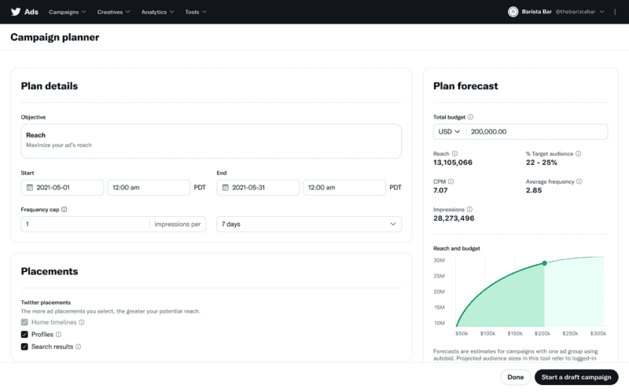

<https://searchengineland.com/twitter-launches-campaign-planner-385990>

## **Microsoft launches Cash back promotions for product ads**

Microsoft Ads is now offering **Cash back promotions to drive more sales and conversions for online retailers.**

* **The new feature is a Microsoft-run cash back program for the US on product ads.** The goal of the program, Microsoft says “is to drive incremental sales and return on ad spend (ROAS) growth for advertisers and retailers.”
* When a user clicks on an ad that features a Cash back promotion, they will have 24 hours after the click to complete the purchase. Microsoft will automatically attribute the purchase to the click and process the cash back.
* All Cash backs are managed by Microsoft and users can redeem their rewards through the Microsoft Cash backs dashboard.
* The Cash back promotions are served for eligible campaigns if and when the AI determines that it will bring in value.
* According to Microsoft, **the goals of the new Cash back promotions are:**
  + Grow sales efficiently by incentivizing users with the right value of savings to drive conversions.
  + Optimize savings to users’ needs by showing them deals for products they care about, thereby increasing efficiency.
  + No effort is required because Microsoft uses your existing campaign setup. Microsoft also handles all optimizations and post-purchase inquiries.

<https://searchengineland.com/microsoft-launches-cash-back-promotions-for-product-ads-385926>

## **Meta introducing new monetization tools for creators on Facebook and Instagram**

Meta is launching new ways for creators to make money on Facebook and Instagram. The updates and tools “will help creators build for the metaverse” Zuckerberg says. There are six new updates that Zuckerberg shared in a Facebook thread.

* More money for creators No revenue sharing on events, subscriptions, badges, and bulletins until 2024.
* Interoperable Subscriptions Lets creators give their paying subscribers on other platforms access to subscriber-only Facebook Groups.
* Facebook Stars Opening up to all eligible creators so more can start earning money from Reels, live, or VOD videos.
* Monetizing Reels Opening the Reels Play Bonus program to more creators on Facebook, and letting creators post their Instagram Reels to Facebook.
* Creator Marketplace Meta is testing a set place on Instagram where creators can get discovered and paid for their content, and brands can share new partnership opportunities.
* Digital Collectibles The platform is going to test NFTs with more creators around the world that can display their NFTs.

<https://searchengineland.com/meta-introducing-new-monetization-tools-for-creators-on-facebook-and-instagram-385924>

## **How Walmart's Shoppable Ads Work on Roku**

Roku and Walmart have made that easier. The streaming platform partnered with Walmart to bring shoppable ads to its viewers. But what does that mean? Continue reading to learn more about Walmart's shoppable ads and how they work.

* Today Walmart and Roku announced a first-of-its-kind partnership to make TV streaming the next e-commerce shopping destination. Walmart will be the exclusive retailer to enable streamers to purchase featured products fulfilled by Walmart directly on Roku, America’s #1 TV streaming platform. The new experience offers product discovery with a seamless checkout experience, enabling purchase directly at the time of inspiration.
* The partnership removes the hassle that comes with streamers having to shop products at a later stage. Instead, they can shop items within seconds of coming across an ad. As noted by Walmart's Chief Marketing Officer, William White, in the blog post:
* This makes Walmart the first retailer to offer a solution of this kind.
* The deal exposes Walmart to millions of streamers and provides the retailer an opportunity to secure sales as soon as viewers are inspired to make a purchase. This eliminates the risk of them forgetting to buy the items or changing their minds after some time.

<https://www.makeuseof.com/walmart-shoppable-ads-work-roku/>

# Calendar Week 24 (Jun 17)

## **Pinterest introduces Idea ads and paid partnership tools**

Pinterest has launched a new ad format – **Idea ads** – and a new partnership tool allowing creators to tag brand partners in their content.

* **Idea ads.**
  + The new Idea ads follow a similar format to [Idea pins](https://newsroom.pinterest.com/en/post/pinterest-introduces-idea-pins-globally-and-launches-new-creator-discovery-features), which were launched last year.
  + Idea ads are an immersive, multi-page format designed for advertisers “to showcase ideas in action.” When shoppers click on the ads they’re taken to the brand’s website to view relevant information.
* **The paid partnership tool.**
  + This allows brands to partner with Pinterest creators. The partnership allows large brands to collaborate with Pinterest’s community of creators and connect with their audiences.
  + With the paid partnership tool, brands can review the tag and approve (or deny) the content.
  + Brands will benefit from the authenticity of the creator’s content. Brands can also promote the creator’s content as their own Idea ad with paid partnership across Pinterest.
  + An early launch of these tools showed that brands who worked with creators saw 38% higher brand awareness, and 37% higher Pin awareness.
  + The new formats and tools are now available in more than 30 countries. You can read the full blog post announcement [here](https://newsroom.pinterest.com/en/post/introducing-new-ways-for-advertisers-and-creators-to-inspire-with-idea-ads).

<https://searchengineland.com/pinterest-introduces-idea-ads-and-paid-partnership-tools-385881>

## **Apple’s ad business may reach $6 billion by 2025**

JP Morgan lead analyst Samik Chatterjee thinks **Apple could bring in $6 billion in revenue from mobile advertising in 2025.**

* The release of iOS14 and the introduction of App Tracking Transparency (ATT) caused a supposed $10 billion in lost revenue for Meta. Chatterjee mentions in the article that this change “drove headwinds for incumbent advertising platforms,” and we can’t help but wonder if this was Apple’s plan all along.
* Chatterjee goes on to predict that the headwinds will lead to a reallocation of advertising funds – many of which will be spent on Apple Search Ads, which directly benefits their advertising business and revenue.
* Earlier this month we reported on a new pricing model for Apple’s search campaigns, Cost Per Tap (CPT). The new model will replace the less popular CPM campaign standard, and reflect the typical cost-per-click model that advertisers are familiar with on other platforms such as Google and Facebook. This change could be an early indication that Apple has big plans for its ad network.
* The largest slice of the Apple pie, still comes from Apple Search Ads, which Chatterjee says will account for about $4.1 billion in revenue in 2025.

<https://searchengineland.com/apples-ad-business-may-reach-6b-by-2025-385837>

## **Sponsored Display launches deny lists, helping brands control ads off Amazon**

**Sponsored Display deny lists** are now available in the Amazon Ads console and Amazon Ads API for vendors and sellers registered within Amazon Brand Registry.

* Sponsored Display ads serve on Amazon and off Amazon on third-party properties, such as websites and mobile apps.
* **The deny list functionality** provides you control to manage your brand presence off Amazon on third-party properties that don't align with your brand.
* Advertisers can upload a deny list of websites and mobile apps where you don't want your ads to show across all your Sponsored Display campaigns.

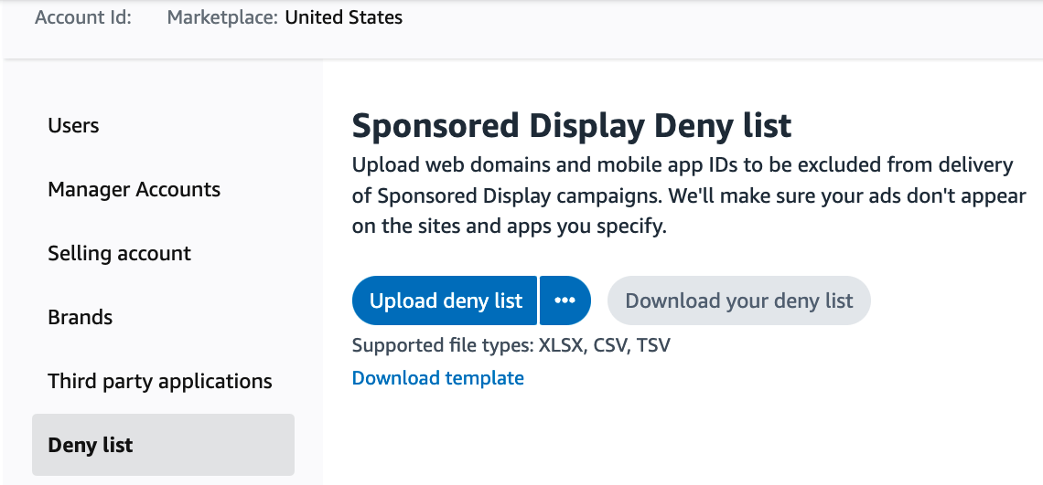

* **Deny lists** provide an additional layer of protection on top of Amazon ads global brand safety policy to allow advertisers to remove websites or mobile apps that are generally brand safe but don’t align with the brand’s value.

<https://advertising.amazon.com/en-us/resources/whats-new/sponsored-display-launches-deny-lists/?ref_=a20m_us_wn_gw>

## **Walmart, Roku partner to evolve shoppable streaming ads ‘beyond the QR code’**

* Walmart and Roku are piloting a new feature that aims to make shopping from TV ads more seamless, according to a [press release](https://www.businesswire.com/news/home/20220616005602/en/Walmart-and-Roku-Debut-First-of-its-Kind-Partnership-to-Bring-Commerce-to-TV-Ads).
* Roku viewers who are served Walmart ads via the streaming service can press the “OK” button on their remotes to be sent directly to a checkout screen. Orders can be purchased using Roku Pay and completed by pressing “OK” again. Walmart then sends the customer an email with their information and fulfills the order.
* Walmart is the exclusive retailer using the technology, which leverages Roku’s OneView ad-buying platform. Roku is also pushing its Roku Brand Studio to help marketers design and execute their campaigns.
* The partnership builds on Walmart’s ongoing efforts to link video and commerce together and shows Roku ramping up its own advertising bets in a tightly competitive streaming market.

<https://www.marketingdive.com/news/walmart-roku-shoppable-streaming-ads-QR-codes/625699/>

## **Where is Video Advertising Heading?**

Going further into 2022 and looking forward to 2023, we can expect to see these key developments in AdTech and Connected TV in particular.

* **The metaverse is the next evolution of the internet,** and giants like Facebook are hedging their bets on it. The opportunity here for the AdTech industry is ad content that exists in this virtual reality world that's tailored to individual users.
* The opportunities for online events like concerts, interactive product placements, and other recent developments like non-fungible tokens (NFTs) all offer ad options.
* A new immersive viewing experience requires **interactive advertising approaches** to reach an audience.
* **Artificial intelligence (AI)** has formed the advertising industry into the way it looks today: The state of media buying is vastly superior compared to the way advertisers conducted their business in the 2000s.
* AI's ability to automate data gathering and analysis to provide every accurate contextualization for ad content, **matching the right research and actions to the ideal consumer, is something that AdTech companies should focus their efforts on.**

<https://www.entrepreneur.com/article/427661>

# Calendar Week 23 (Jun 10)

## **Sponsored Display launches matched target reporting in the Amazon Ads console**

**Matched target reporting is now available for Sponsored Display** vendors and sellers registered in Amazon Brand Registry.

* With the release of **Matched target report**, advertisers can dive deep into which product detail pages their ads are displayed on.
* **The matched target report** gives visibility into **which ASINs and their related product detail pages your ads appeared against** and **resulted in** **at least one click**.
  + For example, if you are using **Sponsored Display product targeting** to help reach **audiences within a specific category** like “running shoes”, you are now able to not only analyze performance at the targeting clause level (i.e. the “running shoes” category) but also **break down performance based on the specific product detail pages your ads appeared on within that category.**
* Advertisers can use this data to gain confidence when using category or dynamic segments by understanding which products were being targeted.
* **The matched target report** is available through downloadable reports within the Amazon ads console and Amazon Ads API.
* For more information on this launch within the Amazon Ads API, see the [Sponsored Display reports section](https://advertising.amazon.com/API/docs/en-us/sponsored-display/3-0/openapi?ref_=a20m_us_wn_sd_060222#/Reports).

<https://advertising.amazon.com/en-us/resources/whats-new/sponsored-display-launches-matched-target-reporting/?ref_=a20m_us_wn_gw>

## **Snapchat now offers Dynamic Ads for Travel**

Snapchat has released an easy and automated way for businesses to reach travelers. The new product is called **Dynamic Ads for Travel**.

* According to Snapchat’s announcement, the new ads will include the following components:
  + Customized catalogs built to meet the needs of travel advertisers
  + Advanced audience targeting based on intent
  + Locally relevant delivery based on destination popularity
* Audience targeting uses machine learning and product ranking to serve ads to users who haven’t been to the advertisers website previously. While locally relevant targeting dynamically retargets users who have been to your website or app with listings they may be interested in.
* Snapchat is gaining momentum with most of its users falling into Gen Z and millennial age groups. And with those groups being the most diverse travelers, Snapchat is a great place to advertise airline and hotel deals, new destinations, and popular hotspots.

<https://searchengineland.com/snapchat-now-offers-dynamic-ads-for-travel-385553>

## **7 TikTok Stats Show Impact Of Combining Paid & Organic Content**

New data from TikTok shows how advertising can be made more effective when brands throw in a mix of organic content.

* TikTok’s data finds users aren’t likely to be won over by ads alone. They want to see brands publishing organic content in addition to paid and sponsored content.
  1. TikTok finds that 79% of users prefer brands that show they understand how to create for the platform.
  2. In Branded Hashtag Challenges, TikTok observed a 2x increase in ROAS for brands that also participated on the platform organically.
  3. One in three TikTok users say they were inspired to buy something recommended by a creator on the platform.
  4. TikTok measured a 173% increase in top of mind awareness after two exposures to a brand’s content on the platform.
  5. Organic content is said to be more likeable after viewing a paid ad, leading to a 20% increase in brand affinity.
  6. Organic content can increase brand recall by as much as 27% if it’s viewed before seeing a paid ad.
  7. TikTok’s data shows an 18% increase in users who say a brand’s organic content is relevant after being exposed to an ad first.
* In surmmary, posting a combination of organic and paid content has the potential to accelerate results for your brand on TikTok.

<https://www.searchenginejournal.com/tiktok-organic-paid-stats/452577/#close>

## **Google Ad Manager Gets 8 Updates**

Google rolls out eight updates to Ad Manager, and announces several more features that are coming soon. The following updates are available in

**Google Ad Manager as of this week:**

* **PPID TTL extension**: Publisher provided identifier (PPID) time-to-live (TTL) is extended from 90 days to 180 days.
* **Optimize pricing**: Increase in auction floor prices to more accurately reflect your inventory’s value. This setting is enabled by default.
* **Facebook rebrand**: ‘Facebook’ is changed to ‘Meta’ throughout Ad Manager to reflect the company’s rebrand.
* **Block ad experiences**: ‘Allow video ads’ is now a block called ‘Block non-instream video ads.’
* **SupplyChain Object complete**: Google is marking the SupplyChain Object complete for MCM Manage Inventory publishers.
* **Google Analytics 4**: GA4 integration with Google Ad Manager for web data is now in open beta.
* **Bid rejection reason**: More granularity added to the ‘Bid rejection reason’ in both reporting and data transfer.
* **WebView API for Ads**: This is now available to help app developers unlock the monetization opportunity in WebView content.

**Google Ad Manager users can expect the following updates to roll out ‘soon’:**

* **Active View measurement**: This is switching from a proprietary viewability measurement technique to using the Open Measurement (OM) SDK for mobile app display inventory in Ad Manager.
* **app-ads.txt**: Buyers will soon buyers begin to enforce the Interactive Advertising Bureau (IAB) standard for inventory transparency, app-ads.txt for Connected TV (CTV) inventory.
* **Query migration**: Google is migrating queries from the deprecated ‘Ad Exchange Historical’ report type to the ‘Historical’ report type.

<https://www.searchenginejournal.com/google-ad-manager-gets-8-updates/453898/#close>

## **Shopify Gets Into Audiences (But Still Not Ads); EA And FIFA Cut Ties On Long-Time Branding Deal**

Late last year, Shopify began testing a prospecting product called Shopify Audiences, and it just graduated to a general release.

* The product uses Shopify’s “unique perspective on purchasing intent from supporting merchants and their buyers,” according to a [release](https://news.shopify.com/introducing-shopify-audiences-the-marketing-tool-independent-merchants-need-now). That’s hardly crystal clear – though it implies Shopify aggregates and analyzes data from across merchants.
* The Shopify Audiences are only available with Facebook and Instagram to start, although the company says it’ll roll out to TikTok, Snap, Pinterest, Microsoft Advertising, Criteo and other partners down the line.
* The release also says Shopify Audiences can be used for audience-level attribution, rather than attributing by campaign. For context, Facebook alerted advertisers that, after the Apple iOS14.5 release, they should [optimize at the campaign level](https://www.adexchanger.com/mobile/how-facebook-is-overhauling-its-attribution-standards-to-deal-with-apples-att/) rather than optimize every element of creative targeting (which used to be Facebook’s bread and butter).
* Despite attempting to discourage gossip of an eventual Shopify ad platform – Shopify refers to each platform partner using its audience segments (Meta, Snap, TikTok, Criteo, etc.) as a potential “ad network” of choice – rumors will fly.

<https://www.adexchanger.com/ad-exchange-news/wednesday-11052022/>

# Calendar Week 22 (Jun 03)

## **Three Innovative Marketing Trends For Amazon Sellers**

According to Marketplace Pulse research, [more than 2,000 sellers](https://www.marketplacepulse.com/articles/amazon-is-adding-thousands-of-new-sellers-daily#:~:text=According%20to%20Marketplace%20Pulse%20research,%2C%20they%20are%20counted%20once).) have joined Amazon every day since 2016. It’s virtually impossible to stand out from this competition without leveraging Amazon Ads, which generates the company [more than $31 billion a year](https://www.cnbc.com/2022/02/03/amazon-has-a-31-billion-a-year-advertising-business.html) in revenue. The teenage years are a time of fast-paced development and growth. This explains why Amazon has been rapidly testing new marketing and advertising tools to help make FBA more profitable for sellers. With this in mind, here are three current and innovative trends that underscore Amazon’s growth spurt.

* **Interactive Streaming Ads:**
  + Last October, Amazon announced a slew of new ad formats at its third annual unBoxed advertising conference. Among the most exciting were two types of ad solutions currently in beta: interactive video and audio ads.
  + Interactive video ads enable customers to shop or browse products while watching Freevee (formerly IMDb) content on Fire TV. These ads respond to voice-activated commands, such as "add to basket," "add to list" or "buy now." This ability to interact with customers while they are streaming video opens up new possibilities for brand engagement.
  + Audio ads are another way Amazon is testing the potential of interactive advertising. Like its video counterpart, shoppers can use voice commands like "send me more information" or "add to basket" during audio ads while streaming Amazon Music on Alexa devices.
* **Social/Live Commerce Marketing:**
  + Consumers trust honest opinions from real people—even those they don’t know. Today, most word-of-mouth marketing takes place on social media. Platforms like Facebook and Instagram have become lucrative sales channels, leading to the rise in social commerce.
  + Amazon has been incorporating social media-like features to help sellers capitalize on the rise of this trend. One of the most obvious is Posts, an image-based feed that looks like Instagram. With this tool, brand owners can create a profile and upload content that links to product detail pages. Amazon displays Posts in your brand’s feed (which shoppers can follow) and on relevant product detail pages. Like other social media platforms, Amazon also provides analytics to track performance.
  + Another way Amazon is exploring the potential of social commerce is Amazon Live, which allows brands to reach shoppers through livestreams. It’s like QVC, but more interactive. You can chat with customers in real time and they can chat with each other.
* **Twitch Advertising:**
  + Amazon Live is a drop in the bucket of the livestreaming industry, which is [reportedly](https://www.marketresearchfuture.com/reports/live-streaming-market-10134) on track to reach a global market cap of $247 billion by 2027. This is due to the rising popularity of Twitch, the undisputed king of all livestreaming platforms.
  + Many Amazon sellers might be unaware that Sponsored Display ads can now target Twitch. This provides an opportunity to reach a massive audience where your competitors might not yet be. This is a low-risk experiment since you can purchase Sponsored Display ads on a cost-per-click basis with no minimum budget. Given the explosive growth of Twitch and the dedicated fan base of its content creators, it’s no wonder Amazon is testing ways to leverage this platform.

<https://www.forbes.com/sites/forbesbusinesscouncil/2022/05/16/three-innovative-marketing-trends-for-amazon-sellers/?sh=79d8b0e9924c>

## **Google Ads shares three automation best practices**

Google’s new best practices guide aims to ease advertiser concerns over adopting an automated keyword and bidding strategy. Google has released a Search Ads Automation Guide that shares some best practices on how to use automation to reach customers. The guide is long overdue for some marketers who have an unfavorable opinion about automation in general. According to a recent Search Engine Land [article](https://searchengineland.com/state-of-ppc-global-report-2022-384950), adoption of automation and recommendations is overwhelmingly positive, while satisfaction is low, with over half of users reporting a negative experience.

* **Best practice 1: use a broad match keyword strategy:**
  + Historically advertisers that used broad match keywords found wasted ad spend and irrelevant clicks. It seems like there haven’t been any new features or updates around broad match. But Google is attempting to help users better understand why they should use them, and with what bid strategy they feel will have the biggest impact for their account. Google states “Broad match keywords work best with Smart Bidding because it ensures you only bid on searches that are expected to perform for you.”
* **Best practice 2: using smart bidding strategies:**
  + Google says that evolutions in automation and machine learning will allow us to simplify how we setup and manage campaigns. The guide goes into great detail on why a smart bidding structure is best to use with broad keywords. But veteran advertisers know that making too many account changes at once, especially moving toward a hands-off automatic approach, can be detrimental for performance. Testing smart bidding strategies are a great idea in general, but be cautious of spend, conversion changes, and general advice around this topic from your Google rep.
* **Best practice 3: use responsive search ads:**
  + Google advises to “use multiple headlines and descriptions to automatically build and serve relevant ads for every query based on auction-time signals.” This is one strategy we can get behind. Responsive search ads allow a level of automation, but within the parameters you define. You maintain control of your ads by creating multiple headlines and descriptions, and allowing Google to show the most relevant combination to your audience

<https://searchengineland.com/google-ads-shares-three-automation-best-practices-385563>

## **YouTube’s new tool for brands means you don’t have to see the same ads nauseam**

Sometimes it’s a little *too* obvious when a company is launching a big advertising campaign on YouTube. If you’re a regular viewer, you may end up seeing the same ads over and over again. This week, though, YouTube announced that it’s [expanding the power of tools](https://blog.youtube/news-and-events/youtube-joins-the-upfronts-building-the-youtube-of-the-future-for-viewers-creators-and-advertisers/) that let brands control how often their ads are shown to specific users.

* Google’s Display & Video 360 platform previously launched a tool [in February](https://blog.google/products/marketingplatform/360/dv360-frequency-ctv/) to cover ad campaigns running across different smart TV apps, including YouTube’s app and apps from rivals like Hulu. This week, YouTube [launched its own complementary tool](https://blog.youtube/news-and-events/youtube-joins-the-upfronts-building-the-youtube-of-the-future-for-viewers-creators-and-advertisers/), YouTube Frequency, which counts ads shown not only on YouTube’s smart TV app, but also across its mobile and desktop platforms. Combined, these programs should mean less ad spam for viewers.
* Seeing the same advertisements over and over isn’t just a pain for consumers — it’s bad for companies, too. They want to know not only that they’re not annoying would-be customers, but that they’re not wasting money by showing the same person the same ad too many times.

<https://www.theverge.com/2022/5/19/23129744/youtube-advert-spam-ad-frequency-tool-brand-ctv-apps-mobile-desktop>

## **Amazon pushes back against proposed antitrust bill**

Amazon is pushing back against proposed antitrust legislation it says would *“cause serious and damaging unintended consequences” for its Amazon Prime loyalty program and the consumers and sellers who rely on the service, per a blog post from its vice president of public policy,* Brian Huseman.

* The [law that Amazon objects to](https://content-na1.emarketer.com/doj-backs-senate-bill-regulate-big-tech-platforms), the American Innovation and Choice Online Act (AICOA), would prevent Big Tech companies from giving their products favorable treatment over competitors.
  + For example, per the regulation, Amazon wouldn’t be able to promote its private label products over those from competing brands.
  + AICOA would also prevent Amazon from requiring sellers on its platform to use its fulfillment services to qualify for Amazon Prime shipping.
* **Naturally, Amazon is vigorously opposed to any bill that would limit its ability to fully monetize its various services, such as Fulfillment by Amazon, as well as reduce its capacity to control every aspect of the Prime experience.**
  + The company asserts that the law unfairly singles out Amazon while leaving other large retailers like Walmart and Target free to do business as they wish.
* There is no question that Amazon holds considerable market power. We put its share of total US retail ecommerce sales at 39.5%, while the next 14 biggest online retailers are collectively responsible for just 31.0%.
  + Amazon is projected to surpass Walmart to become the largest US retailer by 2024, per a report by Edge By Ascential.
  + In 2021, Amazon’s share of total retail spend (9.4%) exceeded Walmart’s (8.6%) for the first time, per PYMNTS data.
  + Third-party fees make up a sizable portion of Amazon’s revenues: In 2021, the company generated $103.37 billion in sales from its third-party seller services, which is more than the revenues from AWS and its advertising platform combined, per its earnings report.

<https://www.emarketer.com/content/amazon-pushes-back-against-proposed-antitrust-bill?utm_campaign=R%26E+briefing+June+3+2022&utm_medium=email&utm_source=Triggermail&utm_term=Retail+%26+Ecommerce+Briefing>

## 

## **Resetting E-Commerce Expectations**

E-commerce was meant to get significantly bigger, and thus everything was to get easier. But e-commerce only grew slightly, and yet everything - from sourcing to advertising - got harder. It didn’t. Instead, every quarter since, e-commerce penetration has been falling back closer to the trendline it was on before the pandemic.

* But e-commerce is bigger than the pre-pandemic trendline would have suggested. It is bigger in dollars spent. E-commerce is [25% above the trendline](https://www.marketplacepulse.com/articles/us-e-commerce-nears-1-trillion); a $975 billion annualized run rate instead of $780 billion. One way to measure e-commerce is through its share of total retail, but it’s just as relevant to look at overall e-commerce spending. As a share of retail, e-commerce is smaller than the pandemic boost predicted, but it is bigger than the shrinking penetration implies.
* However, many e-commerce companies have over-stocked, over-invested, over-hired, and over-built due to misreading the market. For example, Amazon said it built too many warehouses, and Target had too much inventory. The zero interest rates driving the bear market contributed too. An investment in Amazon or Shopify stock in January 2020, months before the pandemic, would have yielded an exceptional return up to the end of 2021. Since then, Amazon’s or Shopify’s stock price has decreased enough to make Walmart (a mostly brick-and-mortar business) a stock that outperformed the two e-commerce leaders.
* E-commerce growth got overshadowed by sourcing, fulfillment, advertising, and other core pillars getting more expensive, slower, or less effective. Containers from China only recently went down from costing [ten times more](https://www.marketplacepulse.com/articles/nine-months-of-10000-container-rates) but are still taking three times longer to import. For most of 2020 and 2021, Amazon had no warehouse space to store additional inventory for sellers, forcing them to scramble to find alternatives. And Apple made changes to the iPhone operating system rendering mobile advertising (for example, Facebook) less effective.
* Many of those challenges remain today. Importing goods is expensive and slow, and direct-to-consumer advertising is challenging. Because of the first two and other issues, margins are getting compressed. Many businesses show flat or negative year-over-year growth. And new problems, like rising inflation and a possible financial recession, are fueling more uncertainty.

<https://www.marketplacepulse.com/articles/resetting-e-commerce-expectations>

# 

# Calendar Week 21 (May 27)

## **TikTok Brings Account Management To Third-Party Tools**

TikTok will now allow businesses to manage their accounts via third-party social media management platforms.

* The initial launch includes integrations with Brandwatch, Dash Hudson, Emplifi, Hootsuite, Khoros, Later, Sprinklr, and Sprout Social.
* This integration with third-party tools gives businesses an easier way to incorporate TikTok marketing into their workflow.
* This integration will allow digital marketers to monitor all their social media accounts from a single platform, which will provide insights into what type of content performs best on each type of social media.
* By analyzing [key performance indicators](https://www.searchenginejournal.com/content-marketing-kpis/social-media-engagement/), brands will be able to develop more effective social media strategies and build engagement, not just on TikTok, but on all social media platforms.

<https://www.searchenginejournal.com/tiktok-brings-account-management-to-third-party-tools/451947/#close>

## **Google Unveils New Ads Manager Tools For Video Ads**

Google Ad Manager announced a new array of tools to save you time, manage your video streams, and grow revenue from videos.

* The **Programmatic Video Health tool** can help you understand the **performance of inventory at auctions compared to others.**
  + A new **video signals card** will show an overview of how your specific video inventory is performing. The signals it reports on include:
    - Viewability
    - App or web domain name
    - Audience information
  + In addition, these signals report the potential revenue impact from videos.

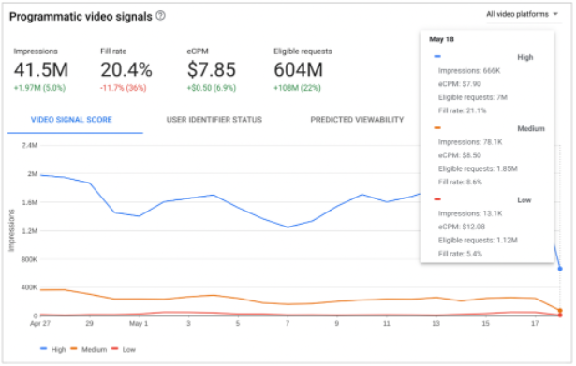

* The second tool added for programmatic and video is called the **Video Ad Serving Template (VAST) errors insights card.**
  + The VAST errors card uses automation to easily show the amount of errors on your video inventory. It also shows what line items are causing errors.
* Lastly, the **YouTube Ads Delivery Tool** can test ad delivery in real-time on YouTube inventory. You’re able to see data such as:
  + Ad requests
  + Key-values
  + Details for winning line items

<https://www.searchenginejournal.com/google-unveils-new-ads-manager-tools-for-video-ads/451120/>

## **Spotify Makes Its Clickable Ads Feature Available Outside of the US**

Spotify said Wednesday that it is expanding its [**call-to-action cards**](https://www.adweek.com/media/spotify-unveils-clickable-podcast-ads/) to advertisers in Australia, Canada and the U.K., enabling brands in those markets to **display interactive ads.**

* **CTA cards** debuted in the U.S. in January as **clickable ads that appear during an ad break and show up later while the user is browsing on Spotify.**
* The ads increase discoverability for brands since it is easier for users to view brands, products and services while listening to content, without having to memorize promo codes or URLs for later use.
* Spotify said its recent tests show **a two times increase in site visits with CTA cards compared with non-clickable podcast ads**—likely the push for the platform to tap into a promising market.
* According to Spotify, nearly one-half the population in markets where CTA cards are now available use the platform.
* Brands including BT, GoDaddy and Huel hopped on CTA cards upon their release in the U.K.

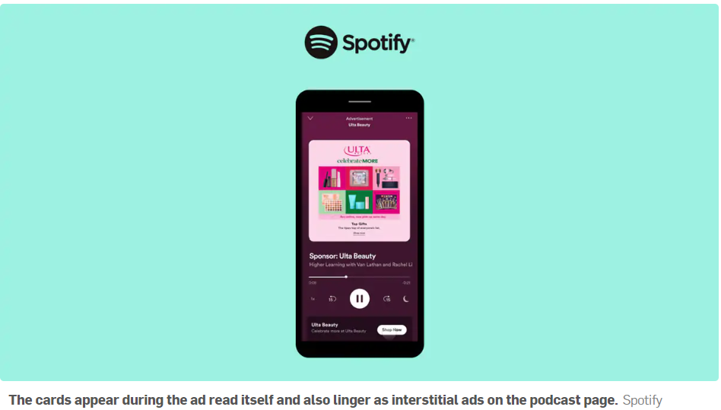

<https://www.adweek.com/social-marketing/spotify-makes-its-clickable-ads-feature-available-outside-of-the-us/>

## **Amazon Stops Hiding Its Private Label Brands**

Amazon has started identifying its brands in search results, tagging them with an “Amazon brand” or “Exclusive to Amazon” badge. Previously, it was inconsistent in disclosing which products it owned.

* Hundreds of brands are part of the Amazon Our Brands, a collection of *“Amazon private brands and a curated selection of brands sold exclusively on Amazon.”* Amazon Basics and Amazon Essentials are unmistakable as brands owned by Amazon, but the portfolio includes many more brands without an obvious connection to the company. Those were previously only known to belong to Amazon by analyzing trademark ownership.
* Most of the Our Brands portfolio brands are from sellers that joined the Amazon Accelerator program rather than brands owned by Amazon. Unlike Amazon Basics, Amazon is not organizing manufacturing or holding inventory for those. Sellers continue to run the brand with some benefits and help from Amazon.
* Amazon private label brands are now marked as “Amazon brand” in search results. Brands sold exclusively on Amazon that are also part of the Our Brands program are marked as “Exclusive to Amazon.”

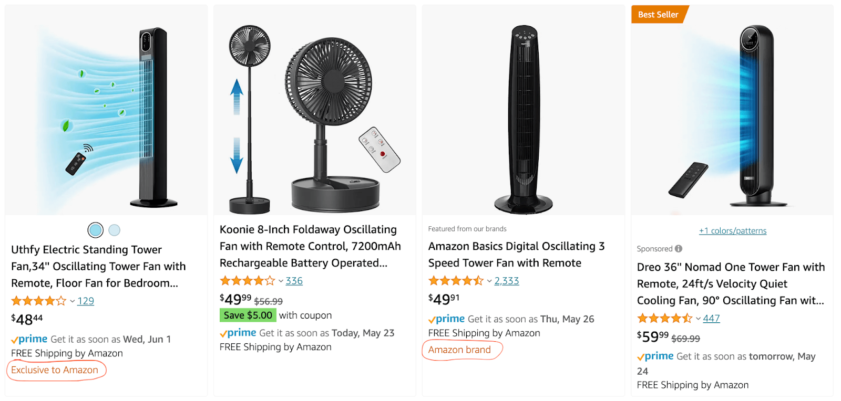

* Amazon also has a “Featured from our brands” badge introduced two years ago. It marks products that take space that otherwise would show sponsored products. The new badge applies to products even if they are not featured, thus identifying Amazon’s owned and exclusive products ranked in search results assumingly organically.

<https://www.marketplacepulse.com/articles/amazon-stops-hiding-its-private-label-brands>

## **Walmart’s ad business grows 30% despite broader slowdown**

Walmart’s global advertising business grew 30% year-on-year in the most recent quarter, [according to an earnings release](https://corporate.walmart.com/newsroom/2022/05/17/walmart-releases-q1-fy23-earnings). The segment was a bright spot in a report that missed Wall Street’s expectations.

* The retailer’s ad unit, Walmart Connect, scaled up with an expansion of self-service capabilities and new products. Walmart Luminate, a customer data-sharing platform the company set up with Dunnhumby in October, saw more than 75% growth compared to the prior quarter, executives said.
* But other areas of digital are slowing down, with e-commerce growing just 1% in Q1. Walmart’s core business could experience further turbulence as it contends with inflationary, labor and supply chain pressures.

<https://www.marketingdive.com/news/walmart-q1-earnings-advertising-retail-media/623974/>

## **Virtual product placement ads are coming to Amazon Prime Video and Peacock**

Announced at this month’s NewFronts, [Amazon](https://techcrunch.com/2022/05/03/amazon-freevee-increases-its-slate-of-originals-establishes-itself-as-a-competitor-to-watch/) and [Peacock](https://techcrunch.com/2022/05/02/peacock-looks-to-original-movies-a-lionsgate-partnership-and-new-ad-formats-to-compete-on-streaming/) demonstrated new ad formats that use similar virtual product placement (VPP) tools, a post-production technique for inserting a brand into a TV show or movie scene.

* **Amazon presented its new VPP tool, currently operating in beta, that lets advertisers place their branded products directly into streaming content after they have already been filmed and produced.** Meanwhile, Peacock’s new “In-Scene” ads will identify key moments within a show and digitally insert a brand’s customized messaging or product post-production so the brand is showcased in the right TV show/movie and at the right time.
* In an illustrative video, Amazon demonstrated how its new VPP program enables brands to strategically insert products post-production into content streaming from Amazon Prime Video and the newly rebranded Amazon Freevee. The video shown at NewFronts had an M&Ms billboard (pictured above) that was digitally added way after the show had been filmed.
* Colleen Aubrey, senior vice president, Advertising Products & Tech at Amazon, explained to the audience, *“Working with content creators and using machine learning, we’re able to insert products and branded findings into a TV show or movie.”* Billboards, signs and screens in any chosen show can now have specific messaging on the streamer. Amazon will now be able to integrate different products into episodes at different moments and scenes.

<https://techcrunch.com/2022/05/17/virtual-product-placement-ads-are-coming-to-amazon-prime-video-and-peacock/>

## **Blockchain and digital rights management company releases world’s first NFT Ad platform**

People and companies are investing a lot of money in land and spaces in the metaverse, just the way they do in the real world, hoping to get a return. This means understanding the [metaverse](https://cointelegraph.com/metaverse-for-beginners/what-is-metaverse-in-blockchain-a-beginners-guide-on-an-internet-enabled-virtual-world) and its full potential, **especially in terms of using advertising to generate passive income from their investments.**

* Within this metaverse, also described as a digital realm, **users can participate in another channel in a user’s marketing mix, similar to banner advertisements, social media and now reels.** However, given its basis as the next social media iteration, the metaverse is also viewed by many as a storytelling medium, enabling immersive 3D ad experiences to tell a more cohesive brand story.
* To support the next generation of marketers and investors, DatChat (NASDAQ: DATS), a blockchain, communications and social media company focused on protecting user privacy, is extending these benefits to [VenVuu](https://venvuu.io/), a metaverse advertising and NFT monetization platform.
* **Landowners have an easy and consolidated way to decide which campaigns to run to generate revenue from their holdings. Advertisers can run campaigns that target the land parcels they want to reach simultaneously across multiple metaverses.**
* By leveraging VenVuu Dynamic NFTs, existing metaverse landowners can monetize their assets by opting into paid ad campaigns that advertisers provide. In turn, brands will also be able to run campaigns across a growing [NFT](https://cointelegraph.com/magazine/nonfungible-tokens/) network that may extend across multiple metaverses.

<https://cointelegraph.com/news/blockchain-and-digital-rights-management-company-releases-worlds-first-nft-ad-platform>

# Calendar Week 20 (May 20)

## **TikTok’s new ad product gives creators a chance to partner with marketers on branded content**

TikTok announced today that it’s launching a new ad product called “**Branded Mission**” that will **allow** **creators to connect with brands and possibly receive rewards for videos.**

* With the new ad product, advertisers can crowdsource content from creators and turn top-performing videos into ads.
* Advertisers can launch branded campaigns and encourage creators to take part in them.
* Brands can develop a brief and release it to the creator community encouraging them to participate in Branded Missions.
* Creators can then decide which Branded Missions they want to participate in.
* TikTok says eligible creators whose videos are selected by brands will “benefit from a cash payment and boosted traffic.”
* On each Branded Mission page, creators will be able to view how much money they have the potential to earn if their video is selected.
* Branded Mission is now in beta testing and available to brands in more than a dozen markets. TikTok says the new ad product will be available in additional markets later this year.
* The company says this new form of two-way engagement between brands and creators allows the TikTok community to have a creative hand in the ads that are part of a brand campaign.

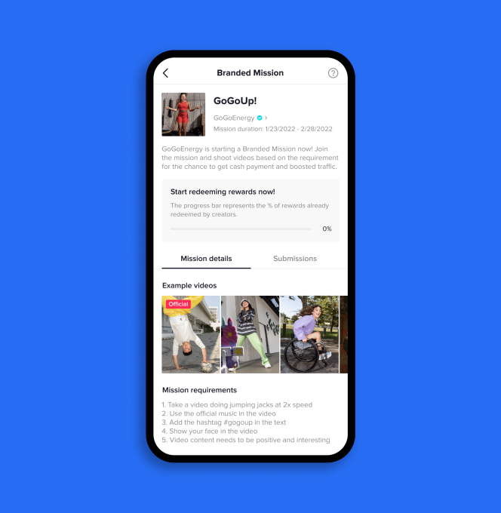

<https://techcrunch.com/2022/05/18/tiktoks-ad-product-gives-creators-opportunities-partner-marketers-branded-content/?guccounter=1&guce_referrer=aHR0cHM6Ly93d3cuZ29vZ2xlLmNvbS8&guce_referrer_sig=AQAAAFDCaLJ9_cPhezs9IQui--HqIDlHM5orLkDz413igm3dKEnj3fysTy9qmoDFSNvMBMd8cXyEJ6swqyOegoUzvU8fsOv4OAFieXltSHZ0MoOzNa_DqGewhAzlmOy9ozjep6OdkcOeQG4Ptcj-BsVXpS45mFe3sSLCrr884tR6Zr1V#>

## **Report: One in Three Amazon Sellers Increasing Ad Spend in 2022 in Increasingly Competitive Marketplace**

[Jungle Scout](https://www.junglescout.com/), the leading all-in-one platform for ecommerce sellers, released its [2022 Amazon Advertising Report](https://www.junglescout.com/t/amazon-advertising-report/), which examines Amazon's $31 billion advertising business, the third-largest in the world, after Google and Facebook.

* The findings show that **32% of brands and sellers on Amazon will increase their ad spend in 2022**, despite concerns about rising advertising costs and challenges managing their strategy and budget.
* The 2022 Amazon Advertising Report includes data from more than 5,000 distinct brands and 950,000 unique Amazon advertising campaigns, revealing trends, strategies, and ad products yielding the best returns on the platform.
* Key insights include:
  + **Amazon sellers are heavily investing in Amazon Advertising — out of necessity.**
    - While 63% of consumers begin their online search for products on Amazon (ahead of Google, Walmart.com or Facebook), this amount is down from 74% in early 2021.
    - Forty-five percent of Amazon sellers say managing their advertising strategy and budget is a challenge for their business. As many as 94% experienced supply chain issues in 2021, in some cases leading to stock outages and reduced exposure on Amazon's platform.
    - Thirty-two percent of Amazon sellers are increasing their Amazon advertising spend in 2022 to increase the visibility of their products and brands.
  + **Consumer ad preferences correlate with impact on returns on ad spend.** 
    - Amazon Sponsored Products, consumers' preferred ad type, saw a 68% return on investment. Sponsored Brands ads, consumers' least-preferred, saw a 41% decrease in return on investment in 2021.
    - Consumers are being more effectively targeted off Amazon with Sponsored Display ads (which appear on third-party websites consumers in the U.S. are visiting), resulting in a higher share of advertising dollars.
  + **However, high advertising spend doesn't always correlate with high returns.**
    - The Health & Household product category saw the highest ad spend but the lowest return on investment in the examined date range.
    - Electronic products ranked second-to-last in ad spend and the highest in returns.

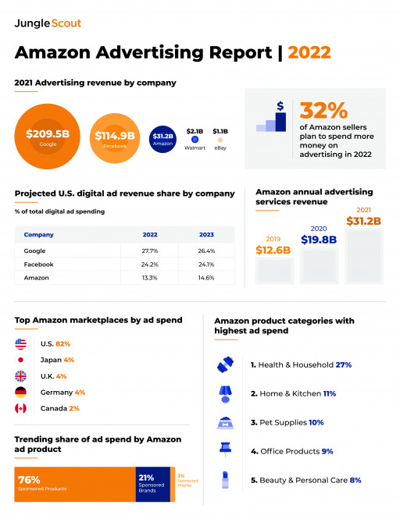

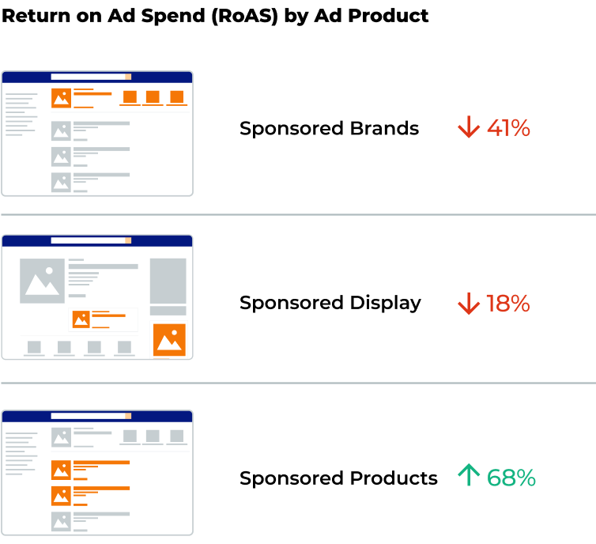

<https://www.globenewswire.com/news-release/2022/05/18/2446169/0/en/Report-One-in-Three-Amazon-Sellers-Increasing-Ad-Spend-in-2022-in-Increasingly-Competitive-Marketplace.html>

## **YouTube Adds New Way To Make Money With Gifted Memberships**

YouTube is rolling out membership gifting to more creators, which gives viewers the ability to buy memberships for other viewers.

* YouTube gives creators another way to earn revenue directly from their audience with membership gifting, a feature comparable to gifted subscriptions on Twitch.
* Monetized YouTube channels have the option to earn revenue by offering memberships to users.
* **How Does Membership Gifting Work?**
  + A channel membership grants perks such as special icons that show up in a creator’s comment section, members-only livestreams, and more. It’s similar to subscriptions, or “subs,” on steaming platform Twitch.
  + Gifted channel memberships can be purchased on desktop during a creator’s livestream. Click the $ button next to the live chat to purchase gift memberships on live streams.
  + Viewers have to opt-in to be eligible to receive gifts on a channel. During the Beta, users can opt-in by clicking ‘Allow Gifts’ when prompted.
  + YouTube distributes gift memberships to viewers based on how much they interact with your channel.

<https://www.searchenginejournal.com/youtube-adds-new-way-to-make-money-with-gifted-memberships/450466/>

## **New Yelp feature: Request a Call**

Yelp has added **a new Request a Call feature to help service businesses more easily connect with potential clients.** Users can specify a preferred call-back time. It’s then up to businesses to either confirm or ask for a different time.

* People who land on your Yelp business page can click on a Request a call button. They must then select a service they want from you, then enter their phone number and preferred call time. This time could be super specific or a larger time window.

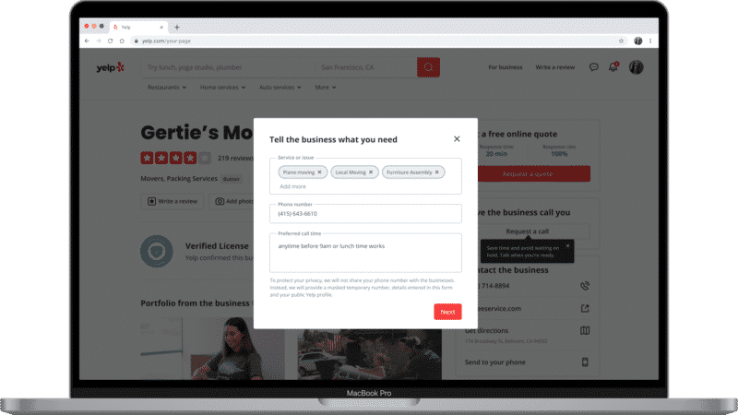

* When someone requests a call from your business, you will get a message in your Yelp for Business inbox, asking them to call the potential customer at the requested time window. Businesses then have three response options:
  + Confirm call time.
  + Reschedule/unavailable.
  + Need more information.
* Businesses won’t be able to call a user on their actual phone number. That’s because, for privacy, Yelp creates a masked, temporary phone number.
* Request a Call is now available to Yelp business pages that have opted into receiving leads via Request a Quote. Support for iOS and Android will come later.

<https://searchengineland.com/yelp-launches-request-a-call-385287>

# Calendar Week 19 (May 13)

## **As Google offers more personalized advertising, Apple suggests that in some cases, personalization doesn’t matter**

**Google** is offering consumers more personalized ad experiences, even as **Apple** tells advertisers that aiming for users who have opted out of tracking may actually offer better results.

* **Google My Ad Center** was unveiled Wednesday at Google I/O. It will provide Google users a more personalized ad experience across Google Search, YouTube, and other platforms.
  + The new tool, expected late this year, will let users view the kind of ads they want to see.
  + Users will be able to give specifics on ads they prefer within My Ad Center: everything from basketball to health to the energy industry. They may even request ads from particular brands.
* Meanwhile, at **Apple**: The consumer tech giant is saying in some circumstances that aiming at consumers who don’t want to be personalized, oddly enough, could yield better results.
  + Apple's Search Ads are [growing in importance as a revenue source](https://content-na1.emarketer.com/apple-will-revamp-its-services-focus-on-advertising-streaming?_ga=2.183614500.36777977.1652433017-1065378323.1652433017) for the company—yet they rely very little on targeting, and personalization doesn’t yield better conversion rates, according to a presentation to advertising clients obtained by 9to5Mac.
* The average conversion rate for users who enable tailored advertisements and those who do not is in a statistical dead heat.
  + Advertisers saw a 62.1% conversion rate for users who opted in to personalized ads. The conversion rate is 62.5% among consumers who have tailored ads blocked.
* Users have a love-hate relationship with personalized ads.
  + 54% of marketers have seen increased engagement with their brand as a result of more personalization, [per Acquia](https://chart-na1.emarketer.com/251855/what-improvements-have-marketers-worldwide-seen-with-customer-engagement-result-of-implementing-more-personalization-of-respondents-aug-2021?_ga=2.108237696.36777977.1652433017-1065378323.1652433017); another 48% saw increased conversions.

<https://www.emarketer.com/content/google-offers-more-personalized-advertising-apple-suggests-that-some-cases-personalization-doesn-t-matter>

## **Engage listeners in a natural way with interactive audio ads**

Amazon Ads’ **i**[**nteractive audio ads**](https://advertising.amazon.com/blog/interactive-video-audio-advertising?ref_=a20m_us_wn_aa_051222_blg_intvaaa) make it easier than ever before for listeners to engage with brands or services whose messaging they find relevant using just their voice.

* When listeners hear an interactive audio ad they’re interested in while listening to Amazon Music ad-supported tier on an Alexa-enabled device, they can simply reply to the Alexa **call-to-action** by voice to take actions such as adding an item to their cart, requesting more info via email, or setting a reminder, without disrupting their streaming audio content.
* In the past, listeners had to remember or say the entire name of the advertised product in order to interact with an audio ad by voice.
* Interactive audio ads make interaction easy, removing the need to remember the name of the product or service, reducing friction, and making it more natural for listeners to take their next step with a brand if they want to — the experience is seamless.
* The feature is a managed service in Amazon DSP available in the US.

<https://advertising.amazon.com/en-us/resources/whats-new/interactive-audio-ads/?ref_=a20m_us_wn_gw>

## **TikTok Launches New Interactive Market Insights Tool to Better Inform Strategic Planning**

TikTok has launched a [new, interactive insights platform](https://www.tiktok.com/business/en-AU/insights?tt4b_lang_redirect=1), which enables you to use a range of filters to discover key data points on your target market/s.

* The new platform, which you can access [here](https://www.tiktok.com/business/en-AU/insights?tt4b_lang_redirect=1), provides a range of filters to hone in on your audience, and learn more about key aspects.

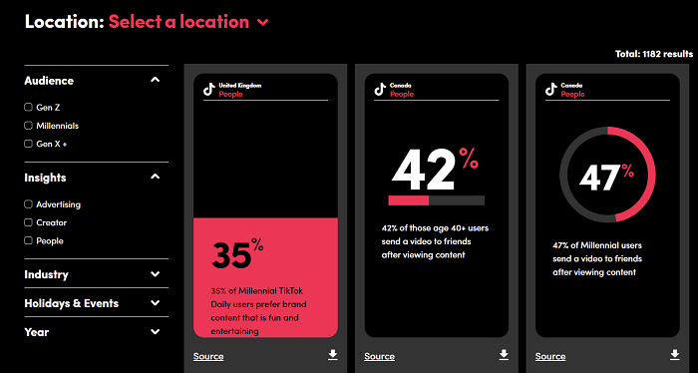

* There’s a range of data filtering tools to choose from, including location, demographics, industry vertical, date, etc.
* It’s similar to [Facebook’s interactive insights tool](https://www.facebook.com/business/insights/i2g) (also worth a look), which is designed to give you a more customized perspective on key data points, as opposed to more generalized studies and whitepapers that may not be aligned with your needs (see also: Facebook’s Monthly Trending Topics tool).
* The info could help to guide your strategic approach, and inform your choices. The only drawback right now is that TikTok’s insights database doesn’t seem too deep, so many of the same data points show up in several categories, which means they may not be as specific as you might like.

<https://advertising.amazon.com/en-us/resources/whats-new/interactive-audio-ads/?ref_=a20m_us_wn_gw>

## **Chinese Sellers Overrun Walmart Marketplace**

More than 50% of new sellers on the Walmart marketplace are from China. A year after Walmart allowed international sellers, they outnumbered American sellers in recent months.

* Walmart announced the expansion to allow international sellers at a conference titled “跨境新征途，把沃新机遇” and hosted a year ago in Shenzhen on [March 25th, 2021](https://www.marketplacepulse.com/articles/chinese-sellers-on-walmart-marketplace). Over the next month - April - just 6% of new sellers were from China. However, by the end of 2021, that had risen to 20%. This year, it continued to increase to reach 40% in April. Of the most recent 1,000 new sellers added, 51% were from China and just 46% from the U.S.
* Walmart marketplace has added nearly 150,000 sellers since its inception. There are still ten times more sellers from the U.S. than China, but Walmart only allowed U.S. companies for most of its existence. There are few sellers from Europe or other countries selling on Walmart. That’s an area Walmart is likely yet to expand; however, there is [little presence of international sellers except for China](https://www.marketplacepulse.com/articles/amazon-marketplace-is-not-international-except-for-china) on other marketplaces.
* In April, Walmart held a similar event in India. At the Walmart Global Seller Summit in New Delhi, the company presented to hundreds of Indian sellers to get them to sell on the marketplace. There are less than 500 sellers from India on Walmart today. It is unlikely that they will reach Chinese seller numbers, but more will join.
* The launch of Walmart Fulfillment Services (WFS), the opening to international sellers, and the increasing presence of advertising in search results have brought the Walmart marketplace close to resembling Amazon. Walmart still has higher requirements for sellers to be accepted, however. But the high market share of international sellers enabled by a fulfillment service to be indistinguishable to shoppers is now true for both.

<https://www.marketplacepulse.com/articles/chinese-sellers-overrun-walmart-marketplace>

# Calendar Week 18 (May 06)

## **TikTok Has A New Way For Advertisers Reach Users**

TikTok announced a new advertising option for brands - TikTok Pulse. This new contextual advertising solution gives brand exposure in the top 4% of videos.

* TikTok Pulse is a new contextual advertising solution, meaning your ads show around top content.
* Currently, TikTok will offer 12 categories of Pulse for brands to choose where to show their content. Some of the categories included (but not all encompassing) are: Beauty, Cooking, Fashion, Gaming
* By allowing you to choose the category of where your ads show, it gives you the ability to engage with the groups that are most relevant to you.
* To make sure that your ads are running next to top content, TikTok will be using its in-house created inventory filter
* One way you’ll be able to measure that impact is through its third party brand suitability and viewability verification. You’ll have access to these tools for post campaign measurement.

<https://www.searchenginejournal.com/tiktok-pulse/448948/#close>

## **Meta Expands Ad Formats And Tools For Small Businesses**

Meta is enhancing its suite of tools for small businesses. The new tools are designed to help with lead generation and customer acquisition.

* During National Small Business Week, Meta announced new ways for SMBs to take advantage of lead generation and share content.
* **Messaging And Conversation Features:**
  + Meta recently identified over 70% of people want to be able to communicate with businesses in a similar way as friends and family: through messaging.
  + In fact, businesses are also realizing the value of messaging customers. They’ve found the ad format that opens a WhatsApp chat is a great way for new customers to discover them and have a conversation.
  + With this new insight, Meta is creating ads for Facebook and Instagram that can be made directly from their WhatsApp Business app.
* **New Lead Generation and Customer Acquisition Tools – Meta is launching a myriad of new tools to help businesses capture and manage leads through the platform. These features include:**
  + **Quote Requests in Instagram:** The Quote Request is currently being tested with selected businesses on Instagram. Essentially, it allows companies to add a “Get Quote” button on their Instagram profile and stickers in their Stories.
  + **Lead filtering with Instant Forms:** In the near future, lead filtering will be available for businesses. This will work by reviewing the responses to a multiple-choice question.
  + **Creative flexibility:** Meta is also testing its Instant Form for more personalization. Selected businesses are able to test adding visuals and content to their Instant Form, giving users more visual information.
  + **Gated content**: Gated content will soon be available for companies to use. By creating gated content, SMBs can provide leads with resources after they fill out the Lead Ad form. This allows the user to stay directly on the platform.

<https://www.searchenginejournal.com/meta-expands-ad-formats-and-tools-for-small-businesses/448938/#close>

## 

## **Google Shares Sneak Peek At New Advertising Features**

Google shares a preview of new advertising features it will be announcing at Google Marketing Live on May 24. These features represent what the Google Ads team has been working on during the first few months of 2022.

* **Improvements To Responsive Display Ads**
* Google’s responsive display ads, which adapt advertising creative to fit different sizes of ad units, are getting upgraded.
* **Mobile Layouts:** 
  + All-new, mobile-first layouts for responsive display ads will be able to accommodate any portrait image or video asset.
  + Responsive display ads are capable of automatically generating video out of static creative. This will allow advertisers to access full-screen mobile ad inventory when mobile-first layouts become available.

### **Machine Learning:**

* + The whole process of generating ads to fit different formats and device types is getting sped up with machine learning.
  + Google’s testing shows that advertisers see twice the conversions, on average, when adding a responsive display ad to an ad group with a static display ad.
* **Creative Inspiration Hub**
  + Available now, Google has developed a home on the web to seek inspiration for advertising creative.
  + There you’ll see real-life examples of ads that worked for businesses across Discovery, Display, Apps, and YouTube campaigns.

<https://www.searchenginejournal.com/google-shares-sneak-peek-at-new-advertising-features/449222/#close>

## **Amazon looks to lure brands with new streaming tech integrations**

Amazon made its second appearance at the Interactive Advertising Bureau’s NewFronts Tuesday with a showcase focused on three areas of its video business: ad-supported streamer Freevee, live streaming platform Twitch and the streaming rights to NFL Thursday Night Football, which go into effect next season.

* Freevee, recently rebranded from IMDb TV, is expanding its content slate and experimenting with new methods of advertiser integration. Both Prime Video and Freevee originals are beta-testing a Virtual Product Placement (VPP) tool that can drop approved brands into programming on a plug-and-play basis after filming has wrapped.
* Amazon is promising viewers and advertisers additional layers of interactivity for Thursday Night Football as well, such as dynamic stat displays, an X-ray feature, Twitch integrations and a new tool that creates ultra-low latency for live broadcasts.
* Finally, Twitch is introducing fresh ways to connect with creators through its owned channels and features like Drops, a popular method of rewarding viewers.

<https://www.marketingdive.com/news/amazon-streaming-newfronts-FreeVee-Twitch-NFL/623078/>

## **Amazon Advertising Is 44% Cheaper Than Facebook Or Google. But That’s Not The Only Only Thing Brands Should Care About**

Software company Sellics released data yesterday showing Amazon ads cost 68% less than Google ads and 44% less than Facebook ads, when comparing average cost-per-click on those platforms.

* In its [*2022 Amazon Advertising Benchmark Report*](https://sellics.com/amazon-advertising-benchmark-report-2022/?utm_campaign=en-benchmarker&utm_medium=email&utm_source=sendinblue&utm_content=20220426_MBMApril2), Sellics found that Amazon also compares favorably with other major players like Instagram (-79%) and LinkedIn (-86%), as well as close competitor Walmart (-13% compared with Amazon US).

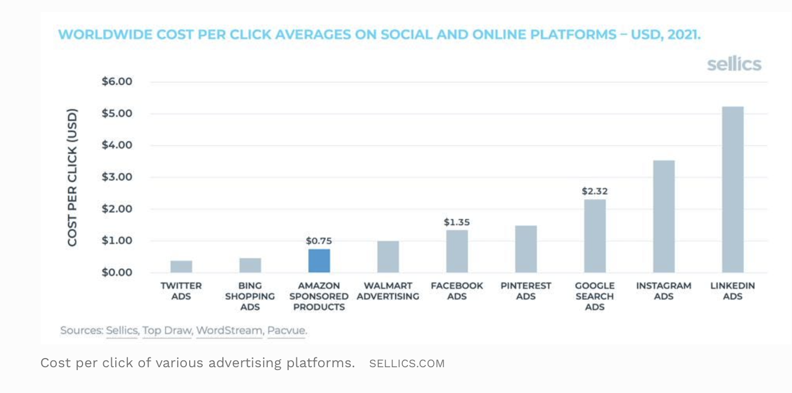

* This is despite cost-per-click on Amazon steadily increasing. Sellics data also show that the cost-per-click on Amazon’s US site has increased by 22% year-over-year from 2021 to 2022.
* This comes at the same time as Facebook and Google become less attractive advertising destinations with [the deprecation of the 3rd party cookie](https://www.forbes.com/sites/kateoflahertyuk/2022/02/19/apple-issues-stunning-new-blow-to-facebook-as-google-joins-the-battle/?sh=1e5113ab59de). Amazon, with its first party sales data, is relatively immune to this effect.
* Amazon is not a silver bullet, however. And cost per click is not the yardstick that all brands should be using. While it is an effective measure of relative affordability, brands need to also consider what the purpose of the advertising strategy is. A brand who’s looking to grow overall market share should not be overly concerned with profitability-oriented metrics like cost-per-click (CPC) and return on ad spend (ROAS).

<https://www.forbes.com/sites/kirimasters/2022/05/06/amazon-advertising-is-44-cheaper-than-facebook-or-google-but-thats-not-the-only-only-thing-brands-should-care-about/?sh=3b13994e4b4d>

# Calendar Week 17 (Apr 29)

## **TikTok Most Downloaded App In Q1 2022**

The short-form video sharing app TikTok was the most downloaded app worldwide in first three months of 2022, according to a report from Sensor Tower.

* TikTok surpassed Instagram as the most downloaded app.
* The top 10 most downloaded apps worldwide in Q1 2022 were:
  + TikTok
  + Instagram
  + Facebook
  + WhatsApp
  + Telegram
  + Shopee
  + Snapchat
  + Messenger
  + CapCut
  + Spotify
* The top 10 most downloaded apps in the United States in Q1 2022 were:
  + TikTok
  + YouTube
  + Facebook
  + HBO Max
  + Instagram
  + Messenger
  + Disney+
  + Cash App
  + Zoom
  + Netflix
* Meta Platforms, formerly known as Facebook, Inc., owned the second, third and fourth most-downloaded apps of quarter one.
* The multi-platform messaging service Telegram rounded out the top five, with more than 100 million downloads.

<https://www.searchenginejournal.com/tiktok-most-downloaded-app-in-q1-2022/447790/>

## **LinkedIn is rolling out a new website link feature**

**LinkedIn is adding links on profiles that have enabled creator mode**. The goal is to increase visibility for a creator’s business, personal website, online store, event or another type of resource, according to LinkedIn.

* The link will appear in the introduction section, beneath your user name and description and above your number of followers and connections.
* The link will no longer appear on your profile if you turn off creator mode.
* LinkedIn is rolling out this feature over the coming weeks to both the web and app.

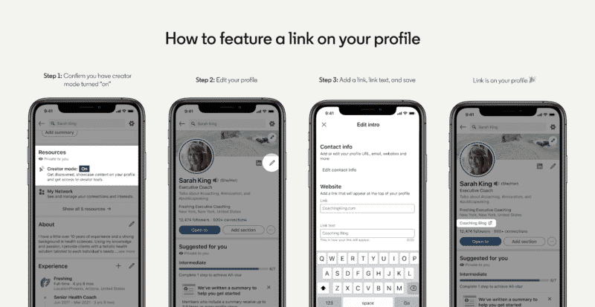

* This new website link feature is a good way to get some extra clicks and traffic to your website from LinkedIn, with customizable anchor text you can use as a call-to-action.

<https://searchengineland.com/linkedin-add-website-link-feature-383894>

## **Google, Microsoft report strong search ad revenue growth**

Search advertising revenue grew in the most recent quarter for both Google and Microsoft. Last night, Alphabet released its Q1 2022 report, while Microsoft released its Q3 earnings report.

* **Alphabet reported revenue of $68 billion**, up from $55.3 billion in Q1 2021. Zooming in on **Google search**, which accounted for 58% of Alphabet’s revenues, here are the key numbers for Q1 of 2022 (compared to Q1 of 2021):
  + Total Google advertising revenue: $54.7 billion (up 22% from $44.7 billion)
  + Google Search & other: $39.6 billion (a 24% vs. $31.9 billion)
  + Google Network: $8.2 billion (up 20% vs. $6.8 billion)
  + YouTube: $6.9 billion (up 14% vs. $6 billion)
* Maps searches for [shopping near me] were up 100% globally year-over-year.
* YouTube is testing ads on Shorts – its short-form (meaning 60 seconds or less) video product. Two types of ads were mentioned: app install and video action campaigns.
* **Microsoft reported revenue of $49.4 billion, up 18% from $41.7 billion in Q3 2021**. The company combines **search and news advertising** together. That revenue was $2.9 billion in Q3 2022 vs. $2.4 billion in Q3 2021.
* LinkedIn revenue grew to $3.4 billion, up 34% from $2.6 billion a year ago. **LinkedIn advertising revenue was up 61% year vs. year.**

<https://searchengineland.com/alphabet-q1-microsoft-q3-earnings-search-advertising-383869>

# **Amazon’s Growth Was Expected To Slow**

Amazon’s growth has slowed to a halt. However, that’s ok. It is lapping Covid-19 boost, which ultimately wasn’t a step-change many had foreseen. Amazon’s first-quarter 1P sales were down year-over-year for the first time in two decades. However, the same quarter was up 44% last year, an unusually high growth resulting from the pandemic e-commerce spending boost. The key is that growth over the two years was in line with previous two-year stacks.

* From Q1 2016 to Q1 2020, sales on Amazon grew on average 17% year-over-year. If growth happened in equal parts over the past two years, it would have been 18% (instead of 44% and -3%). The high increase in 2020 is offset by slow growth in the last four quarters. As a result, Amazon is up just 1.8% from the trendline it was on before the pandemic. By the end of 2022, it will likely fall below the trendline.

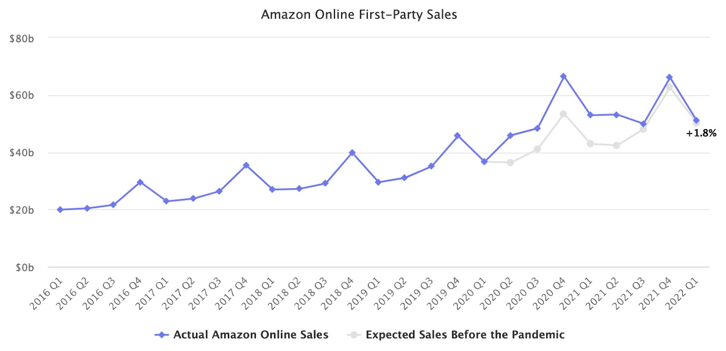

* The number of products sold on Amazon during the quarter was flat from a year ago (partly because of a different mix of products bought). Unlike first-party sales growth, the paid units metric includes Amazon and third-party sellers. Sales by the marketplace and thus overall GMV on Amazon had similar results as first-party sales - they were back on the trendline.
* The lack of growth in the most recent quarter is simply the result of comparing to unprecedented performance in the year before. The 0% growth in Q1 combined with 44% a year prior nets a 20% averaged yearly growth. That’s in line with the trend of units sold over the four years before the pandemic.

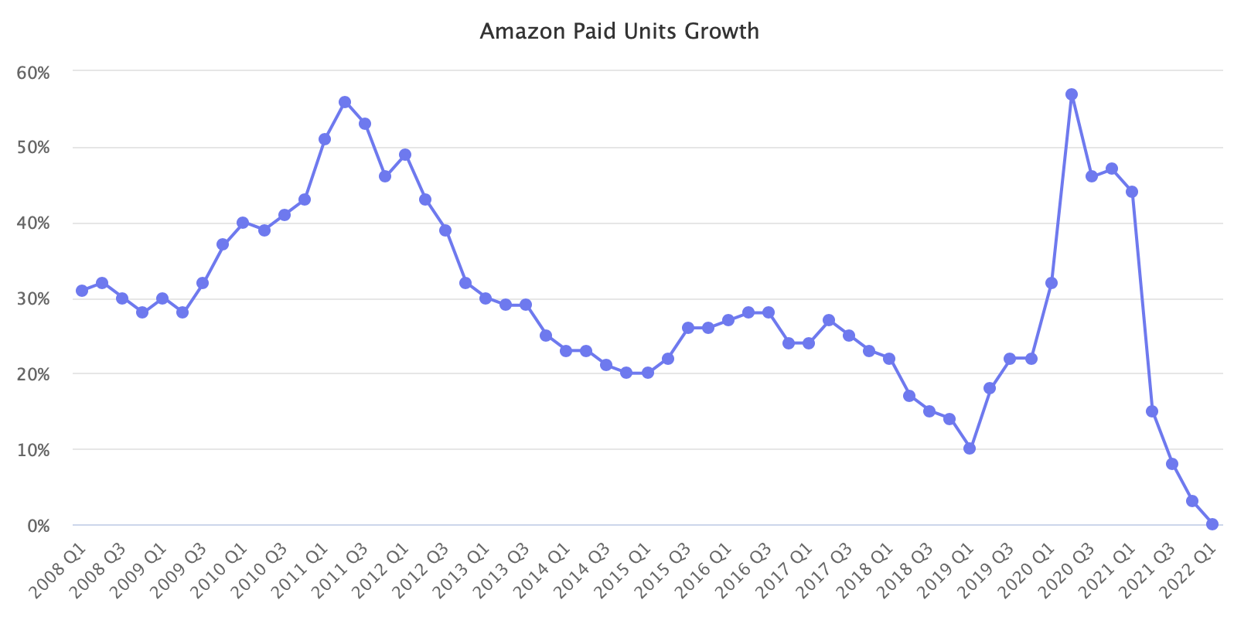

* Amazon’s results reinforce that Covid-19 didn’t accelerate e-commerce - U.S. e-commerce penetration is currently at levels it would have reached even if the pandemic didn’t happen. Though, that’s not universally true across all product categories.

<https://www.marketplacepulse.com/articles/amazons-growth-was-expected-to-slow>

## **Microsoft Advertising brings cash back incentives to ads**

Microsoft Advertising this week announced several new features at their yearly summit event, Microsoft Advertising Elevate 2022. The announcements include:

* **Cash back promotions**: The biggest announcement at Elevate was the addition of cash back promotions. Microsoft has been working feverishly on Edge and Rewards, and this has now matriculated into ads.
  + This is a new ad offering that will incentivize shoppers via a rebate upon purchase. Microsoft will choose the “right amount of cashback for the right ad and right user” allowing for advertisers to gather the best possible return on ad spend.
  + There was no information on where the cash back comes from – either Microsoft Rewards or the advertiser, but this does appear to be dynamic.
* **Ad Creator:** Creating eye-catching ads may soon become easier with Microsoft Advertising’s new Ad Creator. This will allow advertisers to find stock images, pull images from your site and also edit photos directly within the tool.
  + This should save time (and money), making it easier for advertisers to leverage imagery.”We see that visual ads can lead to more engagement, quantified by higher click-through rates (CTRs),” Microsoft said.
* **Other considerations:** Microsoft has also strengthened its commitment to multimedia ads and vertical ads, which are newer ad types. The visual search ad type, multimedia ads, helps advertisers grab attention and Microsoft shared that the security solution ADT “decreased overall cost per click (CPC) and achieved a 9.5x higher ROAS.” Meanwhile, Microsoft said vertical ads will soon include financial advisors, doctors and clinics, legal service providers, and mortgage lenders.

<https://www.siliconrepublic.com/business/amazon-earnings-advertising-business>

# Calendar Week 16 (Apr 22)

## **Manager Account-Level Reporting Now Available In Google Ads**

Google is rolling out **Manager Account** (MCC)-level reporting for all Google Ads users.

* Up until now, advertisers were only able to view reports at **an individual account level.** 
  + All the extra time and effort shifting between accounts to review performance really adds up.
  + The other problem with individual account views was that it made it difficult for advertisers to easily spot potential issues and opportunities.
* Now advertisers can use the dashboards feature at the manager account level.

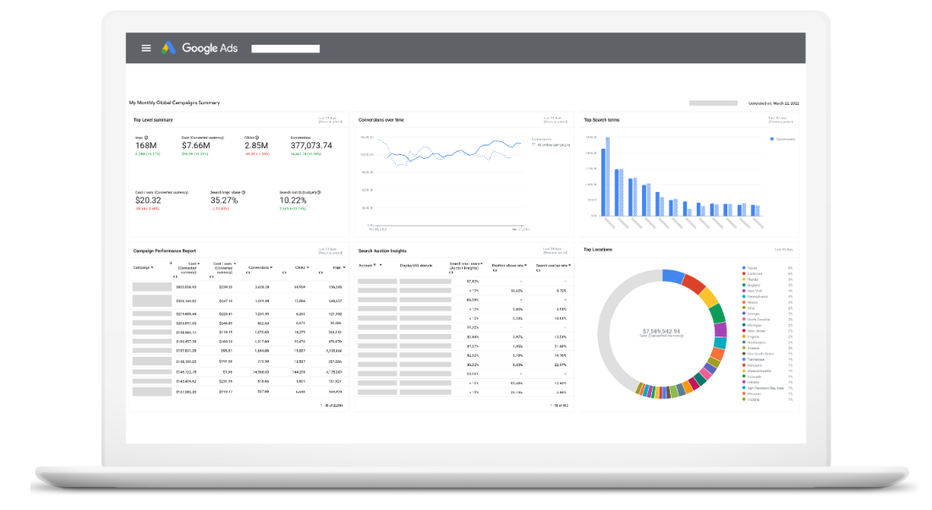

* Along with the manager account-level viewability, **Google Ads updated and improved other features in the dashboard.**
  + Change date ranges and dashboard filters as a whole
  + Add conditional formatting, rich formatting features, and interactive table cards
  + Download reports faster and at a higher quality
  + Resize dashboard cards and layouts dynamically
  + Create a dashboard card by copying over existing reports

<https://www.searchenginejournal.com/google-ads-manager-account-reporting/446509/#close>

## **TikTok’s In-Feed Ads get more visual with Interactive Add-Ons**

A handful of new Interactive Add-Ons have arrived within TikTok’s “For Your Page.”

* These new additions are available globally for In-Feed Ads and will be unique creative additions that will allow for more customized, engaging ads.
* **These new features come in two different flavors, Standard or Premium.**
* **Standard Add-Ons** are made to “reach lower-funnel marketing goals, like driving clicks and conversions”.This includes:
  + [Display Card](https://ads.tiktok.com/help/article?aid=10007089).
  + [Gift Code Sticker](https://ads.tiktok.com/help/article?aid=10007622).
  + Voting Sticker.
  + [Countdown Sticker](https://ads.tiktok.com/help/article?aid=10007621).
  + **Premium Ads** move up the funnel to aid in “brand awareness and community building.” This includes:
  + [Pop-out Showcase](https://ads.tiktok.com/help/article?aid=10007087).
  + [Gesture](https://ads.tiktok.com/help/article?aid=10007088).
  + Super Like 2.0
* The new Interactive Add-Ons are compatible with App installs, Conversion, and Reach & Frequency (Traffic, Video Views) campaigns.

<https://searchengineland.com/tiktok-ads-interactive-add-ons-383717>

## **Creative assets expands to Sponsored Display**

Vendors and Sellers using the Amazon Ads console can now **search for and reuse existing creative assets to build their Sponsored Display campaigns.**

* Sellers can easily reuse creative you’ve already uploaded as a part of their Sponsored Brands, Stores, or Posts efforts within your Sponsored Display campaigns.
* Integration with “creative assets” allows sellers to build Sponsored Display campaigns quickly, as well as provide a consistent shopping experience across your Amazon Ads campaigns.
* When adding a logo or custom image to a Sponsored Display campaign, you can select “Choose from assets” instead of “Upload image” to browse and reuse existing creative assets.
* Sellers can search, sort and filter by name, tag products, and other attributes to find assets easily. Search results can be further narrowed by filtering and sorting by asset types (logo, custom, or product image), upload date, file format, file size, dimension, moderation status, and more.
* Any brand content you upload to a Sponsored Display campaign will also be saved to “creative assets” for easy reuse later on.

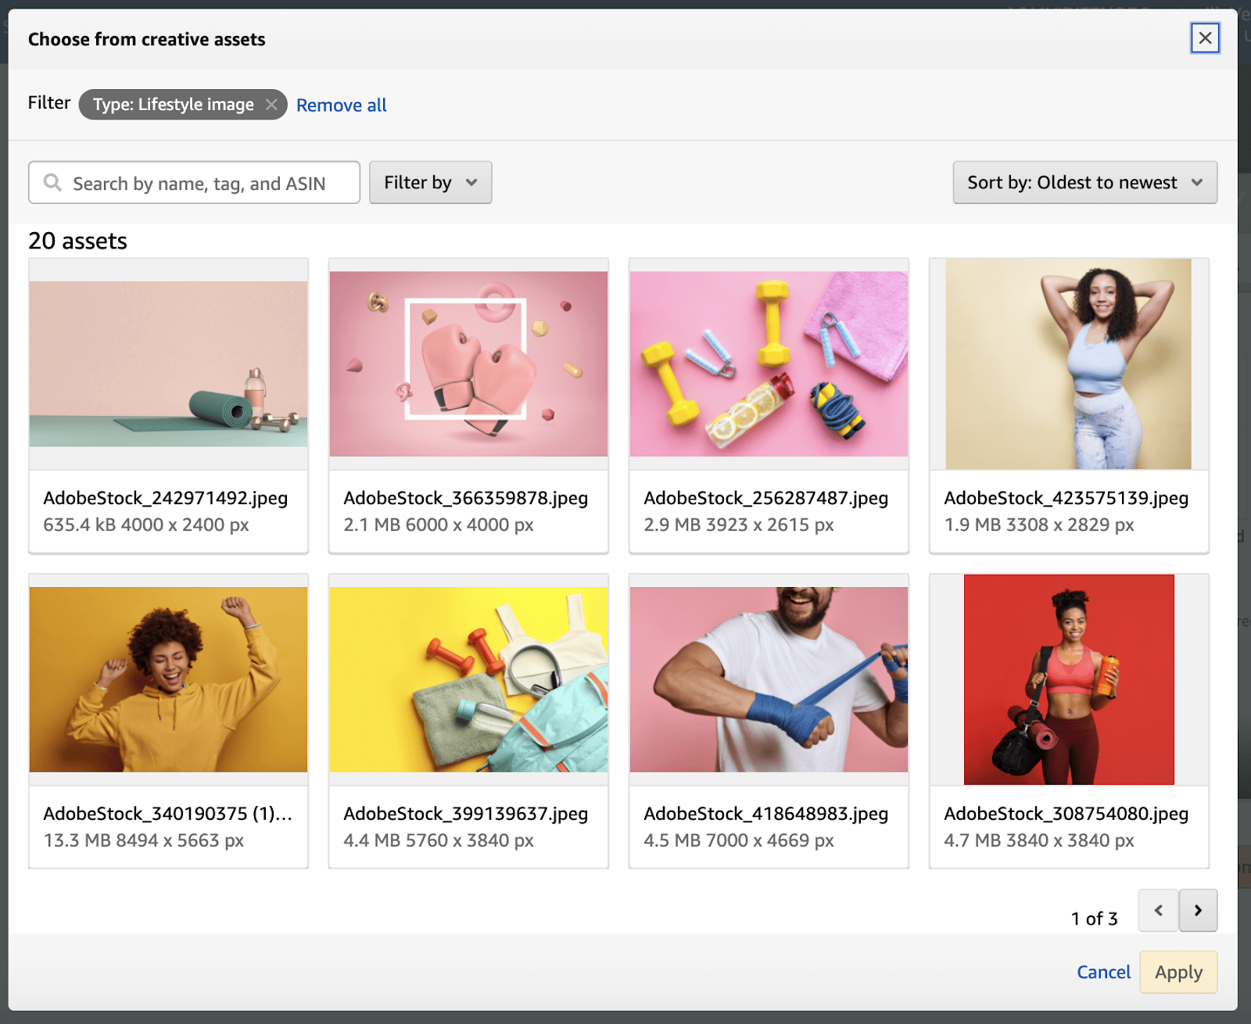

<https://advertising.amazon.com/en-us/resources/whats-new/sponsored-display-creative-assets/?ref_=a20m_us_wn_gw>

# Calendar Week 15 (Apr 17)

## **Reddit Makes Comments Searchable**

Reddit is rolling out a series of updates to its search capabilities including **the ability to search comments and return more relevant results.**

* Reddit users now have an easy way to **search for comments**, and can even refine searches to find comments within specific communities.
  + Users can now enter a query in the Reddit search bar and use the new Comments tab to browse through replies to threads more efficiently.

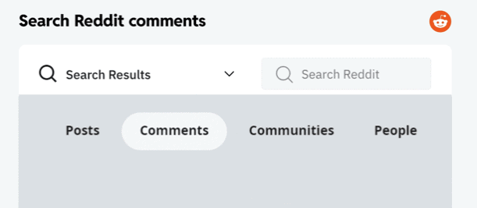

* Reddit is making several adjustments to how it returns search results, which are said to **make the results more relevant**. The adjustments to Reddit search include:
  + **Less restrictive matching**: 100% of a query doesn’t have to match the text of a post to return results.
  + **Understanding search intent**: Reddit will change how it orders search results based on search intent.
  + **New ranking signals:** Users’ clicks and interactions on search results is now a ranking signal for Reddit search.
* Reddit is updating its search results pages on mobile with what it says is a simpler design.
  + Along with the cosmetic updates, the layout of Reddit’s search results pages has been updated to prioritize posts over other content types.

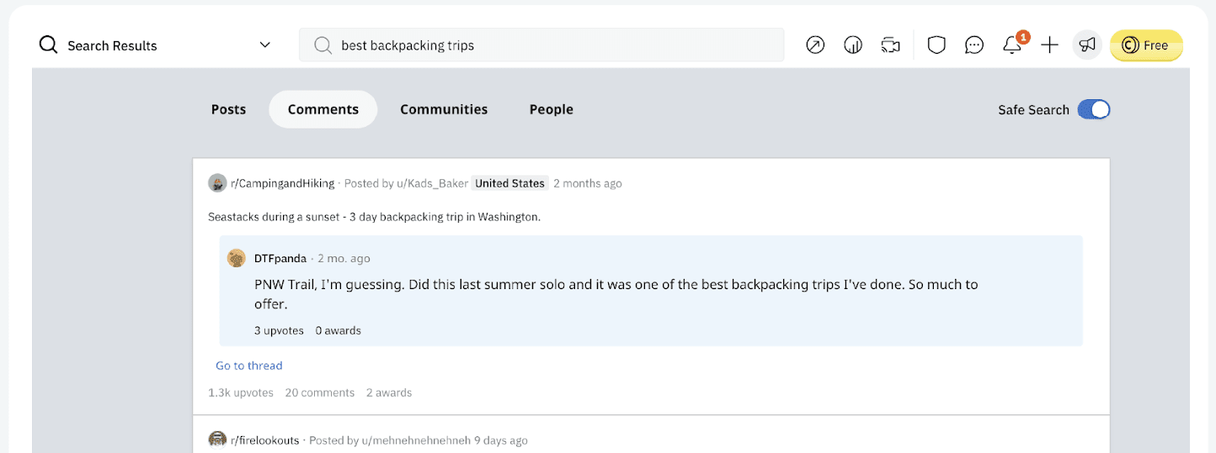

* + In an effort to make Reddit search safer for all users, its reducing the number of unexpected results through understanding searcher’s intent.

<https://www.searchenginejournal.com/search-reddit-comments/445708/>

## **YouTube’s Keyword Research Tool Available To Everyone This Month**

**YouTube Search Insights,** a tool designed to surface valuable keyword data, will be available to all channels later this month.

* YouTube Search Insights is built to assist with content planning by providing data you can use to create more relevant content.
* Data surfaced by Search Insights will inform you about what your specific audience is searching for.
* In addition, you can get data on what the broader YouTube audience is searching for by looking up keywords to see the estimated search volume.
* If a keyword has high search volume, but relatively few relevant results, Search Insights will call it out as a content gap.
* How to access this tool:
  + Search Insights lives within the Research tab in YouTube Studio on desktop.
  + You can access it by logging into YouTube Studio and clicking on Analytics in the left-hand navigation menu.
  + From there navigate to the **Research tab** and look for a section titled **“Your viewers’ searches”.**

<https://www.searchenginejournal.com/youtube-keyword-research-search-insights/445836/>

## **Pinterest for WooCommerce extension turns products into shoppable pins**

Pinterest continues to expand its shopping features for retailers and improve the shopping experience for users.

* The WooCommerce platform has more than 5 million active installations and is used by businesses, agencies and brands for ecommerce.
* The new Pinterest for WooCommerce extension turns all of your products into shoppable product Pins, regardless of what types of products you sell. It also automatically updates product details, such as pricing and availability.
* After installing the extension, your product catalog will show up in the feed of Pinterest users, as well as when they search and browse for products.
* Merchants will get performance data on all interactions with your products so you can track best-selling items or most saved items, Pinterest [announced](https://business.pinterest.com/en/blog/introducing-pinterest-for-woocommerce/) in a blog post.

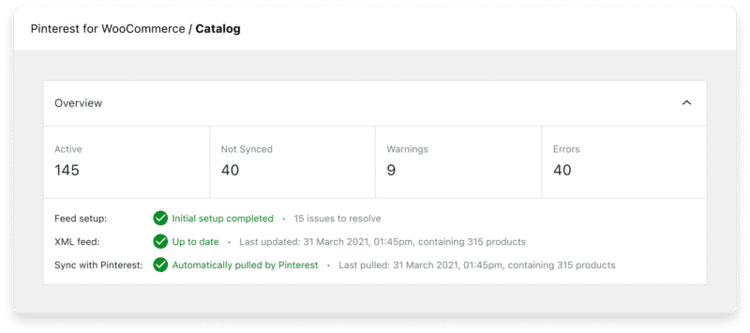

<https://searchengineland.com/pinterest-for-woocommerce-extension-383590>

## **Google rolling out conversion migration tool for Google Analytics 4**

Google is now rolling out a conversion migration tool for you to important your existing goals from Universal Analytics to Google Analytics 4.

* The goals migration tool allows you to quickly recreate eligible goals from your connected Universal Analytics property as conversion events in your Google Analytics 4 property.
* For each eligible Universal Analytics goal you select, the goals migration tool automatically does the following in your connected Google Analytics 4 property:
  + Creates a new Create event rule
  + Marks the created event as a conversion
* Universal Analytics properties can have several different goal types. These two goal types can be migrated using the tool:
  + **Destination goal:** When a user lands on a specific page, such as a “thank you” or “confirmation” page
  + **Event goal:** When a user triggers a specific event, such as social recommendation, video play, or ad click
* You can create up to 30 custom conversion events per standard Google Analytics 4 property.

<https://searchengineland.com/google-rolling-out-conversion-migration-tool-for-google-analytics-4-383609>

# Calendar Week 14 (Apr 08)

## **Education Initiative to Help Advertisers Maximize Opportunities**

TikTok launched a new educational initiative in order to help marketers better understand and utilize the various platform features to reach and engage the TikTok audience.

* Called [Creative Agency Partnerships (CAP) University](https://tiktokcapuniversity.splashthat.com/), the program will take agency partners and freelance creatives through all aspects of effective TikTok creation.
* The initial elements available include ‘TikTok: From Briefing to Pitching,' 'Concepting & Creating for TikTok,' 'Trends and Music Licensing,' and more.

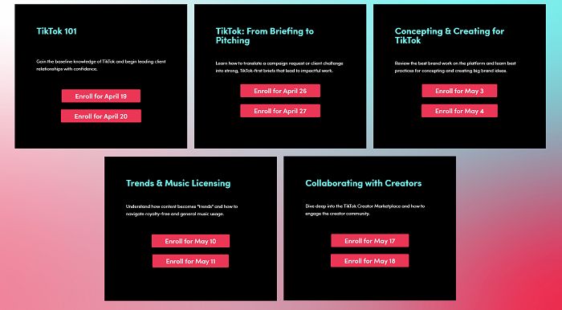

* There’s also an element focused on working with TikTok creators, which is a critical building block for the app’s ongoing growth.
* The new education program could be a great way to polish up your TikTok knowledge, with direct input from the platform’s own creative team.

<https://www.socialmediatoday.com/news/tiktok-launches-new-marketing-education-initiative-to-help-advertisers-maxi/621705/>

## **Instagram's Removed In-Stream Video Ad Placements from its Advertising Options**

Instagram’s taken another small step towards its next evolution, with ad partners now being informed that **in-stream video ad placement is no longer available as an option in the app.**

* Meta is letting advertisers know that they can no longer use Instagram in-stream spots, but that they can use Reels placement as an alternative for video ads on IG.
* Instagram’s currently testing a new, full-screen feed format, which would incorporate static posts, videos, Stories and Reels into a singular content stream.
  + When a Story appears as you scroll, it would be delineated by the frame indicators along the bottom of the UI, while video posts would play as you swipe by, much like TikTok’s presentation style.
* Instagram still has various video upload options available, even without IGTV, with users able to upload video clips up to an hour long through the post composer.
* Within that, in-stream placement will no longer be a viable option, and it could be that Instagram’s removing the option now in order to prepare for the next change, as it then won’t have advertisers relying on this option anymore.
* Following the lead of its Chinese variant ‘Douyin’, TikTok’s working to add in more commerce elements, with a view to helping creators earn more money from their in-app efforts.

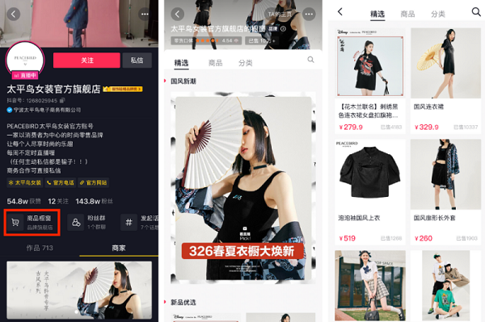

<https://www.socialmediatoday.com/news/instagrams-removed-in-stream-video-ad-placements-from-its-advertising-opti/621722/>

## **Pinterest prohibits climate misinformation in ads, content**

Pinterest wants to remove any traces of climate misinformation from its platform. The company announced it will now remove any ads or content from its platform that violates its new policy.

* Pinterest’s new policy removes climate misinformation and disinformation. Especially:
  + Content that denies the existence or impacts of climate change, the human influence on climate change, or that climate change is backed by scientific consensus.
  + False or misleading content about climate change solutions that contradict well-established scientific consensus.
  + Content that misrepresents scientific data, including by omission or cherry-picking, in order to erode trust in climate science and experts.
  + Harmful false or misleading content about public safety emergencies including natural disasters and extreme weather events.
* The company has cracked down on multiple types of advertising in recent years. Pinterest banned anti-vaccination ads in 2017, stopped running political ads in 2018 and banned weight loss ads last year.

<https://searchengineland.com/pinterest-prohibits-climate-misinformation-ads-content-383438>

## **Google is ready to test Topics, but advertisers remain skeptical**

As Google charges ahead with [testing Topics](https://blog.chromium.org/2022/03/what-to-expect-from-ps-testing.html) — a system based around tracking subjects a web user shows interest in — via small-scale trials, questions remain around its rollout, effectiveness and impact on advertisers.

* The conversation around [third-party cookie deprecation](https://www.marketingdive.com/news/googles-end-to-cross-app-tracking-on-android-marks-latest-advertiser-hurtl/618972/) has lingered for more than two years, with Google adjusting its timeline for the removal multiple times. Its latest move to address privacy and advertiser concerns came in January, when the tech giant unveiled its Topics program that collects information on one topic a consumer has shown interest in over the past three weeks and gives that data to advertisers.
* Information is only stored for a limited period of time to protect consumer privacy, an approach that makes microtargeting virtually impossible.
* Topics replaces Federated Learning of Cohorts (FLoCs), a short-lived initiative that Google boasted was 95% as effective as third-party cookies. However, FLoCs was quickly abandoned in favor of Topics, Google's latest move in the privacy wars that has tech companies and advertisers scrambling to meet new regulations and consumer concerns. By phasing out third-party cookies and cross-app tracking, tech companies also make advertisers more reliant on them, opening new revenue streams for both Google and Apple.
* However, that is still a long way off, as Topics is in the early stages of testing and will likely take time before it's rolled out on a wider scale. But according to experts, issues can still arise from small-scale trials.

<https://www.marketingdive.com/news/google-topics-advertising-floc-privacy-cookies/621762/>

## **Thousands of Etsy Sellers Are Boycotting the Platform Over High Transaction Fees**

“Etsy made bank over the pandemic,” says a [petition](https://www.coworker.org/petitions/cancel-the-fee-increase-work-with-sellers-not-against-us) by Etsy sellers urging users to boycott the platform. Thanks in part to an unexpected [demand for quirky, hand-stitched face masks](https://www.fastcompany.com/90628816/youll-never-guess-what-everyone-bought-on-etsy-during-the-pandemic), the online marketplace better known as a cozy home for independent creators and artisanal goods more than doubled its revenue in 2020; the following year, it acquired two companies, [Elo7](https://techcrunch.com/2021/06/28/etsy-acquires-elo7-known-as-the-etsy-of-brazil-for-217m/) and [Depop](https://www.vox.com/recode/22465048/depop-etsy-1-6-billion-tiktok-youtube-social-media-gen-z), for a total of more than $1.8 billion.

* Despite these gains, on April 11, Etsy plans on increasing seller transaction fees by 30% — a move that striking users are describing as “nothing short of pandemic profiteering.”
* “After the planned increase, our fees as sellers will have more than doubled in less than 4 years,” reads the petition authored by Etsy seller Kristi Cassidy, which has more than 33,000 signatures. The last transaction fee increase on the platform was in [July 2018](https://www.usatoday.com/story/life/allthemoms/2018/06/14/etsy-fee-increase-frustrates-shop-owners-who-may-look-new-platforms/701669002/), when the total commission charged on sales went up from 3.5% to 5%.
* Cassidy and other Etsy users, including both sellers and buyers, are calling for a weeklong boycott of the platform when the new increase goes into effect. “Etsy Strike” now has its own [website](https://etsystrike.org/faq/), and Mattie Boyd, one of the campaign’s organizers, told Hyperallergic that over 12,500 Etsy sellers have said they will support the boycott by putting their shops on “vacation mode.”
* Jane Rhoades, who sells paintings, prints, and hand-sewn works on her Etsy shop and elsewhere, says she’s joining the boycott to protest the overall cost of being an artist on the platform — which also includes payment processing expenses and advertising fees for products sold through Etsy’s “offsite ads” program, which sellers making over $10,000 a year can’t opt out of but receive at a discounted rate (12% versus 15%). Reporting by [the Verge](https://www.theverge.com/2022/3/30/23001727/etsy-seller-strike-boycott-fee-increase) cites a host of other issues, including a controversial “Star Seller” program that some say puts too much pressure on merchants and a surge in outsourced, mass-produced goods on the site.

<https://hyperallergic.com/722658/etsy-sellers-are-boycotting-the-platform-over-high-transaction-fees/>

# Calendar Week 13 (Apr 01)

## **Google launches new highly cited label in search and improved about results for rapidly evolving topics**

Google has [announced](https://blog.google/products/news/fact-checking-misinformation-google-features/) two new features for US based and English language searchers, around helping those searchers evaluate information within Google Search and verify sources and claims of those listings.

* **One is a feature to show a highly cited label in the Top Stories results.**
  + Google will soon launch in the US English search results a new highly cited label that will appear on Top Stories within Google’s mobile search results.
  + This label will help searchers identify stories that have been frequently cited by other news organizations.
* **The other feature is improving the “about this result” feature for rapidly evolving topics.**
  + Google is also using the [about this result feature](https://searchengineland.com/google-search-launches-about-this-result-feature-345649) to help communicate to searchers about the potential issues with search results related to a topic or breaking news story that is rapidly evolving.
  + Google will show the notice that **the search results for a query may be changing because the topic itself is rapidly evolving**.
  + This adds to the about this result feature for [rapidly evolving topics](https://searchengineland.com/google-search-notice-warns-searchers-when-results-are-new-and-possibly-unreliable-349906) where Google would show a notice that reads “it looks like these results are changing quickly.”
  + Google then shows information on how to check the source of the result and also asks the searcher if they might want to come back later in a few hours as Google figures out what is best to rank for those queries.

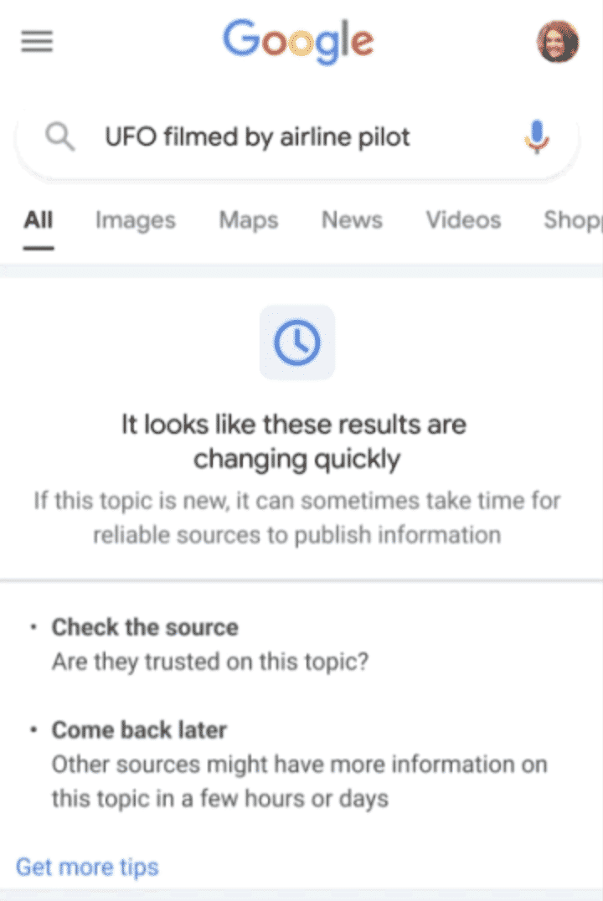

<https://searchengineland.com/google-launches-new-highly-cited-label-in-search-and-improved-about-results-for-rapidly-evolving-topics-383306>

## **TikTok Launches Search Ads Beta For Selected Partners**

TikTok has quietly rolled out **a search ads beta** for specific partners.

* When we explored the TikTok search results page with a few different non-related queries, we saw an ad showing within the first four results:

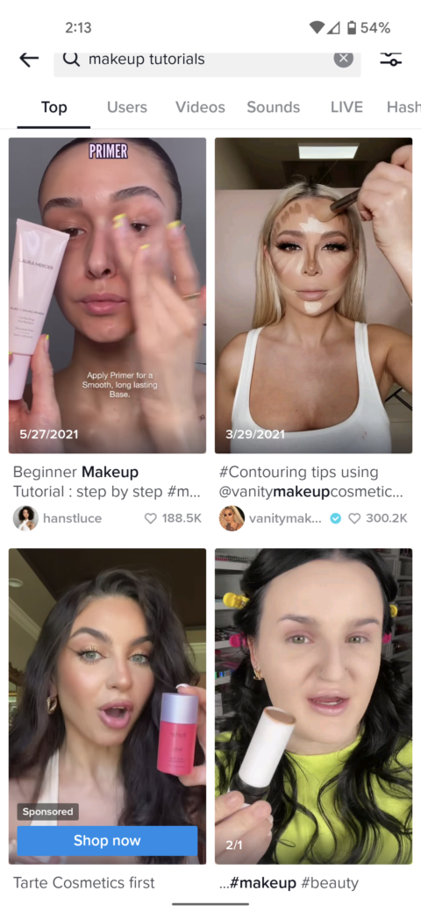

* If search ads roll out to the general public, advertisers will be able to expand your campaign targeting to specific queries. The benefits of this type of targeting include:
  + Better control over campaigns
  + More “bottom of funnel” options
  + Identify user intent and interest
* When search ads are available, advertisers will also receive reporting in the TikTok Ads Manager interface that include:
  + Search term click data
  + Conversion data from search terms
* Search ad targeting unlocks a new level of benefits for marketers. On top of being able to report on search term data, it allows you to take actionable steps in your TikTok marketing.

<https://www.searchenginejournal.com/tiktok-launches-search-ads-beta-for-selected-partners/444128/#close>

## **Microsoft took down 3 billion ads in 2021**

Microsoft removed more than 3 billion ads in 2021. That is nearly double the number of bad ads [Microsoft took down in 2020 (1.6 billion)](https://searchengineland.com/microsoft-advertising-blocks-1-6-billion-ads-while-dealing-with-the-pandemic-says-annual-ad-quality-review-347202) and almost equal to the 3.1 billion ads Google blocked in 2020.

* Advancements in machine learning, multilingual models and human moderation contributed to the significant growth of ad takedowns, according to [Microsoft’s 2021 Ads Safety Report](https://about.ads.microsoft.com/en-us/blog/post/march-2022/2021-in-review-ads-safety-in-microsoft-advertising)
* .Here are some of the statistics Microsoft shared about its year of fighting **low-quality ads, bad actors and scammers**:
  + More than 3 billion ads were taken down.
  + 270,000 accounts were suspended. (This is a decrease from 2020, when 300,000 accounts were suspended.)
  + 400,000 websites were banned from its network. (This was an increase compared to 2020, when 270,000 sites were removed.)
* The number of fake, celebrity-endorsed investment ads increased in 2021. Microsoft said it tried to catch and remove these ads in real-time. Microsoft suspended nearly 10,000 accounts and removed 200,000 ads promoting these schemes.
* A top threat to Microsoft’s advertisers in 2021: bad actors using techniques to get past multi-factor authentication. Microsoft said it “made use of advertisers’ behavioral identity signals to detect such scenarios and protect our customers. We then shared best practices with our advertisers to help them not fall prey to new tactics.”

<https://searchengineland.com/microsoft-took-down-3-billion-ads-in-2021-383303>

## **Walmart plots roadmap for media business with focus on premium ads**

Walmart outlined plans to grow its Walmart Connect advertising platform this year, including through a focus on premium ad experiences, [in a company blog post](https://corporate.walmart.com/newsroom/2022/03/30/walmart-connect-building-meaningful-shopping-experiences-between-suppliers-our-customers).

* The big-box store said **it will begin testing on-site video ads on Walmart.com later in 2022**. It is also developing new ad formats for connected TV and video, along with "omni experiences" across self-checkout screens, TV walls, in-store events and sampling.
* The spotlight on video demonstrates **Walmart is angling for more premium brand dollars** but also suggests that common units like display and sponsored product listings could be nearing a saturation point.
* On the campaign management end, **the chain is enriching its targeting, search and measurement capabilities, and will shift to a second-price auction model that is common in programmatic bidding.** Walmart is quickly scaling its retail media business as the segment draws significant revenue but also faces stiffer competition.
* About half of Walmart Connect's ad sales in the fourth quarter derived from automated channels, Walmart previously stated. Walmart Connect saw its advertiser base grow 136% year-on-year in 2021.
* Connect recently opened a self-service portal for display ads to select advertisers, a mark of maturity for digital platforms that are trying to reach brands with differing budgets. Self-service tends to be less expensive than managed services, where a platform handles campaigns for clients on a more individualized basis.
* Walmart is also broadening the availability of the Walmart Demand Side Platform (DSP), an automated solution for purchasing off-site inventory that was developed with the help of ad-tech partner The Trade Desk. Walmart DSP was announced in August and saw its first pilots [starting in October](https://www.marketingdive.com/news/walmart-unveils-cross-channel-ad-exchange-built-on-first-party-shopper-data/605586/).

<https://searchengineland.com/microsoft-took-down-3-billion-ads-in-2021-383303>

## **Meta’s ad targeting may be producing inaccurate results, study suggests**

Facebook’s ad targeting may be producing inaccurate results. A new study from North Carolina State University found that Facebook’s user profiling system, which tracks behavior to determine users’ interests and serve targeted ads, resulted in irrelevant or incorrect interests around 29% of the time.

* North Carolina State University’s [study](https://news.ncsu.edu/2022/03/new-study-reveals-why-facebook-ads-can-miss-target/) used a small sample—only 146 test accounts—but its results cast further doubt on the effectiveness of Facebook and Meta’s already fraught ad delivery systems.
* Researchers found that simple actions like scrolling through a page once often resulted in targeted advertising. Facebook would also often make incorrect identifications—in one example, visiting the page for Apple Inc. resulted in the fruit being labeled as an interest.
* The study is another blow to Facebook’s advertising services, which have struggled to adapt to changes to Apple’s Identifier for Advertisers and the deprecation of browser cookies. Last fall, Meta revealed that an undetected ad bug meant results were [incorrectly reported](https://www.cnbc.com/2021/09/22/facebook-says-it-underreported-ad-performance-after-iphone-privacy-update.html) for months. Pressure from regulators about privacy also led the platform to [remove the ability](https://content-na2.emarketer.com/facebook-instagram-stop-ad-targeting-tied-race-politics-other-sensitive-topics) to target ads based on a user’s race or political opinions, further weakening the feature.

<https://www.emarketer.com/content/meta-s-ad-targeting-may-producing-inaccurate-results-study-suggests>

## **Etsy Adds New Options for Sellers to Manage Ad Campaigns on the Platform**

Etsy released an update to its Etsy Ads tool that enables sellers to pick which ads should be promoted to buyers on the marketplace.

* “We’ve made improvements to the [Etsy Ads Dashboard](https://www.etsy.com/your/shops/me/advertising/listings) based on feedback from sellers like you. These changes give you more control over your advertising campaign. Plus, they make it easier for sellers with lots of listings to decide which products to advertise,” the company explained in a blog post.
* **Using the new listing-level statistics, Etsy sellers can dig deeper into the data to see how their campaigns are performing. Sellers can see the click rate and Return on Ad Spend (ROAS) for each of the listings they’re advertising.**
* Etsy redesigned the page in a way so that sellers can see all of the stats for each listing they have added advertising to. In addition, the company added a toggle for sellers that will allow them to easily start or stop advertising on a listing based on how well it is doing.
* Seller response on the Etsy community forum has been generally positive about these changes. However, several sellers suggest that Etsy add a way for them to limit advertising campaigns to specific countries.
* **Changes Do Not Affect How Etsy Offsite Ads Work**

<https://www.eseller365.com/etsy-new-options-sellers-ad-campaigns/>

# Calendar Week 12 (Mar 25)

## **Meta rebrands automated ad products, shopping campaigns coming soon**

**All of Meta’s automated ad products will exist together under the name of Meta Advantage**, the company announced. Five of its existing ad products are getting a new name and will be joined by a sixth new-ish product – **Shopping Campaigns** – set to roll out to all advertisers sometime later this year.

* According to Meta, the suite will actually consist of two types of Advantage products:
  + **Advantage**: This lets you automate a specific part of a manual campaign.
  + **Advantage+**: This lets you automate a campaign from beginning to end or part of a manual campaign (e.g., placements or creative).
* Here’s a quick recap of what Meta announced is changing:
  + Lookalike Expansion becomes **Advantage Lookalike**. This tool helps advertisers reach a broader audience than what is defined in their Lookalike audience.
  + Detailed Targeting Expansion becomes **Advantage Detailed Targeting**. This tool finds additional audiences based on the advertiser’s targeting preferences (e.g., interests).
  + Automated App Ads become **Advantage+ App Campaigns.** This tool uses real-time data to adjust ads across audience, placement and creative.
  + Automatic Placements become **Advantage+ Placements.** This tool decides where your ad will show on Meta (e.g., Facebook Feed, Instagram Stories, Reels), with the goal of delivering better results.
  + Dynamic Experiences become **Advantage+ Creative**. This tool creates multiple variations of an ad using a single image or video.
* **Coming soon:** Advantage+ Shopping Campaigns. Currently known as Automated Shopping Ads, this is in beta testing.

<https://searchengineland.com/meta-advantage-suite-383020>

## **Microsoft Advertising updates reporting dashboard with recent reports, real-time previews and more**

Microsoft Advertising has updated its reporting dashboard, the company announced Tuesday.

* The updates include easier access to recent reports, real-time report previews as well as formatting options and shortcuts.
* **Easier access to recent reports.** Advertisers can now select recently run reports from the drop-down menu and use default or customized reporting options, as shown below.

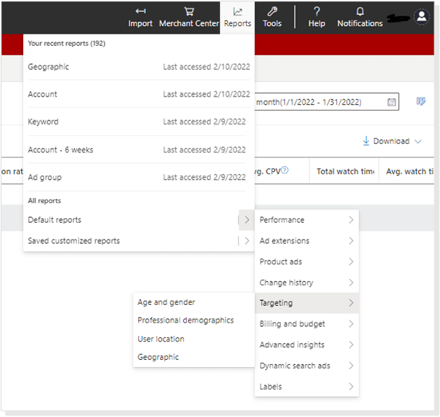

* **New preview options.** Real-time report previews, which adjust as you create and modify your columns and filters, are now available.
* **Additional formatting options and shortcuts.** This update also includes new capabilities around conditional formatting, inline edits, sharing, scheduling, saving, scope changes and common Excel shortcuts.

<https://searchengineland.com/microsoft-advertising-reporting-dashboard-recent-reports-real-time-previews-382878>

## **YouTube Launching 5 New Features For Livestreams**

YouTube announces five new features for livestreams, some of which are currently in testing and others that will roll out later this year.

* These features are previewed in a video on YouTube’s Creator Insider channel. They include:
  + **‘Go Live Together’:** This is a collaborative streaming feature for mobile devices. Go Live Together allows creators to invite guests to stream with them by sending a link.

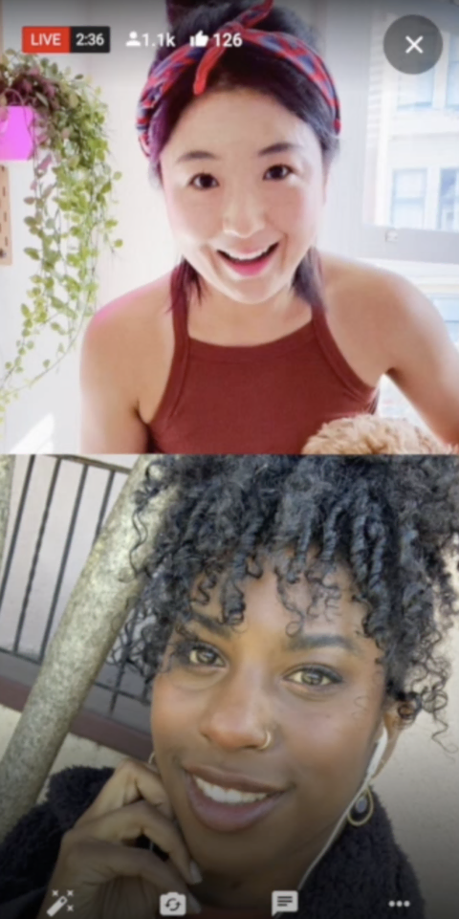

* + **Live rings:** The Live rings will help viewers identify when a channel is live by adding a ring around a channel’s profile picture.

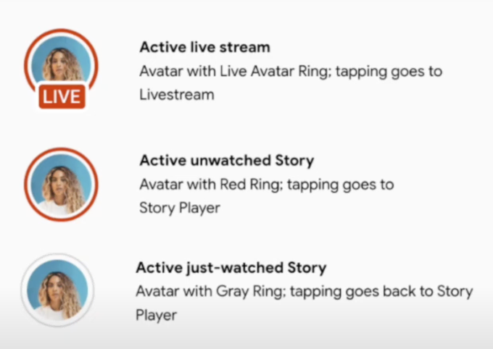

* + **Cross-channel live redirects:** With the launch of cross-channel live redirects, creators with at least 1000 subscribers, and no active community guideline strikes, will be able to direct their viewers to a livestream or premiere hosted on a different channel.
  + **Uninterrupted split screen viewing:** YouTube is working on offering an uninterrupted view of a livestream by taking a split screen approach with two different viewing experiences for mobile devices.
  + **Live Q&A:** With live Q&A a viewer will be able to submit questions during a livestream based on the creator’s question prompt. Questions answered by the creator will be temporarily pinned to the top of the live chat, encouraging other viewers to submit their own.

<https://www.searchenginejournal.com/youtube-launching-5-new-features-for-livestreams/442603/#close>

## **Amazon Briefing: Amazon’s physical advertising ambitions grow as other retailers play catch up**

Amazon’s advertising ambitions are increasingly expanding into the physical world. Last month, Business Insider [reported](https://www.businessinsider.com/amazon-to-sell-digital-ads-inside-fresh-go-physical-stores-2022-2) that Amazon was planning on selling in-store digital advertising inventory to sell to brands in its Amazon Fresh stores. And I spoke with some people with direct knowledge of the program and how Amazon is pitching it to brands.

* Amazon is planning on selling ad placements on digital signage its physical grocery stores beginning in the second quarter of this year, per a document leaked to Business Insider.
* Additionally, the company is reportedly thinking of expanding the inventory to other parts of the shopping experience including smart shopping carts, checkout booths and digital smokescreens on refrigerator doors.
* A big part of Amazon’s pitch is its data: People with knowledge of the program told me that Amazon’s touted metrics it’s offering to brands include ad play count, estimated impressions, impressions by geography as well as tracked ASIN sales data.
* That Amazon is building out digital ad offerings in its physical stores isn’t surprising. But it may well send a shiver down other retail media executives’ spines. Nearly every large retailer is building out an advertising platform with the hope of enticing big brand marketing dollars. Walmart, Target and Kroger have been building out various advertising offerings for years, but others like GoPuff, Instacart, Walgreens, Macy’s and CVS have begun building out more retail media offerings. According to an [estimate](https://www.emarketer.com/content/retail-media-networks-hit-their-stride-2021) from eMarketer, by 2023 retail media will represent $50 billion in marketing spend and receive nearly 20% of all digital ad spend.

<https://www.modernretail.co/platforms/amazon-briefing-amazons-physical-advertising-ambitions-grow-as-other-retailers-play-catch-up/>

## **Meta inks partnership for 3D ads in step toward the metaverse**

Meta Platforms Inc will make it easier for brands to run three-dimensional ads on its Facebook and Instagram social media platforms through a new partnership with an ecommerce technology firm.

* The integration with VNTANA will allow brands to upload the 3D models of their products to Facebook and Instagram and easily convert them into ads, VNTANA said on Thursday in a press release.
* The move is a stepping stone into advertising in the metaverse, said VNTANA Chief Executive Ashley Crowder, referring to the futuristic idea of a collection of virtual worlds that can be accessed through devices such as headsets.
* Meta previously partnered with augmented reality (AR) companies Modiface and PerfectCorp to help beauty and cosmetic brands more easily run 3D and AR advertising.
* Facebook and Instagram users who see a 3D ad while browsing on their desktop or phone can interact with an image of a handbag, for instance, and move it around to view the item from all angles.
* "In a way, this offers a glimpse of what you might expect on future devices like AR glasses," said Chris Barbour, director of augmented reality partnerships at Meta's Reality Labs unit.
* Before VNTANA's integration with Meta, advertisers would need to reformat 3D files to be compatible with Meta's ad systems. Now, brands can use VNTANA to easily upload and convert the files into ads without technical expertise in working with 3D images, Crowder said.

<https://www.reuters.com/technology/3d-ads-come-facebook-instagram-step-toward-metaverse-2022-03-24/>

# Calendar Week 11 (Mar 20)

## **Amazon’s physical advertising ambitions grow as other retailers play catch up**

Amazon’s advertising ambitions are increasingly expanding into the physical world.

* Amazon is planning on selling ad placements on digital signage its physical grocery stores beginning in the second quarter of this year, per a document leaked to Business Insider.
* Additionally, the company is reportedly thinking of expanding the inventory to other parts of the shopping experience including smart shopping carts, checkout booths and digital smokescreens on refrigerator doors.
* A big part of Amazon’s pitch is its data: People with knowledge of the program told me that Amazon’s touted metrics it’s offering to brands include ad play count, estimated impressions, impressions by geography as well as tracked ASIN sales data.
* It is currently only available to select brands that are already stocked in the stores with fresh ASINs available.
* Walmart, Target and Kroger have been building out various advertising offerings for years, but others like GoPuff, Instacart, Walgreens, Macy’s and CVS have begun building out more retail media offerings.
* According to an estimate from eMarketer, **by 2023 retail media will represent $50 billion in marketing spend and receive nearly 20% of all digital ad spend.**

<https://www.modernretail.co/platforms/amazon-briefing-amazons-physical-advertising-ambitions-grow-as-other-retailers-play-catch-up/>

## **Cross-Platform and Mobile Advertising Market is Expected to Reach USD 220.20 Billion By 2028**

**The Cross-Platform and Mobile Advertising Market** is expected to grow from USD 48.40 Billion in 2020 to USD 220.20 Billion by 2028, at a CAGR of 0.209 during the forecast period.

* The driving factor for growth being the increasing use of **internet of mobile** and increase in the need of mobile application. However, concerns associated with **privacy and location** may act as the restraining factors for the market.
* Based on device type, the market is segmented as mobile phones, tablets, laptops and smart TV. Because of the rapid use of mobile devices among individuals, **the mobile device type is expected to bring the highest growth of 6% among all.**
* Based on Advertising type, the market is divided into short message service (SMS)/multimedia messaging service (MMS)/, search advertising, Peer-to-Peer (P2P) messaging, rich media and display advertising, in-game advertising, and in-app advertising. **The most common type of online advertising is done by the display through the use of mobile and other interactive devices.**
* America along with the Middle East & Africa, is the largest the cross- platform market due to the high usage of mobile phones and smart devices in association with the rising use of internet.

<https://www.einnews.com/pr_news/565939568/cross-platform-and-mobile-advertising-market-is-expected-to-reach-usd-220-20-billion-by-2028>

## **Meta to test content tools for advertisers later this year**

Meta Platforms Inc said it will build new tools to **allow brands to prevent their ads from appearing next to unsuitable content on Facebook and Instagram**, and will begin testing the tools later this year to launch in early 2023.

* The social media company also said it selected advertising measurement firm **Zefr** as its partner to provide outside verification that ads appeared only next to suitable content.
* Advertisers have demanded tools to help them customize and prevent ads from appearing adjacent to content the brand deems unsuitable, such as politics or news about death or violence. Meta said **it will build such controls for the Facebook and Instagram feeds for English-speaking markets first.**
* Next year, the company plans to expand the content controls to include other languages, the Stories feature and short-form video feature Reels, among other parts of the apps.

<https://www.reuters.com/technology/meta-test-content-tools-advertisers-later-this-year-2022-03-17/>

## **Amazon now officially owns MGM**

**Amazon today officially closed its acquisition of MGM**, making the Hollywood studio part of Amazon Prime Video and Amazon Studios.

* The deal, valued at $8.45 billion, brings over MGM’s catalog of more than 4,000 film titles, 17,000 TV episodes and valuable IP including James Bond.
* "We are excited for MGM and its bounty of iconic brands, legendary films and television series, and our incredible team and creative partners to join the Prime Video family," said Chris Brearton, chief operating officer of MGM, in a statement.
* When Amazon first announced the acquisition in May 2021, the company highlighted the opportunity to create new content based on MGM’s existing titles.

<https://www.fiercevideo.com/video/amazon-now-officially-owns-mgm>

## **Microsoft’s Automotive Ads get more placements, roll out globally**

Microsoft Advertising has expanded **Automotive Ads placements** and rolled out the open beta to all advertisers globally, the company [announced](https://about.ads.microsoft.com/en-us/blog/post/march-2022/expanding-the-reach-and-scope-of-automotive-ads) Wednesday.

* Since its introduction, **Automotive Ads** have been eligible to show in Bing search, image and video results pages. With this expansion, the format can also display in the **Microsoft Audience Network, the Microsoft Autos Marketplace and the Windows search bar.**

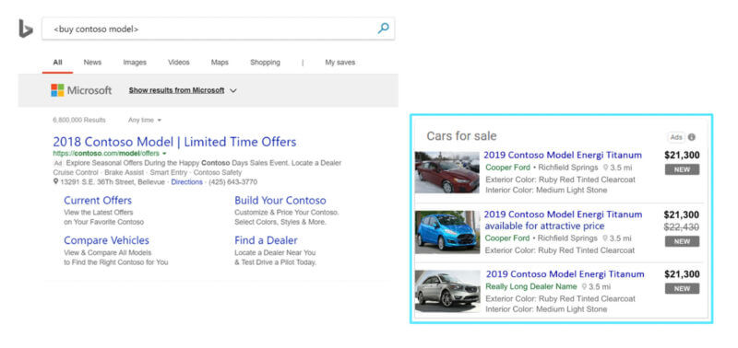

* This format will also begin showing on Yahoo! And DuckDuckGo (Microsoft has agreements to show ads on both these platforms).
* In addition to the updates above, the company plans to roll out more expansions throughout this year. These include:
  + Support for new vehicle types (motorcycles and RVs).
  + Support for monthly pricing and leasing options.
  + Support for more visuals and attributes (such as an attribute for electric vehicles).
* On the Microsoft Search Network, automotive search interest is up 48% compared to 2019, according to Microsoft internal data.

<https://searchengineland.com/microsoft-automotive-ads-get-more-placements-roll-out-globally-382583>

# Calendar Week 10 (Mar 11)

## **Pinterest adds in-app checkout and personalized shopping recommendations**

Pinterest is expanding on its shopping capabilities with in-app checkout and a new personalized recommendations feature, the company announced at its Pinterest Presents event on Thursday.

* **Pinterest Checkout.** Currently in beta, the ability to purchase items within the Pinterest app is now available for certain U.S.-based [Shopify retailers](https://searchengineland.com/shopify-pinterest-app-merchants-turn-catalogs-into-shoppable-pins-334459). The platform expects to roll out this feature to more U.S.-based retailers over the course of this year.
* **Your Shop.** Billed as a “personal shopping concierge, powered by a taste-driven algorithm,” the newly announced “Your Shop” feature is a recommendations engine designed to suggest products, brands and creators to users based on their activities and preferences. Like Pinterest Checkout, Your Shop is also currently in beta in the U.S., with plans for a wider release later this year.
* Soon, Pinterest users will be able to complete transactions without leaving the app, which can decrease friction and potentially bring in more conversions for eligible retailers.

<https://searchengineland.com/pinterest-adds-in-app-checkout-and-personalized-shopping-recommendations-382383>

## **Twitter Shops lets brands showcase 50 products**

Twitter has introduced a new experimental ecommerce feature it calls Twitter Shops. Brands who want to create a shop can curate up to 50 items to include, which Twitter uses can then buy via an in-app browser from the merchant’s website.

* After a brand or business enables a Twitter Shop, a new “View shop” button will appear on its profile page, directly above its tweets. It looks like this:

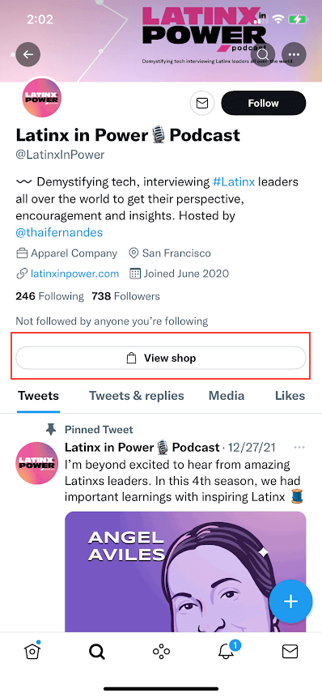

* For now, only iPhone users can view and interact with the shops.
* Twitter only mentioned five brands that have enabled their shops. Those are:
  + @Verizon (showcasing 11 products, as of publishing)
  + @ArdenCove (9 products)
  + @LatinxInPower (50 products)
  + @GayPrideApp (13 products)
  + @AllIDoIsCookUS (14 products)
* Twitter Shops are only available to select merchants and managed partners in the U.S., according to Twitter’s blog post. Twitter isn’t charging brands to open a Shop.
* A Twitter Shop contains a product image, product name, product type, and price.

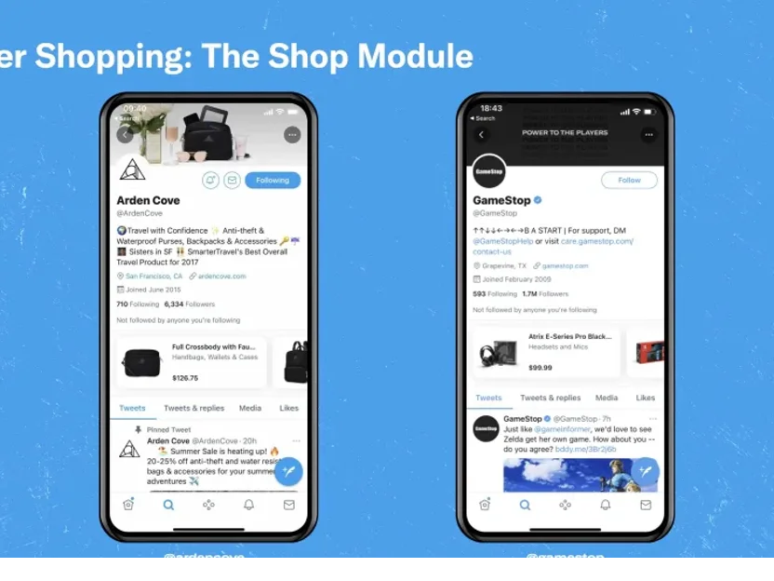

<https://searchengineland.com/twitter-shops-launches-382359>

## **Amazon Is Burying Organic Search Results**

Of the first twenty products a shopper sees when searching on Amazon, only four are organic results. There is little space left for organic results at the top of the page, the real estate that drives most sales. Few purchases happen beyond the first page of search results. And not many shoppers scroll to the bottom of even the first page.

* Amazon search results often start with a sponsored brand advertisement displaying a few products, followed by four sponsored products and four organic results. Then, four more sponsored products (marked as “Highly rated. Based on star rating and number of customer ratings”), and finally a sponsored video ad displaying one product. Editorial recommendations from articles, Amazon’s Choice picks, and other offers come next.
* **It takes scrolling past three browser windows worth of search results to get to the fifth organic result.** It takes even more swipes to see the fifth organic result on mobile. Thus, there is a meaningful difference between the first four organic results and the rest - the first group is significantly more likely to be clicked on.
* Because of the proliferation of search results that are not organic, shoppers are disproportionally more likely to be purchasing a sponsored product. For brands, that means the difference between having a #2 search result versus a #5 could be substantial.
* A decade ago, Amazon search results were largely deterministic and meritocratic. Products that sold well and shoppers liked ranked higher than the rest. Today, that’s only part of the variables at play. More impactful is paying for sponsored placements and figuring out how to be featured by Amazon’s Choice or editorial recommendations.

<https://www.marketplacepulse.com/articles/amazon-is-burying-organic-search-results>

## **Google launches automated vehicle ads**

This new format uses vehicle data feeds in Google Merchant Center to match users’ searches with ads.

* Vehicle ads will roll out to advertisers in more countries at an undisclosed “later date,” Google said in the announcement.
* How vehicle ads work. Vehicle ads are designed to allow auto advertisers to promote their entire vehicle inventory to potential customers on Google.com. This format includes an image of the vehicle, make, model, price, miles and the advertiser’s name (shown in the example above).
* Google matches users with vehicle ads by using the details included in the advertiser’s vehicle inventory data feed (more on that below).
* When a user clicks on a vehicle ad, they’re taken to the vehicle description page on the advertiser’s site. There, they can learn more and fill out a lead form. Advertisers can select which actions to measure, such as leads or store visits, and assign them a value.
* How to get started. To use vehicle ads, advertisers must create a vehicle inventory data feed and connect it to Google Merchant Center. This feed includes data on makes, models, prices, mileage and condition. Since this is done through Google Merchant Center, advertisers can track metrics like clicks over a given time period.

<https://searchengineland.com/google-launches-automated-vehicle-ads-382425>

## **Nordstrom plots ad expansion as retail media network generates $40M**

Nordstrom is sharing more details on its advertising program to capture the interest of brands that are adjusting their strategies to account for privacy headwinds that have shaken mainstay platforms.

* While Nordstrom's bid to crack into the space is still early days, it's already generating tens of millions in revenue and has developed close ties to marketers like L'Oréal's Luxe group, which owns the Lancôme and Kiehl's brands. On a call discussing Q4 earnings earlier this week, executives also nodded to an opportunity to help scale newcomers.
* Nordstrom is framing the Nordstrom Media Network as part of its larger [Closer to You mission](https://press.nordstrom.com/news-releases/news-release-details/nordstrom-expands-advertising-nordstrom-media-network) that centers around personalizing the customer experience. **That effort has included an extensive ad campaign and** [**growth roadmap**](https://www.prnewswire.com/news-releases/nordstrom-outlines-long-term-growth-strategy-closer-to-you-301222458.html) **that touches on improving services, broadening who Nordstrom serves and its product portfolio, and better using technology to paint a full picture of customer behavior.**
* The Nordstrom Media Network currently carries on-site media placements like sponsored product ads and brand pages and off-site options including paid social and display ads, YouTube video ads, search and shopping ads and affiliate campaigns. Native display pages will soon be added to the on-site suite, [according to Nordstrom's website](https://www.nordstrom.com/browse/about/nordstrom-media-network).
* Nordstrom has recently introduced new shopping channels that try to capitalize on the e-commerce boom and could factor into the Nordstrom Media Network. Last March, it [rolled out a livestream shopping portal](https://www.retaildive.com/news/nordstrom-debuts-interactive-livestreams/596869/), adding to momentum for virtual events that have become common during the pandemic.
* **Nordstrom is moving quickly to deepen its ad products during a period where other retailers are seeing their own advertising programs hit new levels of maturity.** Walmart now [generates $2 billion annually from ads](https://www.marketingdive.com/news/walmarts-ad-business-hits-2b-as-automation-plays-larger-role/619094/)and is implementing its own demand-side platform, a complicated piece of ad tech. Target, which also reported earnings this week, said it wants to expand its Roundel media network into a $2 billion business within the next several years.

<https://searchengineland.com/pinterest-adds-in-app-checkout-and-personalized-shopping-recommendations-382383>

# Calendar Week 09 (Mar 04)

## **YouTube Adding More Analytics Data About Views & Revenue**

**YouTube is working on ways to give creators more data about video performance**, including detailed reports about the sources of views and revenue.

* YouTube plans to actively assist creators with generating new video ideas by adding reports on trending.
* YouTube is working on new reports showing an overview of different video formats and views generated by each type.
  + Advertisers will be able to see data on how many hours of video you uploaded, how many hours you streamed, how many views you received for each format, and more.

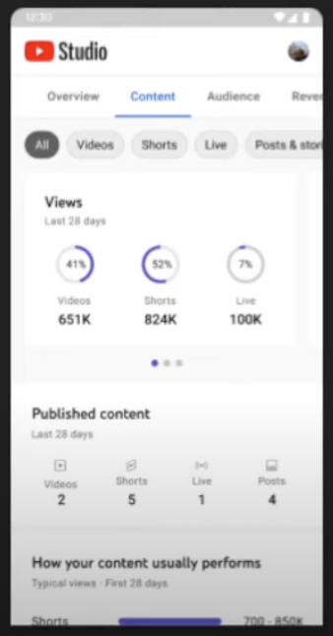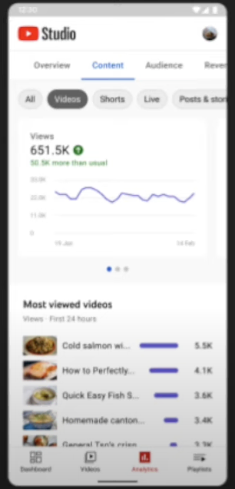

* For creators eligible to monetize their videos, YouTube plans to add more data about the individual sources of revenue.
  + Revenue data will be broken down by type of video, and how the revenue was generated.

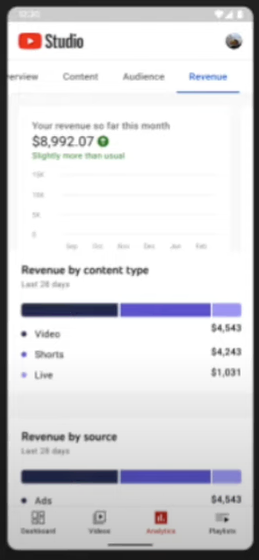

* The new revenue report will offer a more detailed look at memberships, tagged products, SuperChats, and all the different ways to make money on YouTube.

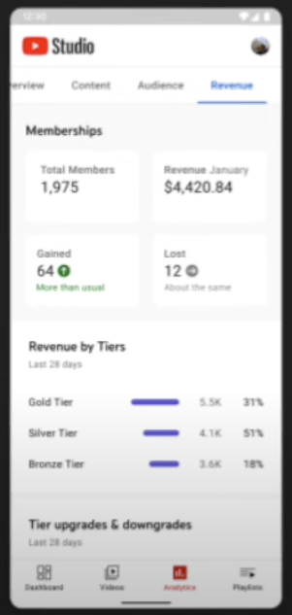

* YouTube recently launched an experimental tool showing **the popularity of certain search terms and which video topics have a lack of content.**
  + That tool will be expanded to show which topics are trending on YouTube and which videos are starting to grow in popularity with your audience.

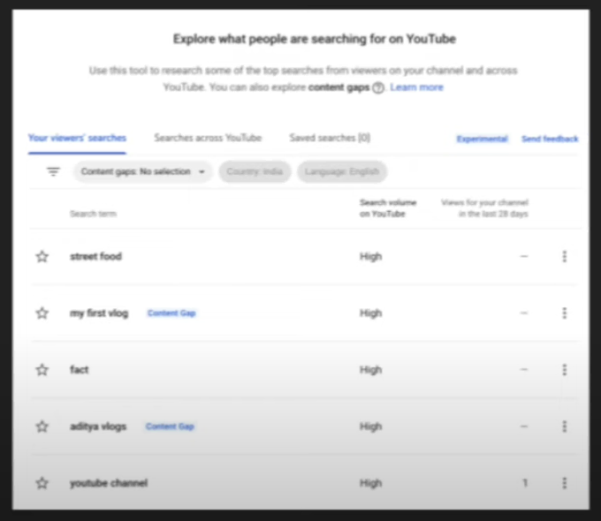

<https://www.searchenginejournal.com/youtube-adding-more-analytics-data-about-views-revenue/439632/#close>

## **Etsy sellers to pay 30% higher transaction fees beginning in April**

**Etsy will raise its seller fees from 5% to 6.5% (a 30% increase**), the company announced during its Q4 2021 [earnings report](https://s22.q4cdn.com/941741262/files/doc_financials/2021/q4/Exhibit-99.1-12.31.2021.pdf). The new seller transaction fee will take effect starting on April 11.

* In many cases, Etsy’s seller fees are still lower than eBay’s and Amazon’s, but the margin is getting thinner, which may also erode some of the benefits of selling on Etsy.
* **Etsy last increased its transaction fees in 2018, raising them from 3.5% to the current 5% rate.**
* .Etsy’s plans for the added revenue. “We plan to reinvest a considerable portion of that incremental revenue back into the marketplace because we want to directly have that benefit the seller,” said Etsy’s CFO, Rachel Glaser, during the company’s Q4 2021 earnings call.

<https://searchengineland.com/etsy-sellers-30-higher-transaction-fees-381322>

## **TikTok videos can now be 10 minutes**

**The maximum video length on TikTok has increased – again – this time to 10 minutes**, the social media platform has confirmed.

* This change, which is rolling out globally over the next few weeks, follows months of testing.
* At launch, TikTok videos were limited to 15 seconds. TikTok later increased the maximum video length time to 60 seconds, then tripled that to 3 minutes last July.
* This change offers an opportunity to keep viewers engaged longer on the platform, without having to watch multiple parts of a video series.
* TikTok is already the third most popular social network (behind Facebook and Instagram) and continues to see its user base grow.

<https://searchengineland.com/tiktok-10-minute-video-length-381434>

## **What’s A Good Google Ads CTR/CPC/CPA In 2022?**

See how your Google Ads campaign performance measures up against the latest benchmarks from Wordstream by LOCALiQ.

* Their data consists of data points from thousands of campaigns in both Google and Microsoft Ads for the top 20 industries.

## **Average Click-Through Rate In Google Ads By Industry:**

* + The average click-through rate across all industries sat at 3.17% in 2021. In LOCALiQ’s data, the industries they pooled together outperformed that CTR, averaging over 6%.

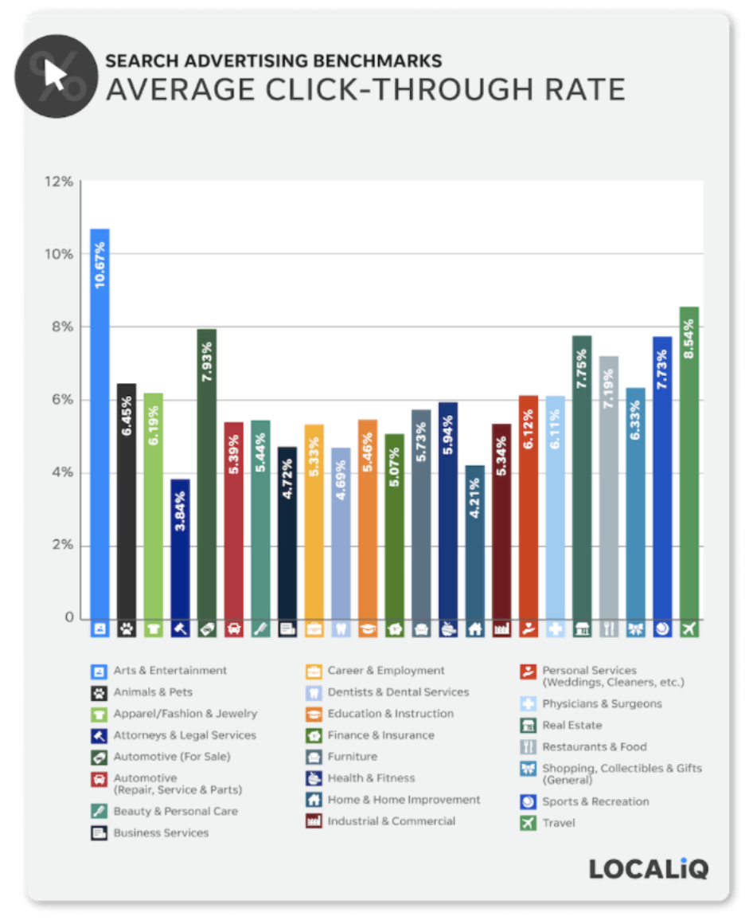

* **Average Cost-Per-Click In Google Ads By Industry:**
  + While the Attorneys and Legal Services showcased the lowest CTR, they also boasted the highest average [CPC](https://www.searchenginejournal.com/win-in-competitive-costly-ppc-environments/386998/). In 2021, the average CPC for this industry came in at $8.67.

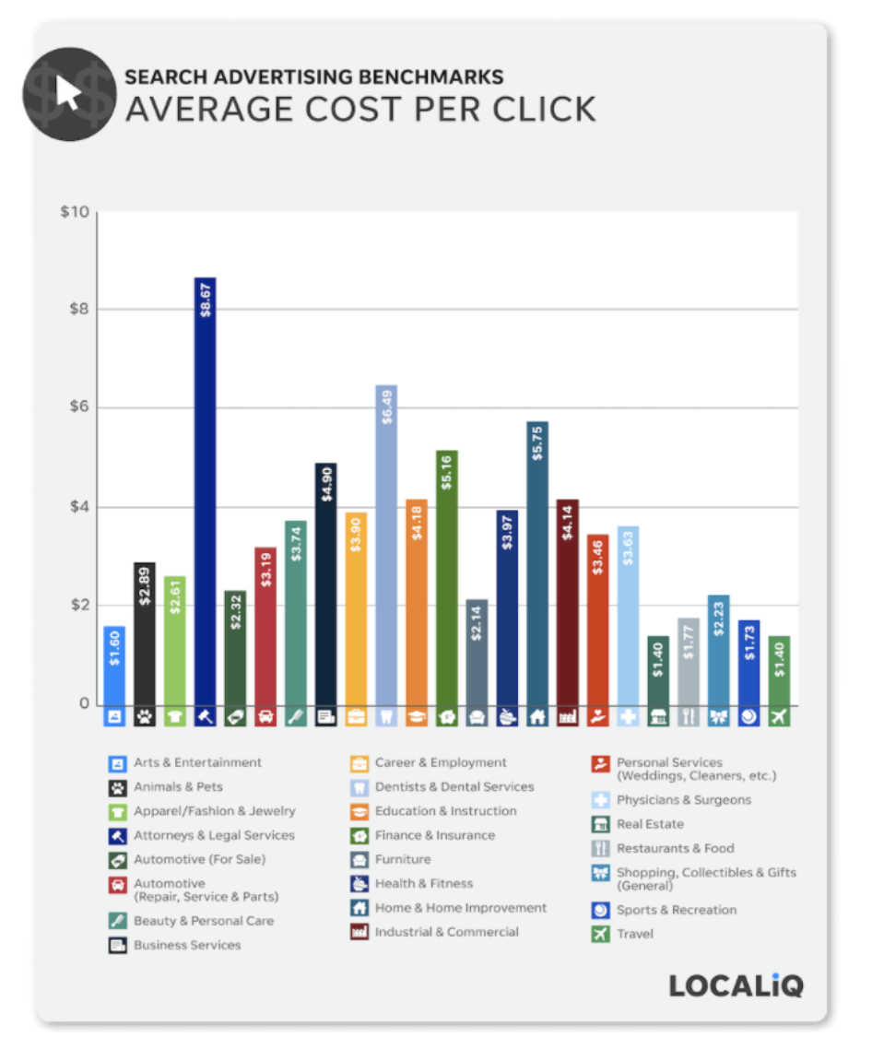

* **Average Conversion Rates In Google Ads By Industry:**
  + When looking at the data from 2021, the average Conversion Rate varied highly across industries. On the high end of performance, Animals & Pets had the highest conversion rate at 19.19%, followed by Physicians and Surgeons at 19.15%.

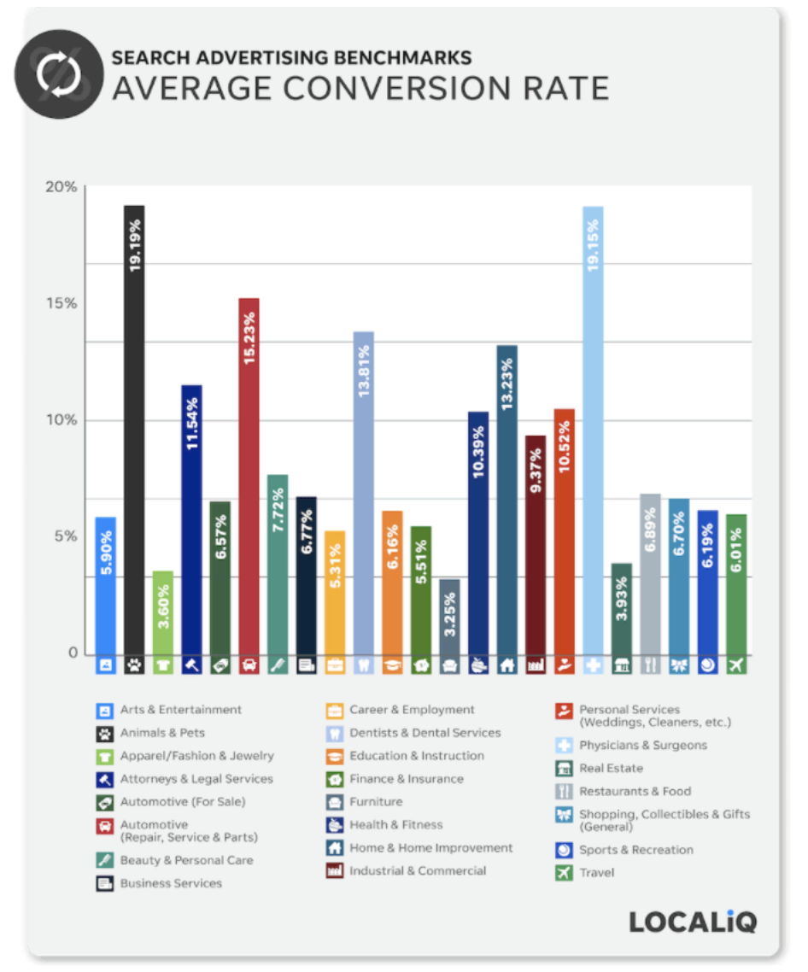

<https://www.searchenginejournal.com/data-whats-good-ctr-cpa-conversion-rate-adwords-2018/248947/#close>

# Calendar Week 08 (Feb 25)

## **Shoppers may soon be able to message merchants via Google Shopping**

Google is testing a new messaging feature that would allow customers to send messages to the customer service email address provided in your Google Merchant Center account.

* Google has invited select merchants to participate in this pilot via email.

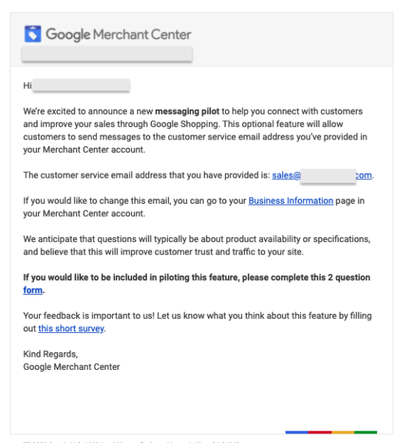

* Providing potential customers with a way to contact retailers via Google Shopping may increase the value of the platform for both merchants and customers.
* Winning over more shoppers and retailers will also help strengthen Google as a shopping destination, helping it compete with the likes of Amazon, eBay and other marketplaces.
* The company has not announced when (or whether) this feature will become widely available.

<https://searchengineland.com/shoppers-may-soon-be-able-to-message-merchants-via-google-shopping-381115>

## **Microsoft Ads Launches Dynamic Descriptions For Dynamic Search Ads**

Microsoft Ads rolls out **Dynamic descriptions for Dynamic Search Ads.** In addition to the already present dynamic headlines, advertisers can now choose to serve dynamic descriptions to users.

* Similar to dynamic headlines in Dynamic Search ads, Microsoft Ads will generate descriptions automatically that are geared towards highest relevance to each user.
* There will be a new “**Descriptions” column as part of the DSA (Dynamic Search Ads) Search Terms report.**
* Any brand or advertiser that is considered to be in a sensitive vertical, such as Pharmacy, Financial Services, etc., will not be eligible for dynamic descriptions.
* While advertisers can choose to utilize these new dynamic descriptions starting today, **Microsoft will make dynamic descriptions the default option in Dynamic Search campaigns for everyone starting in April.**
* For advertisers that are wanting to maintain more control of ad copy, there will be an option to opt out of this feature.
* This change to Dynamic Search campaigns is another nod towards automation. As the complexity of campaigns increases, the goal is to take some of the day-to-day management away from advertisers.

<https://www.searchenginejournal.com/microsoft-ads-launches-dynamic-descriptions-for-dynamic-search-ads/439081/#close>

## **Monetize Facebook Reels With Overlay Ads**

Facebook is starting to monetize its reels platform with overlay ads, which gives users another way to monetize their content.

* Reels monetization will roll out gradually. By mid-March, overlay ads will be available to almost all countries that currently have in-stream ad programs.
* This is a completely new ad format to Facebook that they are testing. The overlay ads will be available in two formats:
  + **Banner ads**
  + **Sticker ads**
* **Both ad formats will layer on top of Facebook reels in a transparent format.** This means that viewers will be able to watch their favorite content creators uninterrupted, while subtly being introduced to relevant ads to them.

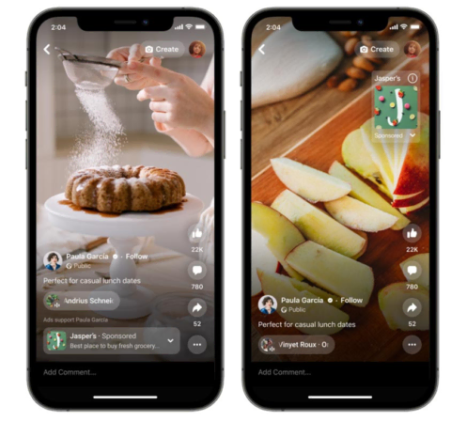

* Depending on which format is chosen, the placement of the overlay will vary.
  + For banner ad placement, these will appear at the bottom of a Facebook reel.
  + In the sticker ads format, the content creator gets to choose where in the reel the overlay appears.

<https://www.searchenginejournal.com/monetize-facebook-reels/439449/#close>

## **Google Ads Announces Top 3 Priorities for 2022**

Google Ads sheds light on their top three priorities for 2022: automation, measurement, and privacy. Learn how they're tackling these topics.

* **New Opportunities With Automation:** 
  + *“Over 80% of Google advertisers are now using automated bidding to free up time and improve ad performance.”*
  + Under the Automation pillar, Google is emphasizing the use of [Performance Max](https://www.searchenginejournal.com/google-ads-performance-max/435595/) and [Discovery](https://www.searchenginejournal.com/why-you-should-be-using-google-discovery-campaigns/371500/) campaign types.
* **The Future Of Measurement:**
  + It’s no secret that measurement has been a challenging topic for most advertisers. With the iOS 14 update, the future removal of third-party cookies, and more – new approaches to measurement will be critical for success.
  + Google is rolling out new solutions to privacy and measurement including:
    - Enhanced conversions
    - Consent mode
    - Conversion modeling
    - Data-driven attribution
  + The solutions put into place will rely on your first-party data and privacy-safe APIs.

## **Delivering Expectations For Digital Privacy:**

* + It’s difficult these days to go without hearing of some sort of privacy breach. Google understands the increasing need for user privacy and controls.
  + Google has updated their [privacy playbook](https://www.thinkwithgoogle.com/future-of-marketing/privacy-and-trust/marketing-privacy-playbook/) to capture these needs both from the advertiser and user perspective. The three main highlights of this playbook include:
    - Building direct relationships with customers
    - Ensuring measurement remains accurate and actionable
    - Keep your ads relevant
  + In building direct relationships with customers, you’re able to capture first party data for more 1:1 direct communication, such as email marketing or in-app messaging.

<https://www.searchenginejournal.com/google-ads-announces-top-3-priorities-for-2022/438491/#close>

## **The Game Within The Game: How Brand Conquesting Took On A New Twist During The Super Bowl**

The Super Bowl continues to capture the attention of increasingly distracted consumers, both for the game and the ads.

* The instant gratification potential for some of these advertisers can be extraordinary, as it’s become so easy for people to immediately buy products they see during the Big Game that just cost a few bucks — like beer, soap, shavers or snacks. Just pop the name of the brand you saw into the search bar on Amazon, Walmart, Instacart, whatever, after seeing the ad
* Just because people can search for you doesn’t mean that you’ll be easily found in the still wild west that is omnichannel commerce. Brands can siphon your big investment with just a few shekels by buying sponsored search results for key terms related to any brand — known in the industry as “conquesting.”
* Conquesting is not new. Brands have been conquesting other brands on Google for well over a decade. But with more consumers beginning their shopper journey on retailer sites like Amazon, conquesting is becoming a much higher stake game for brands for two reasons. First, retailer sites like Amazon, Walmart and Instacart are much lower in the funnel and the risk of being conquested most immediately translates into lost sales. Second, many retailer sites are designed to remember your purchase history and recommend past products you have ordered for the next time you buy. So losing sales to a competitor the first time from conquesting may mean you never get a chance to win that consumer back again.
* **This year’s Super Bowl gave marketers a perfect case study for observing this new evolution of brand conquesting in action.** One one side of the field we had the offense — the Super Bowl advertisers (Budweiser, Cheetos, Irish Spring, etc) who each spent an estimated $7 million for a 30 minute ad spot on NBC. On the other side, we had the defense — brands who didn’t buy Super Bowl ads but tried to “intercept” the brands who did by conquesting their brand terms at the exact moment they were likely to get the most national exposure.

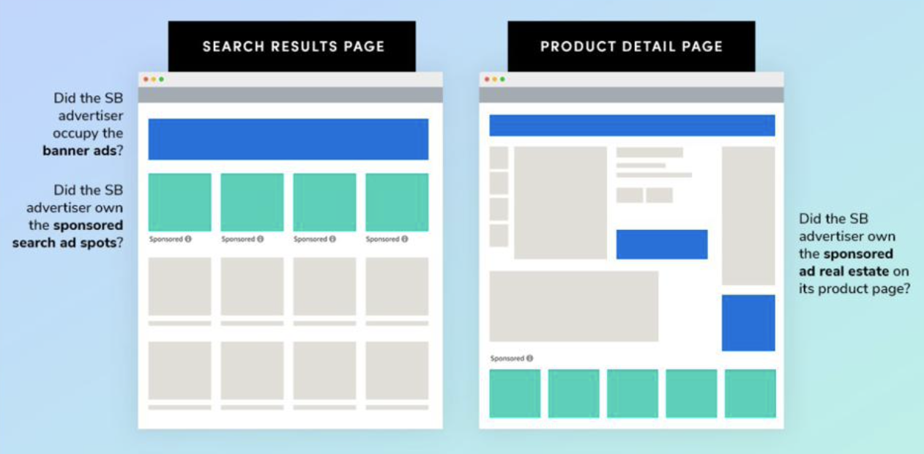

* So how did this battle of brand versus brand play out? During the course of the game, according to [Profitero](https://www.profitero.com/), there were [more than 6,000 instances of brands](https://www.profitero.com/blog/super-bowl-2022-brand-interceptions) attempting to intercept another brand on Amazon, Instacart, and Walmart.com (full disclosure, I work at Profitero). For example, Modelo and Corona attempted to intercept products from AB InBev more than 300 times in four hours. Meaning that if you typed in “Bud light Next” or “Michelob Ultra” on Instacart during the game you were more than likely to see a Corona or Modelo product ahead of them in sponsored search results. And to rub salt on the wound, even if you clicked on an AB InBev product, you were most likely to see a Modelo or Corona ad on their product page.

<https://www.forbes.com/sites/sarahhofstetter/2022/02/17/the-game-within-the-game-how-brand-conquesting-took-on-a-new-twist-during-the-super-bowl/>

# Calendar Week 07 (Feb 18)

## **TikTok’s brand safety center consolidates transparency updates, announcements and partnerships**

TikTok has launched **a brand safety center** as a hub for articles, partnerships and other resources related to brand safety and transparency, the company [announced](https://www.tiktok.com/business/en-US/blog/tiktok-launches-new-brand-safety-center) Tuesday.

* The brand safety center includes TikTok’s mission statement, the latest brand safety announcements, information about its partnerships and certifications, the platform’s transparency updates and case studies.
* As TikTok builds out the advertising capabilities, the brand safety center may be a convenient reference for brands to understand how TikTok is tackling these issues.
* The launch of the new [Brand Safety Center](https://www.tiktok.com/business/en/brand-safety) is just the latest step in our ongoing journey to become the world’s safest platform for brands and their customers. Over the next year, you can expect to see TikTok:
  + Expand our partnerships and solutions into new markets.
  + Work alongside industry groups to set definitions and standards for critical brand safety issues, such as misinformation and ad adjacency.
  + Support TikTok creators and brands working together to tell their stories in authentic and safe ways.
  + Enable small and medium-sized businesses to make informed decisions to keep their brands safe.
  + Adapt and expand our solutions to match new product innovations.

<https://searchengineland.com/tiktoks-brand-safety-center-380405>

## **Snapchat introduces attributable mid-roll ads for Snap Stories**

Snapchat is launching **mid-roll ads for Snap Star Stories**, the company [announced](https://newsroom.snap.com/creators-mid-roll-ads) Monday.

* The new, attributable ad product is currently in closed beta and the company expects to roll it out more widely later this year.
* “In beta testing now with an early set of U.S. [**Snap Stars**](https://support.snapchat.com/en-US/article/snap-stars), Snap Stars will receive a share of the revenue generated from ads within their public [**Story**.](https://support.snapchat.com/en-US/a/about-stories) Stories lower the barrier to content creation and engagement, and we believe placing ads within a Snap Star’s public Story will allow an easier path to financial success.” Snapchat says.
* This new feature gives advertisers another product they can use to reach potential customers. Being able to tie conversions from these ads to a given creator also helps advertisers understand their ROI.
* Since creators will get a slice of the revenue generated by their mid-roll Snap Stories, the format might encourage more adoption among influencers, which could, in turn, also increase user engagement and adoption.

<https://searchengineland.com/snapchat-introduces-attributable-mid-roll-ads-for-snap-stories-380350>

## **Google AdSense launches related search for content pages**

Google has launched related search for content pages, a new AdSense feature that **displays search terms related to the content of the pages users are reading**, the company announced Monday.



* Advertisers can use related search on your content pages to encourage your users to explore relevant topics on your site and engage with search ads.
* To use related search on your content pages, advertisers need to complete the necessary contracting steps for AdSense for Search.
* Advertisers can create related search units in your AdSense account, style them to match the look and feel of your site, and start using them with a simple code change.
* The main benefit here is that you may be able to get more ad revenue by directing users to your internal search results, where AdSense will show them more ads.
* Additionally, this is somewhat similar to “related articles” widgets, which means that it can encourage users to explore more of your content.

<https://support.google.com/adsense/answer/11575703>

## **E-Commerce Lost Market Share in 2021**

U.S. e-commerce penetration decreased in 2021 because offline retail grew faster than e-commerce for the first time in history, and the online shopping boost from the Covid-19 pandemic cooled off.

* According to the Department of Commerce, e-commerce represented 13.2% of total retail spending in 2021. Down from 13.6% in 2020. Despite online shopping increasing to [$870 billion](https://www.marketplacepulse.com/stats/us-ecommerce/us-total-retail-sales-unadjusted-114) from $762 billion, e-commerce market share instead decreased because offline retail sales grew faster. That never happened before.
* Total retail sales reached [$6.6 trillion](https://www.marketplacepulse.com/stats/us-ecommerce/us-total-retail-sales-unadjusted-114) in 2021, up a staggering 17.9% year-over-year. That growth was the fastest in decades (which wasn’t because the previous year’s - 2020 - growth was slow; even facing lockdown headwinds, retail spending was up that year). Retail spending grew by $1 trillion in a year. It took from 2013 to 2020 to grow by a trillion before that.

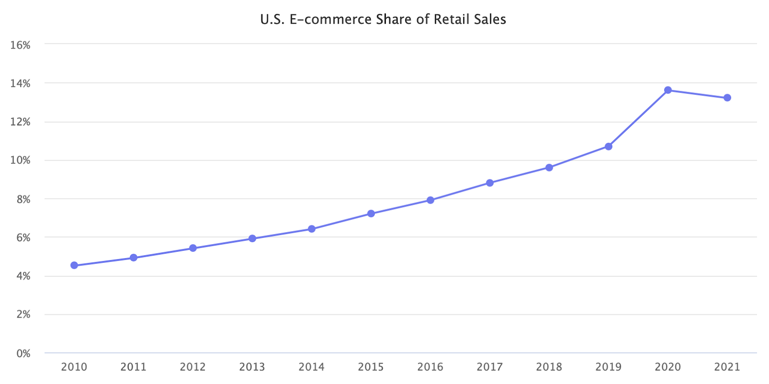

* The lockdowns of 2020 led to a lot of forced e-commerce and online grocery adoption, and a lot of growth was pulled forward. While initially, that growth looked like a step-change, it is now settling back to a trend line it was on for over a decade - U.S. e-commerce penetration is currently at levels it would have reached even if the pandemic didn’t happen.
* E-commerce sales in 2021 would have potentially reached $762 billion if the pandemic didn’t happen, and online spending would have continued on the ten-year 14.8% growth trend line. The actual $870 billion sales it reached were up 14.2% from that trend line. Thus shoppers were still spending more online than historical trends would have suggested, but they were also spending more in physical stores.

​​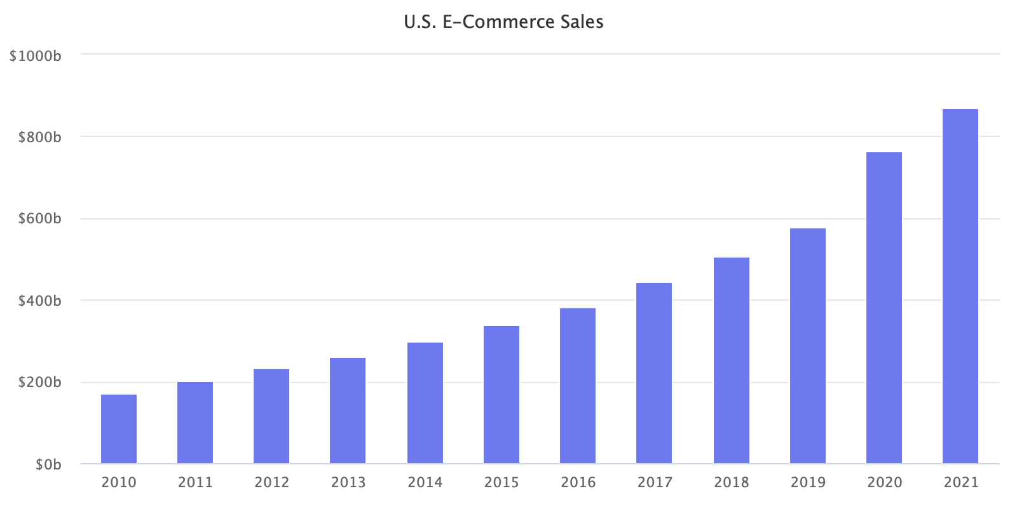

* Invisible in those numbers are varying changes in different categories. For example, online grocery did have a step-change. But even Walmart, one of the major players in online grocery, only grew e-commerce by 11% in 2021. However, adoption of online grocery, changing habits, remote work, and others might end up rewiring shopping patterns long-term.

<https://www.marketplacepulse.com/articles/e-commerce-lost-market-share-in-2021>

## **Walmart Breaks Out Ad Business Revenue At $2.1 Billion And Details How Ads Power Its Retail Evolution**

The company broke out advertising revenue for the first time, with Walmart clearing $2.1 billion worldwide. $500 million of that total was credited as revenue earned as a reduction to an advertiser’s cost of sales (make of that what you will). The other $1.6 billion was pure media biz.

* **Walmart’s ad revenue disclosure comes two weeks after Amazon reported advertising as its own business segment for the first time – earning** [**$31 billion in 2021**](https://www.adexchanger.com/ad-exchange-news/amazon-breaks-out-advertising-services-at-last-on-a-31-billion-run-rate/)**.**
* “We expect Walmart Connect to continue to scale over the next few years with plans to become a top-10 ad business in the midterm,” Walmart CFO Brett Biggs told investors about the retail media unit.Walmart Connect is part of a two-pronged initiative for Walmart: ecommerce and margin expansion.
* The high-margin advertising business is an important factor in what Walmart calls its “growth algorithm” – a plan to invest heavily in brick-and-mortar overhauls and fulfillment while maintaining or even growing its overall profit margin.
* Walmart’s margins are under pressure by temporary forces, such as inflation and the current labor and supply-chain crunch, but also by long-term investments in home delivery, new store set-ups to accommodate online pick-up orders and its grocery business. (Groceries are low-margin sales but valuable because the category brings loyal, regular shoppers.) To balance those investments, Walmart is adding high-margin businesses, such as the third-party seller marketplace and, notably, advertising.
* Half of Walmart Connect’s business in Q4 2021 was automated platform sales, double the rate of programmatic in 2020. That number will continue to spin up, and is an elixir to Walmart’s overall profit margin.

<https://www.adexchanger.com/ecommerce-2/walmart-breaks-out-ad-business-revenue-at-2-1-billion-and-details-how-ads-power-its-retail-evolution/>

# Calendar Week 06 (Feb 11)

## **YouTube reveals 2022 roadmap for shopping features, Shorts and more**

YouTube has laid out its 2022 roadmap for shopping features, Shorts and other updates for brands and creators.

* **More robust shopping experiences.** Shopping capabilities will expand via shoppable videos, Live Shopping and via the user interface of the YouTube app.
* **Shorts.** YouTube plans to keep adding features to its Shorts format, the platform’s answer to TikTok and Instagram’s Reels. In addition to new effects and editing tools, YouTube plans to introduce the ability to reply to individual comments by creating another Short (similar to TikTok).
* **New insights for creators.** New insights will be added to YouTube Studio.
* **Channel guidelines**, which can help creators influence the tone of conversations on their channel, are currently being tested.

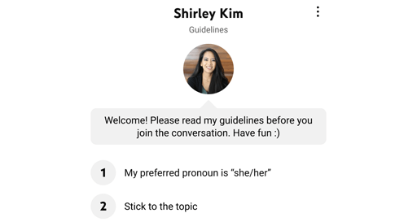

* **Collaborative livestreaming** will also be introduced, enabling creators to go live with other creators.

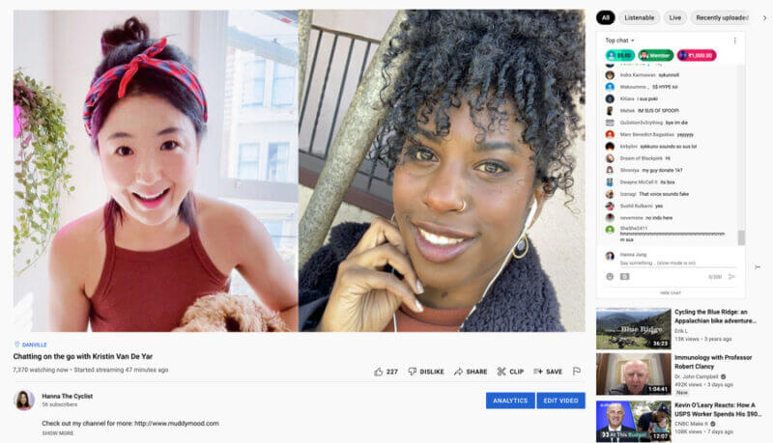

* YouTube has begun testing **gifted memberships**, which allow viewers to purchase channel memberships for other viewers in a livestream.

<https://searchengineland.com/youtube-2022-roadmap-for-shopping-features-shorts-380248>

## **Microsoft Advertising launches Cruise Ads**

Microsoft Advertising is launching **Cruise Ads** in open beta, the company announced Wednesday.

* Cruise Ads are Microsoft Advertising’s latest vertical-specific ad format and are currently only available to advertisers targeting customers in the U.S.
* Cruise Ads are an automated ad format that leverages feed data to match offers to searches. Keywords aren’t necessary, although advertisers can use negative keywords for optimization.
* Cruise Ads appear on the right-hand side of the Bing search results and appear alongside mainline text ads. They can trigger for queries such as cruise name, location, length, etc.

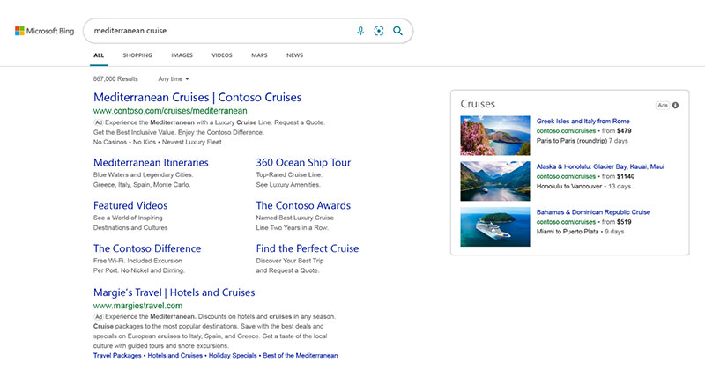

* In 2021, Microsoft Advertising began launching **a series of vertical-specific ads** that operate similar to Cruise Ads. They include:
  + Automotive Ads
  + Tours and Activities Ads
  + Credit Card Ads
  + Health Insurance Ads
* **Vertical-specific ad formats** may drive more engagement than one-size-fits-all formats because they’re better able to address the searcher’s intent by providing additional relevant details.

<https://about.ads.microsoft.com/en-us/blog/post/february-2022/does-it-really-matter-if-a-cruise-ship-was-raised-cage-free>

## **Yelp introduces Keyword Boosting, rolls out Custom Location Targeting to all advertisers**

**Yelp has introduced Keyword Boosting**, a feature that enables business owners to optimize their ads for specific keywords, the company announced Tuesday.

* **Introducing Keyword Boosting.** This new feature allows local businesses to **direct their ad budget at desired keywords** (somewhat similar to keyword match types in Google Ads or Microsoft Advertising).
  + Business owners can select keywords to boost (or block) from the default keywords that Yelp uses to match ads to customer searches or input their own keywords.

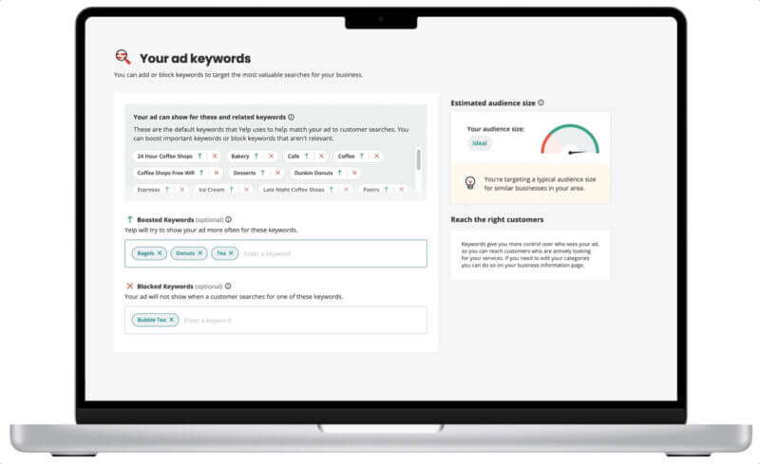

* **Custom Location Targeting rolls out to all Yelp Ads customers.** Yelp also expanded its Custom Location Targeting to more advertisers, enhanced its ad budgeting feature and added templates for Yelp Connect subscribers.
  + First announced in May 2021 for home and local services businesses, **Custom Location Targeting enables business owners to designate specific locations for their ads to appear.**

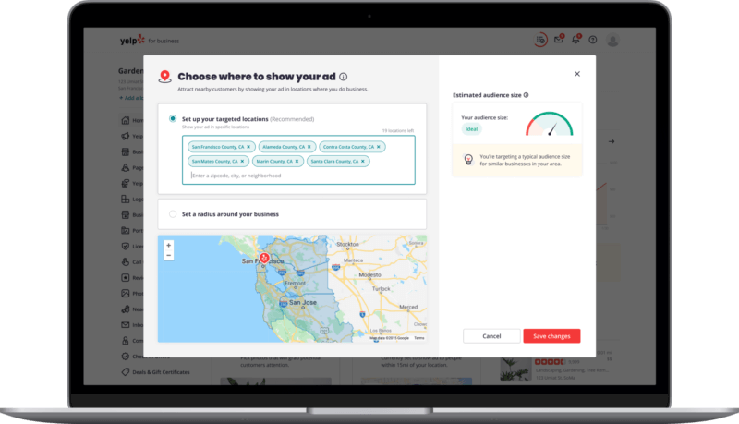

* **Enhanced ad budgeting**. The company has also enhanced its budgeting feature by leveraging more data, such as rating, category, listing age and region.
* **Yelp Connect templates.** Yelp is also providing templates to subscribers of its [Connect](https://searchengineland.com/yelp-introduces-connect-and-new-waitlist-features-for-restaurants-321909) social publishing and advertising tool to help them write more effective posts.

<https://searchengineland.com/yelp-introduces-keyword-boosting-rolls-out-custom-location-targeting-to-all-380054>

## **Advertising Is Masking Amazon’s Unprofitability**

Without the high-margin advertising revenue, Amazon’s retail business is increasingly unprofitable. It was at break-even as recently as 2015. Since then, as advertising revenue grew, so did Amazon’s use of that growth to fund the rest of the retail operations.

* Amazon’s operating income from retail operations was $6.3 billion in 2021. It would have been a $24.8 billion loss if not for the advertising business. Because advertising has a virtually zero marginal cost, and thus, nearly all of its $31.2 billion in revenue was profit.
* Retail operations include online sales, physical stores, third-party marketplace, advertising, and Prime membership (all of Amazon except AWS cloud hosting). Not all of those businesses are equally profitable. According to Amazon quarterly results, operating income ex AWS was $6.3 billion in 2021. That, minus advertising’s naively assumed $31.2 billion income, yields a $24.8 billion loss.
* Even if a more realistic 90% or 80% of advertising revenue was treated as profit, the rest of the retail business was still massively in the red. In the fourth quarter of 2021, Amazon’s retail operating loss was $1.8 billion, the highest loss in over six years. It would have been an $11.6 billion loss if not for advertising.
* Advertising is very clearly Amazon’s most profitable business segment. Both in terms of profit margin and dollars. AWS cloud hosting is often assumed to be funding the rest of Amazon. However, advertising is already nearly half the size of AWS and generates more operating income.

<https://www.marketplacepulse.com/articles/advertising-is-masking-amazons-unprofitability>

## **Changes To Google Ads Keyword Matching And The Repercussions For Marketers**

On Sept. 23, Google updated us with the news that it was rolling out **improvements to its keyword matching technology, as well as changes to the rule on how keywords are selected within advertisers’ accounts.** While the announcement might seem innocuous, the changes may be having serious consequences for marketers both big and small.

* Google claims that these changes improve keyword matching precision, give advertisers better control and attract more relevant, high-performing traffic using fewer keywords — but there’s a downside. While the changes may sound copacetic, the reality is that they present a major risk to advertisers and have the potential to completely destroy marketing budgets.
* [Google stated](https://support.google.com/google-ads/answer/10286719?hl=en) that *“the updated phrase match simplifies match types by combining the control of phrase match, and the expanded reach of the discontinued broad match modifier. The new phrase matching behavior is more expansive than the former phrase match, and slightly more restrictive than the discontinued BMM.”*
* Basically, when people search for anything on Google, **the search will no longer trigger ads for only the queries (i.e., keywords) and phrases they explicitly specify. Instead, phrase match keywords will trigger ads for so-called close variations. Shockingly, the same is even true for exact match.**
* This means advertisers will likely see greater search volumes, but it also means you can no longer control the keywords that you want to spend money on, and these “close variations” can quickly draw unwanted traffic to a client’s site.

<https://www.forbes.com/sites/forbesagencycouncil/2022/02/11/changes-to-google-ads-keyword-matching-and-the-repercussions-for-marketers/?sh=6682082a51f3>

# Calendar Week 05 (Feb 04)

## **Microsoft rolls out portfolio bid strategies and automated integration with Google Tag Manager**

Advertisers on Microsoft’s platform have two more ways to save time that might otherwise be spent adjusting and configuring their campaigns.

* Portfolio bid strategies are now available globally, Microsoft Advertising [announced](https://about.ads.microsoft.com/en-gb/blog/post/february-2022/portfolio-bid-strategies-and-other-february-product-updates?feed=blogposts) on Tuesday. The platform’s automated integration with Google Tag Manager (GTM) is also now generally available.
* Portfolio bid strategies automatically adjusts bidding across multiple campaigns to balance under- and over-performing campaigns that share the same bidding strategy (like maximize conversions, target CPA, target impression share, etc).
* Automated integration with GTM. Microsoft Advertising’s integration with Google Tag Manager enables you to automatically copy the setup used by your existing Google tags.
* Portfolio bid strategies can help save time that might otherwise be spent manually adjusting bids. The automated GTM integration also helps you save time by copying over the Google tag setup you’re already using.

<https://searchengineland.com/microsoft-portfolio-bid-strategies-integration-google-tag-manager-379592>

## **Google Ads creates unified advertiser verification program**

Google Ads will merge its advertising identify and business operation verification programs into a unified advertising verification program in March, according to an email sent by Google Ads to some advertisers today.

* The Google Ads unified advertising verification process is similar to the [current identity verification process](https://searchengineland.com/google-will-roll-out-identity-verification-program-to-all-advertisers-333462) – you’re required to submit your legal business or individual name, along with any other supporting documentation. This information will be displayed in an ad disclosure.
* Google said it will ask advertisers questions (e.g., the advertiser’s industry and billing country) related to their Google Ads and account, which will be shown in a new section, *About your business*. Why? So Google can understand whether you are a direct or indirect provider of the products or services being advertised.
* Advertisers must submit their *About your business* answers within 30 days. Failure to do so will result in your account being paused. On top of that, Google said there will be an additional 30 days to complete any requested verifications, which could be identify, business operations, or both.
* Advertisers were previously given 30 days to start identity verification, and an additional 30 days to complete it. And advertisers were previously given 21 days to complete business verification, and were given a 7-day notice period before account suspension.

<https://searchengineland.com/google-ads-unified-advertiser-verification-program-379568>

## **Amazon lifts the lid on its $31bn advertising business**

Amazon has for the first time published its advertising services revenues, revealing that the US e-commerce giant made $31.2bn in ad revenue last year. The figures were included in the company’s fourth-quarter earnings report for 2021, with ad revenue in the last quarter up 32pc to $9.7bn.

* It provides more clarity on a growing part of Amazon’s business. The last major earnings break out the company made was when it separately reported Amazon Web Services (AWS) for the first time in 2015.
* The sheer size of Amazon’s ad business puts it ahead of many other tech companies, including Microsoft, which reported advertising revenue in 2021 of more than $10bn in its [most recent earnings call](https://www.siliconrepublic.com/business/microsoft-earnings-2022-cloud-azure). While $31.2bn is around half the [ad revenue reported by Google](https://www.siliconrepublic.com/business/google-alphabet-earnings-revenue-q4-stock-split) last year, it soars past YouTube ad revenue for 2021.

<https://www.siliconrepublic.com/business/amazon-earnings-advertising-business>

## **Pinterest’s AR shopping feature expands to include furniture and home décor**

A new Pinterest feature will allow consumers to see what furniture or other home décor items will look like in their own home, using augmented reality (AR). Similar technology has already been put into place by major retailers, like Amazon, IKEA and Wayfair, as well as others in the home design space, like Houzz.

* This virtual shopping experience for home décor is launching in the U.S. across more than 80,000 shoppable Pins, which makes it Pinterest’s largest AR shopping investment to date.
* It’s also the third “Try On” product Pinterest has launched over the past two years. Its first efforts were in the beauty market, with Try On features that allowed consumers to virtually experiment with different lipstick shades and eyeshadows, totaling 14,000 shoppable Pins.
* This attempt to funnel consumers’ more casual browsing into retail transactions has been Pinterest’s larger focus over the years. But the company has been slow to adapt to various market shifts, including the move away from static images to video as shopping inspiration, for example — at least until more recently. L
* **The company told TechCrunch it’s not currently monetizing its AR shopping feature.** But its retail partners on the efforts are brands that have already seen both organic and paid advertising success on Pinterest, and are now taking advantage of another way to allow consumers to discover products organically.

<https://techcrunch.com/2022/01/31/pinterests-ar-shopping-feature-expands-to-include-furniture-and-home-decor/>

## **Facebook is the big loser of the fourth quarter’s advertising wars**

Facebook, now Meta, has emerged as the fourth quarter’s biggest loser in the hotly contested advertising wars.

* Facebook’s admission is the most concrete data point so far on the impact to the advertising industry of Apple’s App Tracking Transparency feature, which reduces targeting capabilities by limiting advertisers from accessing an iPhone user identifier.
* Meanwhile, Amazon broke out its advertising revenue for the first time ever in its fourth-quarter earnings on Thursday, surprising many in the process.
* The e-commerce giant said its ad revenue came in at $31 billion for 2021, which is more than the $28.8 billion in ad revenue that YouTube posted for the year.

<https://www.cnbc.com/2022/02/04/facebook-is-the-big-loser-of-the-fourth-quarters-advertising-wars.html>

# Calendar Week 04 (Jan 28)

## **Google offers new replacement for advertising cookies after 'FLoC' falls short**

Alphabet Inc's Google on Tuesday announced its second try at enabling advertisers to buy ads based on users' browsing interests without having to rely on what it has described as privacy-invasive tracking cookies.

* Google wants to block tracking cookies in its Chrome web browser by the end of next year, which would prevent advertising companies from logging the websites someone is visiting.
* Advertisers, website owners and privacy groups have all raised alarms over the planned transition, and complaints have led antitrust authorities in the United States, United Kingdom and elsewhere to watch Google's plans closely.
* **Google's initial solution, known as Federated Learning of Cohorts, or FLoC, aimed to constantly group people into big baskets designed by algorithms based on websites users visited in the last week. Advertisers could show ads to a preferred basket, but they would not know the individuals in it or what interest they shared in common.**
* But in tests last year, some advertisers found FLoC less effective than cookies for choosing users to target and the system carried the risk of exposing an individual's browsing history, Google product director Vinay Goel told Reuters.
* The new browser system, which is called Topics, **groups each user in up to 15 baskets out of about 350 human-designed choices such as "fitness" and "travel" based on three weeks of browsing. Advertisers will see up to three baskets per user as they decide whether to show that individual an ad.**
* ​Goel said browsing is tracked only on websites that enable Topics, and users can dissociate from a topic or turn off the technology altogether. Testing will begin within months, he said.

<https://www.tbsnews.net/tech/google-offers-new-replacement-advertising-cookies-after-floc-falls-short-363220>

## **Smart Shopping and Local campaigns to be transitioned to Performance Max by end of September**

Google Ads will automatically transition existing Smart Shopping campaigns into Performance Max campaigns between July and September 2022, the company announced Thursday. Local campaigns will automatically be transitioned between August and September 2022.

* The company will also launch a “one-click” self-service tool in Google Ads for advertisers that would like to transition specific Smart Shopping or Local campaigns ahead of the dates mentioned above.
* **“Based on early testing, advertisers who upgrade Smart Shopping campaigns to Performance Max see an average increase of 12% in conversion value at the same or better return on ad spend (ROAS),”** according to Google. However, results can vary, so it may be worthwhile to test out your transitioned campaigns with the self-service tool once it’s available, ahead of the forced transition deadline.
* This is a significant change to how Smart Shopping and Local campaigns work. Advertisers that don’t want to transition those campaigns over to Performance Max should begin exploring other options, as these campaign types (as we know them) will disappear by the end of September.
* In December 2021, Google announced that, beginning on February 15, 2022, all existing and future Smart Shopping campaigns will use a shared budget type. The change won’t have any impact on performance and the campaigns will continue to behave like a standard, non-shared campaign budget.

<https://searchengineland.com/smart-shopping-and-local-campaigns-to-be-transitioned-to-performance-max-by-end-of-sept-2022-379294>

## **TikTok Launches 'TikTok Tactics' Online Course to Help Marketers Level-Up their Platform Approach**

TikTok has launched a new, video-aligned platform training course for marketers, designed to provide tips and insights on how to make best use of the platform for brand promotion and development.

* The new ‘[TikTok Tactics’ course](https://tiktok-tactics.com/) is an ‘easy to follow, best-practice guide to advertising on TikTok’, which provides a range of lessons on attribution, targeting, creative best practices and more.
* Each course segment includes a video overview, which eventually points to three varying approaches to each, based on where you’re at in your marketing program.
* For example, as you can see here, in the ‘Attribution’ element, TikTok notes that beginners with limited development resources should start with the standard website pixel, to help track user response data for your campaigns, while more advanced marketers are organizations can move on to its Pixel developer mode and API integration for advanced tracking.
* Each element follows the same path, outlining how it can contribute to your overall TikTok marketing strategy, and how you can level up each aspect relative to where you’re at in your process.

<https://www.socialmediatoday.com/news/tiktok-launches-tiktok-tactics-online-course-to-help-marketers-level-up-t/617798/>

## **Coinbase new NFT marketplace would look to draw new users by offering them a different kind of experience to what its rival offers**

According to the Coinbase Vice President for Products, Sanchan S. Saxena, the essence of the platform is to show how easy it is for users to buy NFTs. **The new NFT marketplace will allow users to connect with various self-custody wallets and buy NFTs.**

* In Saxena words, “we are building an open marketplace, and you will be able to buy an NFT using any self-custody wallet of choice OR using your CB account and custody it with CB. You can buy an NFT that was minted on any platform, right on CB NFT.”
* **Coinbase will be prioritizing user experience above anything else. It’ll be marketing the ease of using its NFT platform compared to other options in the market.**
* Saxena also promised to share Coinbase social discovery feed preview and show users how to discover new NFTs by following artists.
* There’s no timeline yet for when the Coinbase NFT platform will launch. The exchange released a waitlist with the initial announcement back in October 2021. But the previews suggest that the launch will come soon.

<https://www.fxempire.com/news/article/coinbase-shows-users-how-its-nft-marketplace-will-operate-879868>

# Calendar Week 03 (Jan 21)

## **Google Ads launches placement reports for Performance Max campaigns**

Google Ads has launched **placement reports for Performance Max campaigns**, the company confirmed on Thursday.

* [Placement reports](https://support.google.com/google-ads/answer/11465047) can be generated to see where ads have served for Performance Max campaigns as well as how many impressions they’ve received.
* Google created the placement report to provide some insight into where Performance Max ads are showing, which may help advertisers with their brand safety efforts.
* Unfortunately, the data only shows where ads have served and their impressions — not click data.
* Performance Max campaigns became [available to all advertisers](https://searchengineland.com/performance-max-campaigns-are-now-widely-available-and-will-include-smart-shopping-and-local-campaigns-in-2022-375702) in November 2021.
* Google also announced that, beginning sometime in 2022, [Smart Shopping and Local campaigns](https://searchengineland.com/performance-max-campaigns-are-now-widely-available-and-will-include-smart-shopping-and-local-campaigns-in-2022-375702) will be rolled into Performance Max, which might indicate that the company is trying to usher more advertisers to this campaign type.

<https://searchengineland.com/google-ads-launches-placement-reports-for-performance-max-campaigns-378835>

## **TikTok Sets Goal of $12 Billion in Advertising Revenue in 2022**

ikTok’s advertising revenue in 2021 reached nearly $4 billion, according to a report by Chinese media outlet LatePost. Multiple sources also said that the company’s goal for 2022 is to achieve at least triple the growth – or at least $12 billion in sales.

* TikTok’s advertising business came from ByteDance’s Chinese Commercialization Department, which built a mature strategy, product and sales system so as to enable TikTok’s advertising business to quickly get on track during the initial stages of its launch. ByteDance has also directly marketed its Chinese advertising placement product Pangle overseas.
* Currently, TikTok’s advertising operations are undertaken by the official platform TikTok for Business (TTFB), led by Blake Chandlee, Head of TikTok’s Global Commercialization, reporting to Zhou Shouzi, Head of TikTok.
* Official data show that TikTok had 1 billion monthly active users worldwide in September 2021. The platform’s current advertisers are mainly small and medium-sized internet companies.

<https://pandaily.com/tiktok-sets-goal-of-12-billion-in-advertising-revenue-in-2022/>

## **Google Search Console launches desktop page experience report**

With the [upcoming Google page experience](https://searchengineland.com/googles-page-experience-update-coming-to-desktop-next-month-378446) update coming to desktop, today Google launched **a new page experience report for desktop in Google Search Console.**

* Advertisers can access the report by [clicking here](https://search.google.com/search-console/not-verified?original_url=/search-console/page-experience&original_resource_id) or by going to Google Search Console, and clicking on the Page Experience link under the experience tab.
* Here is a screenshot of this report for one of my sites:

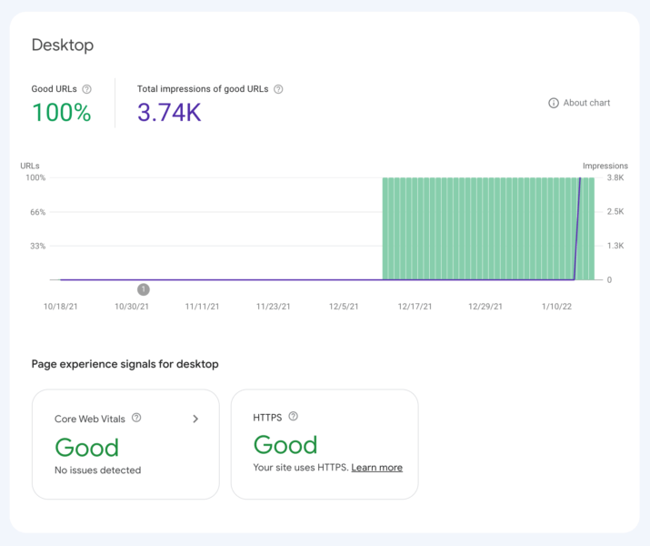

* Google first launched [the page experience report](https://searchengineland.com/google-search-console-adds-page-experience-report-and-filters-for-search-performance-report-347864) in April 2021 before the launch of the page experience update.
* The new Google Page Experience report offers metrics, such as the percentage of URLs with good page experience and search impressions over time, enabling you to quickly evaluate performance. You can also drill into specific pages to see what improvements need to be made.
* Advertisers can use this report to make the necessary adjustments to the desktop versions of your pages before Google rolls out the desktop version of the page experience update.

<https://searchengineland.com/google-search-console-launches-desktop-page-experience-report-378626>

## **How To Use Amazon Attribution & Brand Referral Bonus Programs**

As the cost per click (CPC) on Amazon rises, and the platform takes a stronger stance against black hat ranking tactics, more sellers have been looking at ways to drive external traffic to their Amazon [product detail page](https://www.searchenginejournal.com/amazon-advanced-seo-guide-top-rankings/317343/).

Additionally, some brands – particularly those without a Direct to Consumer (DTC) website or those wanting to use sales from external traffic sources to help the organic rankings on the ecommerce giant – will turn to advertise off Amazon to help drive the conversions needed to get those rankings.In the past, the disadvantage of sending external traffic to Amazon was that there wasn’t a way to track that traffic’s results and conversion rates. Amazon does not allow adding pixels to their product detail pages, so it was difficult to determine the effectiveness of external campaigns driven to Amazon.

* To address this issue, Amazon has introduced two programs that work together to help you see how external traffic is performing and get credit back on the fees for products you sent to Amazon.
* These programs are the Amazon Attribution and the Amazon Brand Referral Bonus.
* The **Amazon Attribution program** has been available for a couple of years. It enables you to drive external traffic and see specific data on the traffic results that you send to Amazon.
* On July 2021, Amazon introduced the **Brand Referral Bonus program**.
* With this program, when you drive external traffic, Amazon will discount the referral fees you pay for the products you sell with the traffic you sent to your product detail page on Amazon. To use the Brand Referral Bonus program, you must first be involved in the Amazon Attribution program and Brand Registry.
* The amount of referral fee credit you receive will be based on the category of your product, the same way that the referral fees themselves are calculated on the platform.There’s up to a 14-day attribution window depending on the type of ad.

<https://www.searchenginejournal.com/amazon-listings-brand-referral/432212/#close>

## **Meta Considering NFT Marketplace Within Facebook and Instagram**

Meta could be researching an NFT Marketplace within Facebook and Instagram, [according to a report by Financial Times](https://www.ft.com/content/2745d50b-36e4-4c0a-abe0-e93f035b0628). But, what could such a move mean for photographers finding footing in a young but exploding market? Could NFTs work to prevent image theft on social media?

* The report, which is based on several anonymous “people familiar with the matter” suggests that **Meta is building support for NFTs that would allow users to display the digital collectibles on their profiles, as well as buy and sell on the platform.**
* While the report hasn’t been confirmed by Meta, it doesn’t come as a surprise. The company launched its own digital currency wallet last year, while [Instagram head Adam Mosseri](https://markets.businessinsider.com/news/currencies/instagram-nfts-non-fungible-meta-metaverse-adam-mosseri-crypto-collectibles-2021-12) said that the social media platform was “exploring NFTs” [in a Story last month](https://twitter.com/alex193a/status/1472047221017354244). The company rebranded as Meta late last year to highlight a shift to the metaverse, a virtual world built on several major technology concepts including virtual reality and [NFTs](https://decrypt.co/82992/nfts-key-accessing-metaverse-beyond).
* But, while a move to NFTs isn’t surprising, the reports leave questions as to how, exactly the digital collectibles could be integrated and how adaptation by a platform with well over two billion users would influence the NFT market.
* We reached out to Daniel Yurcho, a blockchain entrepreneur, NFT consultant, and founder of Yurokat Inc. who theorizes that such a move would bring NFTs to more people, while initially creating higher prices before leveling out. “Meta’s involvement in the NFT market would really increase the exposure of NFTs to the average person,” he says. “Initially I think the market would be flooded with more buyers than NFT creators, resulting in generally higher prices. The value of NFTs still has to be based on something, and not created out of thin air. Both NFT projects, and individuals who already have a large follower community could likely charge higher prices with a sudden flood of consumers.”
* **Meta hasn’t provided further details about the possibility of an NFT Marketplace**, outside of Mosseri’s post that Instagram is “actively exploring” NFTs. Exactly how an NFT space would look on the platforms—and how they would benefit creators and users—is still up for debate.

<https://www.rangefinderonline.com/news-features/industry-news/meta-considering-nft-marketplace-within-facebook-and-instagram/>

## **Coinbase announces NFT marketplace partnership with Mastercard**

Coinbase Global Inc. said it will let users make purchases on its planned NFT marketplace through their Mastercard Inc. cards—without having to own cryptocurrency.

* The largest U.S. cryptocurrency exchange announced the partnership with payment giant Mastercard on Tuesday, **which aims at simplifying the experience of buying non-fungible tokens**, the digital ownership certificates for goods such as art pieces, that have seen soaring popularity in the past year. Coinbase has accumulated more than 2.5 million people on its waitlist for its NFT platform since it announced the plan last October, making it a challenger to leading platforms such as OpenSea.
* Under the partnership, **Mastercard will classify NFT as “digital goods,” which will allow cardholders to make NFT purchases through both credit cards and debit cards**, a change from the status quo in the U.S. where many crypto purchases are supported with just debit cards.
* NFT, one of the hottest corners of crypto that has ballooned to a $44 billion market, has drawn growing interests from retailers and institutions outside of the cryptocurrency industry. **Recent trademark filings from WalmartInc. show the retail giant intends to sell its own collection of NFTs.**

<https://fortune.com/2022/01/18/coinbase-nft-marketplace-mastercard-crypto-parternship/>

## **Walmart is preparing to go big on the metaverse, with its own NFTs and crypto**

Walmart Inc. is preparing to create its own cryptocurrency and collection of non-fungible tokens, filings with the U.S. Patent and Trademark Office show, setting the stage for meeting its customers in the emerging metaverse.

* The retailer sought several new trademarks in December that show it intends to make and sell virtual goods such as electronics, decor, toys, sporting goods and personal-care products.
* Walmart in August advertised a position to develop “the digital currency strategy and product roadmap” while identifying “crypto-related investment and partnerships,” according to a job posting on the company’s website.
* The applications were among a flurry the company filed on Dec. 30, including three under “Walmart Connect” — the name of the company’s existing digital advertising venture — for a financial exchange for virtual currency and advertising.
* Walmart has continued to explore capabilities in that realm. In October, the Bentonville, Arkansas-based retailer started a pilot program in which shoppers can buy Bitcoin at Coinstar kiosks in some of its U.S. stores. The test with Coinstar, which is known for the machines that let customers exchange U.S. coins for paper bills or gift cards, includes 200 kiosks in Walmart stores.

<https://fortune.com/2022/01/17/walmart-metaverse-own-nfts-crypto/>

# Calendar Week 02 (Jan 14)

## **METAVERSE, AUDIO AND GAMING ADVERTISING—WHAT TO EXPECT IN 2022**

Now, the notion of the metaverse—as distant a reality as it might be—challenges us to consider the interconnectivity between all platforms through which we consume content, conduct business and relate to one another. As new channels continue to find their footing, **the ability to measure, verify, and predict the quality and performance of media investments will follow.**

* **Metaverse interoperability will be key**
  + **The metaverse—**whose extended reality technologies permit the sharing of fully immersive online experiences—will continue to have a moment with Meta attempting to scale a first-mover advantage.
  + Still, the metaverse remains mostly conceptual. It’s early days for both the hardware and software and the content required to meet the meta-opportunity.
  + While the metaverse will take years to be realized, expect progress in 2022 to be driven by advancements in augmented and virtual reality.
* **Brand suitability concerns in digital audio**
  + Programmatic execution of digital audio media buys is growing but is still a comparatively small percentage of total dollars spent. Whether an ad actually ran will be key, but brand suitability will also be a major concern.

<https://adage.com/article/opinion/metaverse-audio-and-gaming-advertising-what-expect-2022/2392751>

## **Twitter buys minority stake in digital advertising firm Aleph**

**Twitter Inc** has picked up a minority stake in **Aleph Group Inc**, the digital advertising firm said on Tuesday as it seeks to go public in the United States.

* Emerging markets-focused Aleph, which helps large digital platforms connect with advertisers and customers, counts Meta Platforms Inc, Spotify Technology SA, and Microsoft Corp-owned LinkedIn among its customers.
* Founded in 2005 as IMS Internet Media Services,Aleph was valued at $2 billion last year after private equity firm CVC Capital Partners bought a stake worth $470 million.
* Latin American fintech company MercadoLibre Inc. is also among Aleph's investors, having picked up a stake worth $25 million in August last year.

<https://www.reuters.com/technology/twitter-buys-minority-stake-digital-advertising-startup-aleph-2022-01-11/>

## **Google Business Profiles sets waiting period for new owners and managers**

Google updated its Google Business Profile, formerly Google My Business.

* **When a new owner or manager is added to an existing Business Profile, they must wait for 7 days before they can manage all the features of the profile.**
* During this 7 day period, the new owner or manager gets an error if they try any of the following:
  + Delete or undelete a profile.
  + Remove other owners or managers from a profile.
  + Transfer primary ownership of a profile to themselves or a third user.
  + An existing owner or manager tries to transfer primary ownership of the profile to a new owner or manager still in their first 7 days.
* If the new owner or manager deletes their account within the first 7 days, they’re removed from the profile. If they undelete their account, they must be added to the profile again.
* It is a new limitation Google is making, maybe to increase security and prevent fraud or hack attempts.

<https://searchengineland.com/google-business-profiles-sets-waiting-period-for-new-owners-and-managers-378551>

## **Amazon Live rebuilt Live experience**

Amazon has been unable to unlock live commerce three years after launching Live in February 2019. Its amateur content didn’t attract viewers and, without users, brands and influencers are unwilling to commit to it.

* Amazon Live is shoppable videos streamed by influencers, sellers, and brands, featuring products shoppers can easily purchase. It also has a chat functionality that allows shoppers to interact with the host. The videos attract the biggest audience during Prime Day when Amazon typically hosts its own - it had [30,000-70,000 active viewers](https://www.marketplacepulse.com/articles/prime-days-growth-is-stalling) during Prime Day 2021.
* **In November 2021, Amazon rebuilt the Amazon.com/Live experience to mimic other streaming platforms like Twitch (owned by Amazon) or video platforms like YouTube.** It now has a list of highlighted creators, users can follow creators, and it lists dozens of live and previously live streams. Yet, there is zero interest from shoppers - Amazon Live maxes out at less than a thousand active viewers on a regular day.
* The audience is tiny because there is little reason to watch the live streams. They are not entertaining or well made. Despite being about shopping, they are too focused on selling. They have no chance competing for attention with YouTube, TikTok, or even QVC. Amazon Live’s *catch-22* is that no shoppers watch the videos because they are not interesting, and there are no interesting videos since no shoppers are watching them.
* **Amazon’s challenge is that its website and app are best for shoppers who know what they are looking for. The search bar is its core feature. It is not a destination for browsing or for getting inspired or entertained.** The features it launched over the years to become experience-led eventually fell by the wayside. Most Amazon shoppers are likely uninterested or unaware of the many things it can do.

<https://www.marketplacepulse.com/articles/amazon-live-is-embarrassing>

## **Best Buy joins Walmart, Target with in-house media company**

Best Buy is launching [Best Buy Ads](https://www.bestbuyads.com/), its new in-house media company designed to help its suppliers provide shoppers with targeted, timed promotional messages based on its customer relationships and insights. According to Best Buy, it interacts with its customers 3 billion times a year in-store and online.

* In [August 2021](https://chainstoreage.com/best-buy-lets-advertisers-directly-target-its-customers), Best Buy began enabling advertisers to use Criteo’s cross-retailer, self-service platform to reach BestBuy.com and BestBuy.ca shoppers in the U.S. and Canada. Through sponsored products, the platform helps Best Buy customers further discover and purchase products.
* The Criteo retail media platform allows brand marketers and agencies to reach consumers shopping on e-commerce sites, while executing campaigns with full transparency and control. Leveraging artificial intelligence (AI) capabilities, Criteo’s retail media ads conform to the same targeting and personalization as Best Buy’s organic product placements, helping ensure a seamless and relevant shopper experience.

<https://chainstoreage.com/best-buy-joins-walmart-target-house-media-company>

## **NFT Marketplace LooksRare Nears $400 Million in Sales in Just Three Days After Launch: Report**

Amid rising numbers of NFTs entering the market every day, a new online marketplace for these digital assets have been launched, named “LooksRare.” Within just three days, the NFT marketplace has recorded a sales volume of $394 million (roughly Rs. 2,912 crore), a report by CoinTelegraph said. The platform was officially launched on January 10. Presently, OpenSea has been reigning in the NFT selling space. Reports have predicted OpenSea sales from last year to amount around $10 billion (roughly Rs. 739,225 crore).

* Kicking off its operations, LooksRare offered to levy two percent fees on basic sales and no fees on private sales of [NFT](https://gadgets.ndtv.com/tags/nft) pieces. [OpenSea](https://gadgets.ndtv.com/tags/opensea), on the other hand, charges a 2.5 percent fee on every transaction, the CoinTelegraph [report](https://cointelegraph.com/news/opensea-competitor-looksrare-exceeds-394-in-sales) added.
* **“LooksRare is the community-first NFT marketplace that actively rewards traders, collectors and creators for participating.** Why do we need another marketplace? Because the NFT community deserves better,” the platform wrote on its [website](https://docs.looksrare.org/blog/launch-post).
* The top NFTs that stirred interest among buyers on LooksRare are the Meebits collection, which come from LarvaLabs — the same creators behind [Cryptopunks](https://gadgets.ndtv.com/tags/cryptopunks) and Autoglyphs.
* **The LooksRare marketplace has indexed all NFT collections on the** [**Ethereum**](https://gadgets.ndtv.com/finance/ethereum-price-in-india-today-inr) **blockchain.** “That means you can trade all the Ethereum NFTs that are available on OpenSea
* **The platform is rewarding NFT buyers and sellers from eligible collections, with its native token called LOOKS.**

<https://gadgets.ndtv.com/cryptocurrency/news/nft-marketplace-looksrare-sales-volume-usd-400-million-meebits-opensea-rival-2706068>

# Calendar Week 01 (Jan 07)

## **Best Buy joins Walmart, Target with in-house media company**

**Best Buy is launching Best Buy Ads**, its new in-house media company designed to help its suppliers provide shoppers with targeted, timed promotional messages based on its customer relationships and insights.

* According to Best Buy, it interacts with its customers 3 billion times a year in-store and online.
* In August 2021, **Best Buy began enabling advertisers to use Criteo’s cross-retailer**, self-service platform to reach BestBuy.com and BestBuy.ca shoppers in the U.S. and Canada.
* Leveraging artificial intelligence (AI) capabilities, Criteo’s retail media ads conform to the same targeting and personalization as Best Buy’s organic product placements, helping ensure a seamless and relevant shopper experience.
* **Walmart and Target – are also active in enabling targeted advertising for their customer bases.**
  + **Walmart recently rolled out a** [**demand-side platform**](https://www.chainstoreage.com/walmart-continues-revamping-ad-platform)for suppliers and their media and ad agencies in time for the 2021 holiday season. Walmart demand-side platform (DSP) is a collaborative effort with independent demand-side platform The Trade Desk.
  + **Target launched its Roundel ad network** in 2019 as a tool for CPG brands to create personalized digital ad campaigns aimed at Target customers. **Roundel** helps advertisers connect directly with Target's customers through personalized, relevant marketing messages across Target's owned platforms and hundreds of select off-platform channels.
* With the help of some of its partners and the [**Best Buy Foundation**](https://corporate.bestbuy.com/social-impact/), Best Buy Ads is launching an advertising-focused Career Pathways program through [Best Buy Teen Tech](https://corporate.bestbuy.com/teen-tech-centers-help-build-brighter-futures-video/) Center locations across the country.

<https://chainstoreage.com/best-buy-joins-walmart-target-house-media-company>

## **Pinterest: Brands Debuting New Products Must Catch the Attention of Gen Z**

**Brands debut more than 30,000 new products every year, and roughly 95% of them do not see long-term succes**s, according to research from Harvard Business School. How can brands beat those odds? **Pinterest suggests courting Generation Z.**

* **Insider Intelligence** projected last year that **Gen-Z will top millennials as the largest consumer base for new products by 2026**, and **Information Resources (IRi)** found that members of Gen-Z were 20% more likely than other generations to try new products and compare them with the brands or products they were currently using.
* **Pinterest** said in a blog post Wednesday that **Gen-Z “loves novelty**,” citing research from CareerBuilder, which found that the age group switches jobs more than other generations.
* Brands that connect with Gen Z will see an average of 14 times greater revenue growth opportunity with Gen-Z than other generations, according to IRi.
* **Pinterest shared three things for brands to keep in mind when it comes to introducing new products and targeting Gen-Z**:
  + Members of that age group are 16% more likely than other generations to say video ads appeal to them when shopping for new products, according to IRi.
  + “**Zoomers** want to buy from brands that understand their values and preferences. You can connect with them by embracing the channels they live on and highlighting their individual passions through personalization. They’re big—but not monolithic.”
  + According to research from McKinsey, members of Gen-Z use products to help them express their unique identity, and they relish standing out, so brands should use their ad copy and creative to explain how the product can help them leave their mark.

<https://www.adweek.com/social-marketing/pinterest-brands-debuting-new-products-must-catch-the-attention-of-gen-z/>

## **Google launches ‘Shops’ section in mobile search results**

**Google has launched a “Shops” section in the mobile search results.** **The Shops section shows three retailers** (but can be expanded to show up to ten) **based on their organic search rankings** and is available on mobile devices for select shopping-related queries in the U.S.

* **This feature currently shows 3 shops and users can then expand to see up to 10 merchants** depending on availability. The selection of results shown and their order are based on organic search ranking.

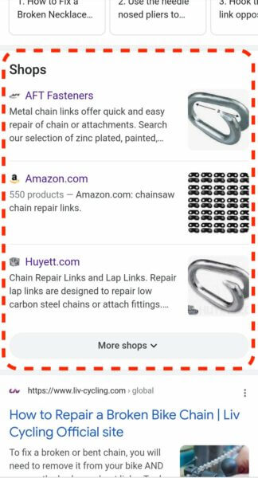

* Over the last two years, Google has expanded its shopping-related results from being a paid product to also offering plenty of visibility opportunities organically, beginning with the introduction of [free product listings](https://searchengineland.com/in-major-shift-google-shopping-opens-up-to-free-product-listings-333288) in April 2020.
* The company has also introduced a [**“deals”** section](https://searchengineland.com/google-announces-new-deals-sections-promotional-tools-and-expanded-reporting-ahead-of-the-holiday-shopping-season-350652) in the search results and launched Shopping integrations for [Shopify](https://searchengineland.com/google-unveils-its-shopping-graph-an-expanded-shopify-integration-and-more-shopping-features-at-i-o-348735), WooCommerce and GoDaddy, among other e-commerce platforms.
* The Shops section is another area in the search results where retailers might potentially appear, which can increase awareness for their brands and drive traffic.
* Non-shopping results may also appear in the same results page as the Shops section. The addition of more shopping features may potentially push non-shopping-related results further down the page, which can affect click throughs.

<https://searchengineland.com/google-launches-shops-section-in-mobile-search-results-378256>

## **Spotify is turning podcast ads into in-app banner ads to increase clicks**

Spotify [announced today](https://newsroom.spotify.com/2022-01-06/spotify-introduces-call-to-action-cards-for-podcast-ads/) that it is rolling out **new “call-to-action cards” for podcasting ads**, which are in-app advertisements correlated to the audio ads you hear in podcasts.

* The company says that these **call-to-action cards (CTA cards)** will appear in the Spotify application as soon as a podcast ad begins playing.
* CTA cards will appear in the app as soon as a podcast ad begins playing, and will resurface later on while you’re exploring the Spotify app—making it easier to check out the brand, product, or service you heard about while listening.
* During testing, Spotify says that tests have shown “twice as many site visits with these new clickable ads compared to non-clickable podcast ads.”
* Spotify says that the new call-to-action cards will launch with select Spotify Original & Exclusive podcasts in the U.S. beginning today.
* Advertisers can be especially excited—our tests have shown twice as many site visits with these new clickable ads compared to non-clickable podcast ads.

<https://9to5mac.com/2022/01/06/spotify-is-turning-podcast-ads-into-in-app-banner-ads-to-increase-clicks/>

## **Meta will remove targeting options for sensitive topics on January 19**

**Meta will remove certain targeting options relating to sensitive topics on January 19, 2022.** “Health causes,” “sexual orientation,” “religious practices and groups,” and “political beliefs, social issues, causes, organizations and figures,” were among the examples of targeting options slated for deprecation.

* Facebook advertisers should ensure that they are not relying on the targeting options mentioned below or any other targeting options that may relate to sensitive topics, as those will likely be deprecated at some point as well.
* **Campaigns can continue to deliver to impacted targeting options until March 17, 2022**, “in the vast majority of cases,” Meta said. Until March 17, advertisers will be able to make most edits at the campaign level without affecting targeting.
* After March 17, edits for impacted campaigns will not be possible at the campaign, ad set or ad level.
* The company will also remove targeting options that haven’t been widely adopted, citing that they may be redundant with other options or be too granular, although it did not specify which options.

<https://searchengineland.com/meta-will-remove-targeting-options-for-sensitive-topics-on-january-19-378095>